|  |
| --- |
| Climbing and General Training Tracker |
|  |

Table of Contents

Analysis 3

The Problem: 3

The stakeholders: 3

Solving the problem computationally: 4

Abstraction: 4

Decomposition: 4

Thinking Ahead: 5

Logistics: 5

Procedural and Object-Oriented Thinking: 5

Conclusion: 6

Software and Hardware Requirements: 6

Limiting Factors: 7

Research: 8

Interview: 8

Existing Solutions: 10

1 – Crimpd: 10

2 – Gym Tracker: 11

Questionnaire: 12

Proposed Solution: 14

Success Criteria 15

DESIGN: 18

Website Arrival: 18

Login: 18

The Website Flow Chart: 20

Question Pages: 20

21

My Plan: 21

My Progress: 22

Start Exercise / Today: 22

23

Stopwatch: 23

Navigating The Website: 23

Logout Button: 24

IMPLIMENTATION STAGE 25

Processes in the website: 25

Git Repository: 26

Initial Approach: 26

External Style Sheets: 27

Switching between Login and Signup: 28

XAMPP: 32

Database: 32

The User_Table: 34

Signup: 35

Login: 38

Question Pages: 41

Sessions: 45

Login Bugfixes: 46

My Plan Page: 47

Plan Maker Attempt 1: 48

Plan Maker Attempt 3: 54

Plan Maker attempt 4: 58

Bug Fixes: 60

Storing The Users Plan: 65

New Navigation Bar: 68

Questions Finishing Touches: 69

Questions Database Logic Fix: 70

Created My Day Page: 71

Saving Users Exercise Data: 74

My Analytics Page: 76

Stopwatch Page: 78

Test New My Plan Page: 80

Bug Fixing 2: 82

# Analysis

## The Problem:

For my project, I am designing a website where a user can create an account and the website will develop a climbing training plan. This will be similar to existing programs such as Crimpd (https://www.crimpd.com) and other general gym tracking apps (https://www.strong.app). The website can analyze and suggest better ways to train for the user’s needs. On creating an account, the user can specify their goals and the website will tailor their climbing and training to their needs.

The overall goal of the website is to enhance a climber’s training structure and exercise efficiency. This will allow climbers to use the resource to develop their skills faster and with less injury.

The reason I am making this website is that climbing training plans and information is hard to understand and incoherent to implement without paying money for professional trainers, this makes climbing training hard to begin and understand. My resource will allow all levels of climbers to train with consistency and understand which exercises to do and why.

For this to function the website must have an easy user interface for users to quickly navigate to what they need. The website will also need a database to store users’ login details to allow personalized experiences.

On arrival to the site, users will be prompted to log in or signup, after signup users will have an optional quiz that will tailor the website’s suggestions to the user. Then users will be shown options such as account, logbook, exercise finder, and my plan. Users can follow these options to navigate to which feature they wish to use.

## The stakeholders:

The project will be accessible to all internet users who use a web browser, this means this won’t limit most potential users. The main user base will be experienced climbers who are looking to structure their training to improve or maintain strength. However, the website will also be useful to other sporting athletes who want to track and organize their training.

The target audience is climbers looking for a free method to further their training. This will mean my main audience will be experienced and/or dedicated climbers with an interest in improving.

There should be few language and other interaction complications since being a website the language can be translated by the browser. This mean the limit to my audience is the number of interested climbers.

I’ve selected a potential user to represent my target audience, Ben Cook. He’s a 17-year-old climber with a few years’ experience in climbing training. He has a large interest in climbing training but has never used structured plans due to the accessibility limits such as money and time. Due to this ben has struggled with numerous injuries and plateaus during his climbing. Using a free climbing plan maker Ben will be able to organize his training and avoid injuries and maintain stable progress.

I have frequent contact with Ben since we climb together on a regular basis this will allow me to update and adapt my product as its being developed to make sure it is tailored to the potential audience.

## Solving the problem computationally:

My problem is well suited to computational methods of solving problems since computers are quick and optimized for algorithms such as recommending exercises to users and well as providing an easy and quick method for users to access the resource.

### Abstraction:

Abstraction is a method of removing elements of code or programs that aren’t relevant or important to the main purpose of the program. For my problem, I’ll ignore the styling and appearance of the website while I focus on the basic functionality such as the database and algorithms working. I will also focus on more important functions such as login and sign-up services and the climbing logbook.

Abstraction is also hiding data useless to users and code from the user this involves a fluid experience for the user through a GUI. Users won’t be able to see code and how the website works such as the code to optimize training plans and suggest exercises. Users will only see the outputs from the code.

By coding the most important functional aspects of the site first I’ll ensure that I follow a direct order of programming and be able to test later website functions without limitations as the backbone programming is already there.

In my program, I will abstract the following and more:

* Simplistic layout only shows items relevant to the current page
* Hamburger menu to allow navigation
* Showing progress in a simple graphical form
* Plan will be designed on a weekly rotation
* Personalization algorithm will work of simple answers (multichoice, yes/no, scale)

### Decomposition:

I will need to use decomposition to help me effectively complete the website. Decomposition is the method of breaking down problems into simpler, smaller tasks. This helps make problems easier to approach and complete as its easier to focus on smaller manageable parts than trying to do it all at once.

For example, when coding algorithms for login I will focus on individual elements then put them together such as visuals then database then input. This will make it easier to focus on the purpose of the code I am writing and help keep code modular.

When decomposing the development of the home page I’ll separate it into these main parts:

* Home page design
* Login feature
* Additional Links e.g. forgot password button
* Username and password storage
* Username and password login checker

For the home page design ill need to consider the useability and appearance the page should be visually interesting but also easy to interact with.

I plan to store usernames and passwords in a database. I will hash the password before storage and then to check the password I will hash the inputted password and compare the two hashed passwords.

I’m adding a forgot password button to make the site more accessible, if users forget their password, they will still be able to gain access to their account after proving their identity.

For all navigation on the home page, I will use JavaScript to provide functionality without having to reload the website. This will make the page more appealing to users especially people with slower internet.

### Thinking Ahead:

Thinking ahead is a way of planning a method of producing a program such as deciding on features and methods beforehand.

* I will program as a website as I have experience with creating functional websites and it provides access to the program without download.
* For the languages I will use the normal network stack, HTML, CSS and JS. However, I will also use PHP since I have a lot of experience with PHP and it is very effective at modelling data and interacting with databases.
* The outputs from the site will be visual and inputs will be mostly buttons.

### Logistics:

Navigation on the website will be mostly mouse based with large buttons to click on with short descriptions more detailed information will be displayed after navigating to specific pages. During workouts, the site will use sounds to present time, reps, and sets to allow users to complete workouts without watching their phones.

### Procedural and Object-Oriented Thinking:

The method of thinking about code can either be procedural, object oriented or both.

Procedural think involves breaking down a problem into smaller problems as described in decomposition and coding each of these mini problems as callable functions. This limits the need for code to be repeated and makes debugging easier since each function does a specific task.

OOPs model organizes design around data as objects and defined how objects interact with each other rather than functions and logic. Each object has its own attributes and behavior.

For my website I will use a mainly procedural approach but incorporating OOP in certain algorithms such as connecting to the database and creating the user’s plan. Using OOP to create the users plan makes sure the user’s data is handled safely and is encapsulated. It also means that multiple plans can be created as different objects without having to repeat code or use while loops.

### Conclusion:

The examples above demonstrate how solving this problem via computational methods is appropriate. Using computers to solve this problem is highly effective and efficient, making it much easier than alternative methods such a pen and paper.

If my solution is effective users and stakeholders will be able to use my website to generate a tailored training plan to help them improve their climbing while reducing the risk of injury.

## Software and Hardware Requirements:

Due to the nature of websites the requirements for using the website are minimal. Users will need an internet browser and an internet connection. Minimal hardware specs are necessary. The website is using mostly JavaScript rather than many webpages this reduces the need for the website to reload constantly.

Hardware requirements:

|  |  |
| --- | --- |
| Hardware Requirement | Justification |
| Monitor or other digital display | To display the website |
| Mouse or Touchscreen | To interact with website |
| Pentium 4 processor or better | To meet standard web browser requirements |
| 100MB Secondary storage space | To meet standard web browser requirements |
| 128MB RAM | To meet standard web browser requirements |
| Windows 7 or Higher (IOS 10.5.6, Linux released after 2010) | To meet standard web browser requirements |

Software Requirements:

|  |  |
| --- | --- |
| Software Requirement | Justification |
| For general usage of website, no additional software is needed that is not included in the default web browser. | Web Browser to access and load website |
| For Designing and Coding the Website | |
| XAMPP | To Host webserver and database |
| Apache | Included in XAMPP, webserver host |
| MySQL | For the Database |
| Visual Studio or alternative editor | To write and edit code. Additionally provides debugging and other IDE extras |
| Web Browser | To Open webserver |
| Git (optional) | For version control |
| PHP | So that PHP can be run |
| Optional extensions to be used during development | |
| CSS Peak | Easy of coding CSS |
| Git Graph | Easy of version control |
| HTML & CSS Support | Additional html and CSS debugging tools |
| IntelliSense for CSS | Easy of CSS coding |
| Jupyter and extras | All around ease of coding improvements |
| Live SASS compiler | To convert SASS to CSS where needed |
| Path IntelliSense | Ease of PHP coding |

## Limiting Factors:

A limiting factor is the school internet, I will primarily be coding on visual studio and the internet blocks many features that make coding easier such as certain extensions.

To get around this challenge I will install all extensions I need at home.

## Research:

### Interview:

The interview will be with my stakeholder and will allow him to influence the features that could end up in the final product. I’ll be asking him simple questions that will allow me to understand what is necessary for the website. Ben’s answers are shown in a different colour and have been condensed to bullet points for simplicity.

**What would you like the website to take into account when designing your plan?**

* **My Availability**
* **My Goals**
* **My experience**
* **My Current Weaknesses**

**Is tracking individual exercises and performance overtime important to you?**

* **Yes**
* **Tracking progress of exercises is important**
* **Progress should be easy to see by putting it on a graph or table**

**What are your favorite features of other solutions you have used previously?**

* **A Timer**
* **Lots of exercise choice**
* **Descriptions for exercises**

**Is it useful to still have options to manually edit your plan?**

* **Yes**
* **Being able to swap days is useful**
* **Being able to change exercises is essential**

**Is the presentation of the training plan important to you?**

* **Sometimes**
* **Functionality is more important**
* **Display should be simple and to the point**

**What is the most important feature for the training tool besides making the plan?**

* **Being able to view the individual day I am on so I don’t have to think too much when I want to start training.**

**How many exercises should be the max per day?**

* **7**

**How many days should be the limit for a week?**

* **5**

**How many strength training days should be the max?**

* **3**

**Is a login system important?**

* **Yes**

**Is the login screen presentation important?**

* **Yes**

**Should the login screen be simple or have lots going on?**

* **Simple with a relaxed design**

**How should the plan be displayed?**

* **Day by day**
* **As a table or list**

**Timer or Stopwatch?**

* **Either, both are useful**

**Collect history or all exercises?**

* **Yes**

**Is a password confirming box important for the signup page?**

* **Yes**

**Should the signup page look similar to the login page?**

* **Yes**

### Existing Solutions:

#### 1 – Crimpd:

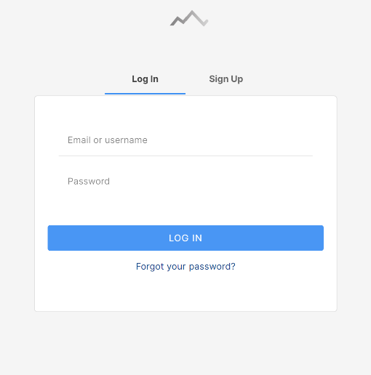Crimpd is an existing climbing-specific training app. Crimpd provides users with a selection of workout movements and short workouts, Users use multiple of these in conjunction to create a full workout session. Crimpd also provides a detailed graphical display of progression and a point system to show users how much work they have done in each aspect of climbing.

This is Crimpd’s login/signup page it’s very simple and directs users’ attention towards where to input data this makes login and signup quick and easy. In my site I will use a simpler design on the signup page.

Having a simple signup page with limited questions upon initial site arrival will present the program as simple to use which makes it more approachable to potential users.

They also have an easy to find “Forgot your password?” which improves verification of user via email confirmation.

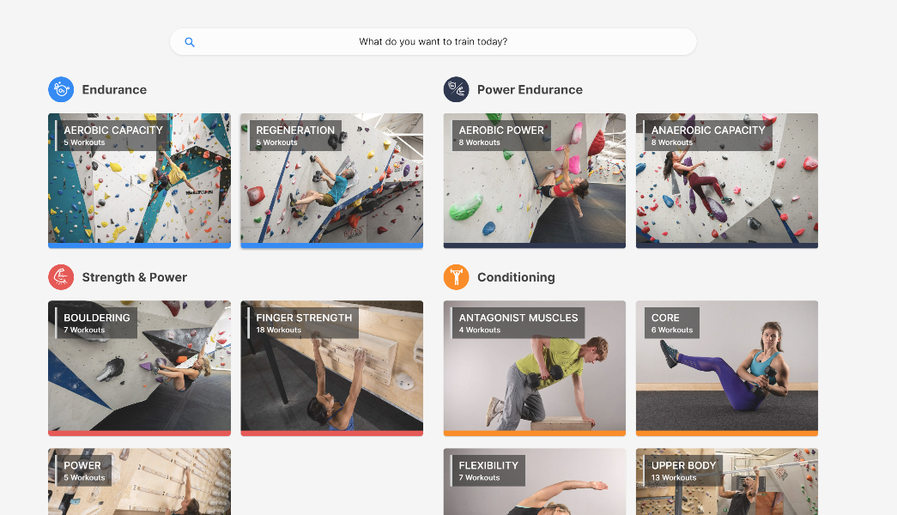This is Crimpd’s home page, it is divided into types of workouts with simple names and logo coordination. This makes it simple to find a specific workout to complete.

Color coordination makes it easy to spot what component of climbing your training and helps locating specific components when in different exercise views.

By having simple photos of exercises as backgrounds it makes it easy to understand what an exercise is and allows beginners to understand what the name of an exercise means.

They use abstraction to hide unneeded details such as workout description and equipment since it isn’t needed when briefly looking at what area of climbing to work on.

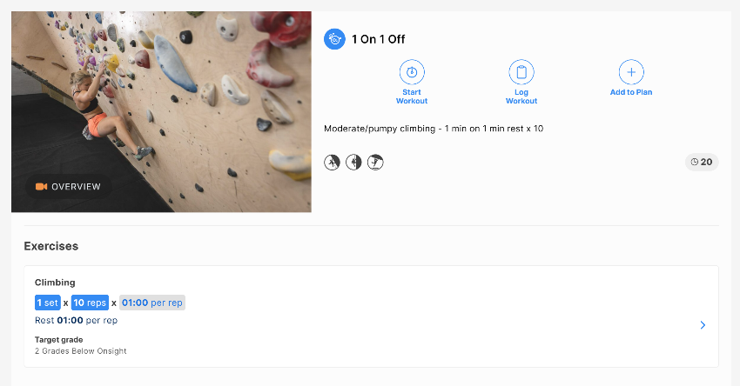This is the page shown when clicking on a specific exercise, in here they show all the details to the user since it’s no longer to abstract and hide data. There are 3 main buttons clearly labeled and visible. This makes it easy for users to know where they can navigate off the page.

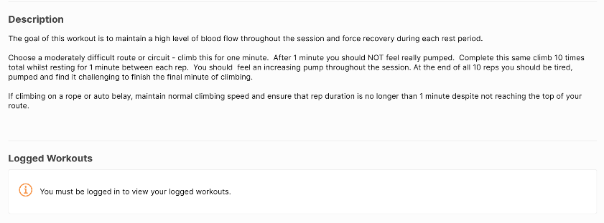It also has a demonstration video available to watch, this makes it easier to understand for users. They also have a basic description of sets, reps and times. This makes it obvious how long a user will spend on an exercise.   
They also provide a brief description of what the exercise achieves and how to perform it. This makes it clear for anyone who is new to training or prefers words over the video.

#### 2 – Gym Tracker:

Strong gym tracker is a non-specific training app tailored to Apple and IOS. It doesn’t have a website of desktop app but has android and IOS apps on their designated stores. Strong also improves its accessibility by making it work on Apple Watches which for some 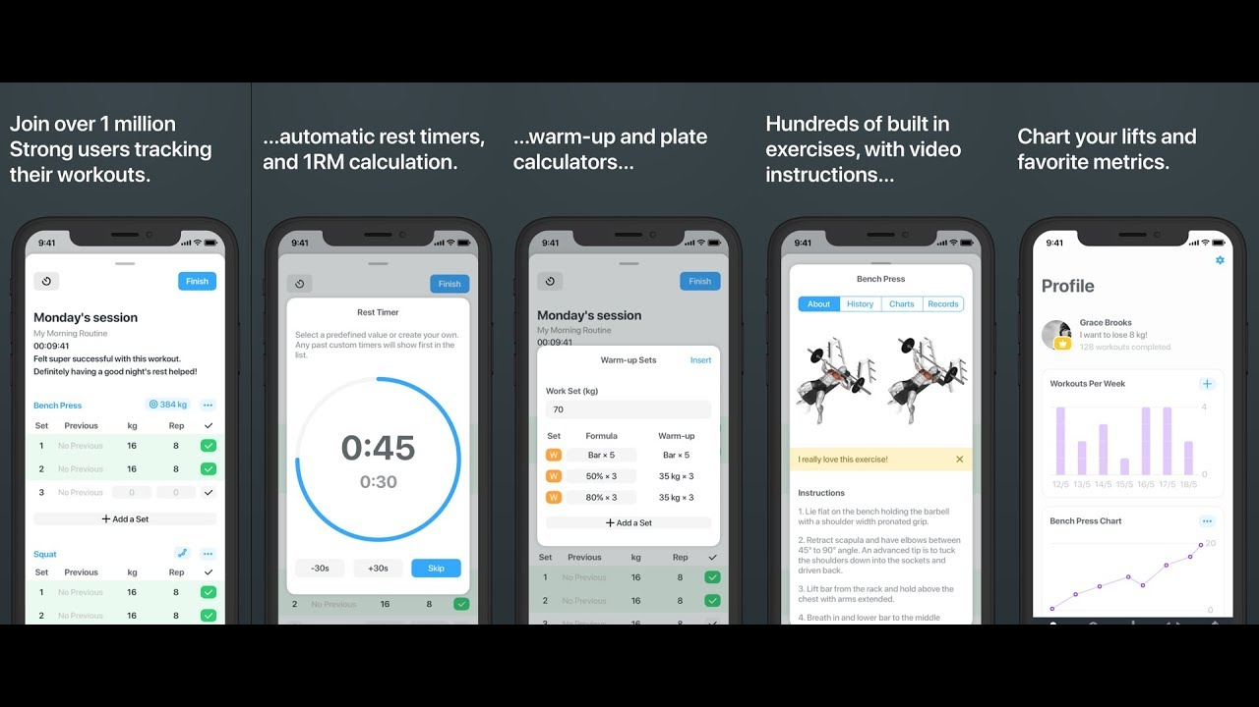people can make it easier and quicker to view and interact with the service.

Strong workout provides a plethora of features with a sleek and clean user interface which promotes ease of use.

### Questionnaire:

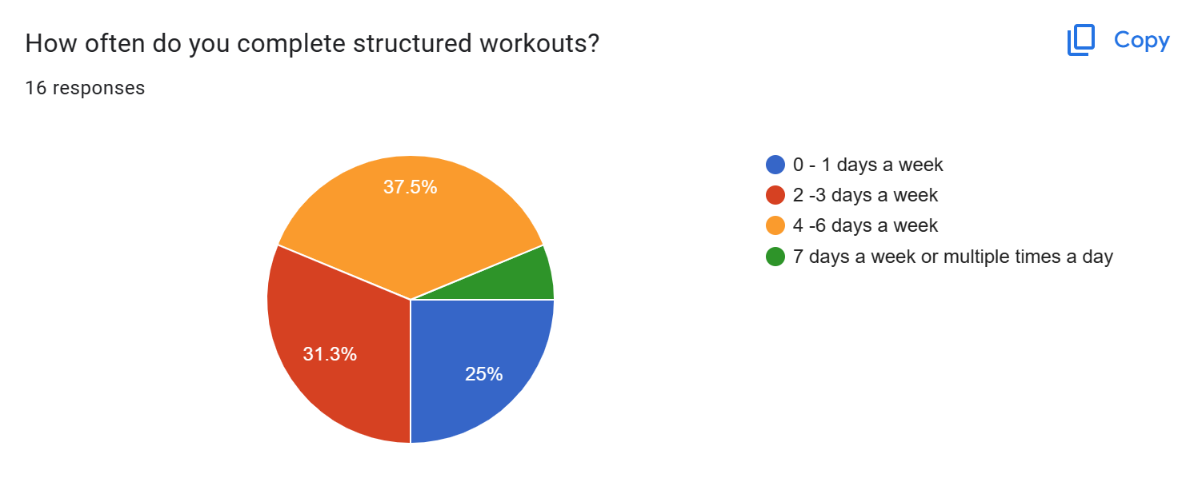I conducted a structured google form questionnaire and collected responses from my class and other students. This will help me understand my markets needs and wants. I’ll use this information to improve my website design.

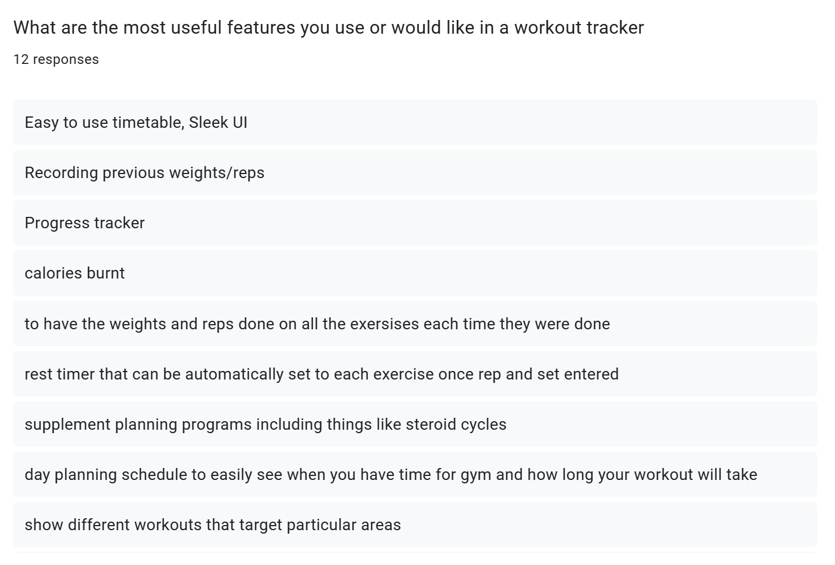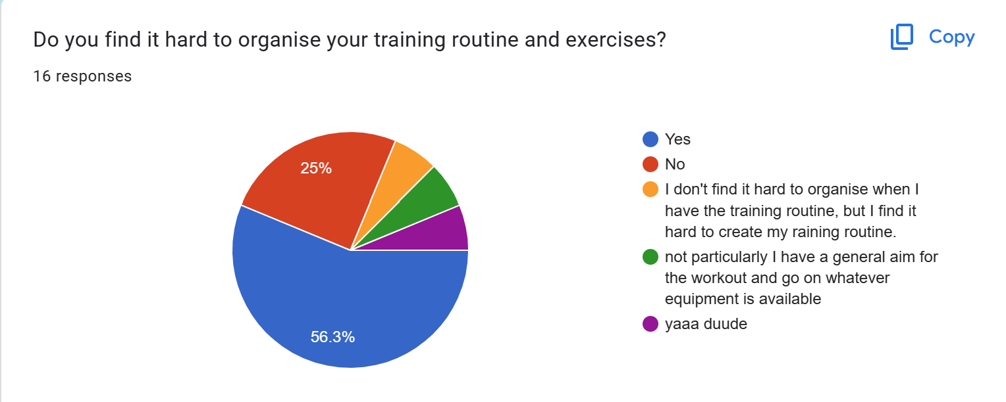This shows that that there are many potential candidates for my program. However, this is off a small sample so the results may be unrepresentative of the whole population.

These are some of the feature suggestions for the website. I will try to incorporate as many of these as possible however these ones I won’t:

1. Calories Burnt – I won’t incorporate this since the website can be used on any internet device and most likely won’t be a wearable. Collected data won’t be specific enough to provide users an accurate calorie figure.
2. Progress Tracker – I’ll use occasional testing to track progress for users and normal workouts can be used to track progress. Data will be shown on graphs since it is more visual for users.
3. The website will suggest reps and sets for all exercises and will help with rep and rest timings to help usability.
4. 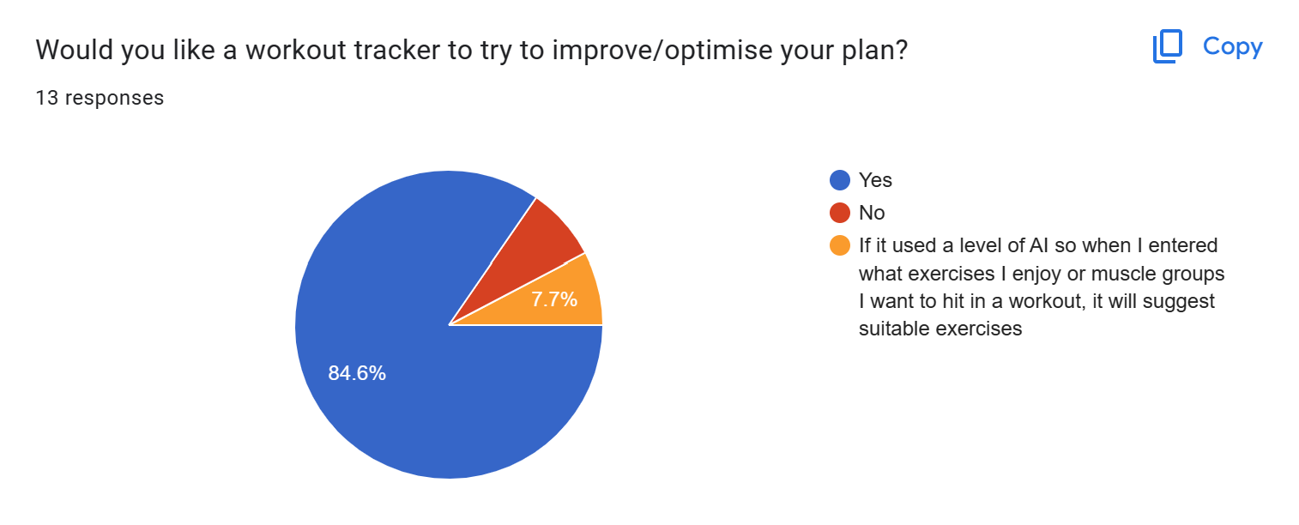Supplement and diet programs won’t be included in the app as my knowledge in these areas is limited.

The responses to this show there are reasonable demand for a product like mine.

## Proposed Solution:

These are the main features proposed for the website as learned from the questionnaire, interview and previous solutions.

|  |  |
| --- | --- |
| Login Page | Simple, maybe a picture background. Focus on the login area no clutter. |
| Signup Page | Similar style to login page. Password confirm is important. |
| Question Pages | Simple, questions: Availability, goals, experience, areas to improve. |
| Plan Algorithm | 3 strength days max, 5 days total max, should tailor using questions. 7 exercises per day. Lots of exercise variation. |
| My Plan page | Simple display, table or list. Should allow manual editing of plan. Include exercise descriptions. |
| My Day page | Shows individual page, allows tracking of each exercise. Stopwatch or timer here? Simple display like My Plan page. |
| My Progress page | Graphical display of progress for all exercises |
| Stopwatch Page | Stopwatch and timer |

## Success Criteria

|  |  |  |
| --- | --- | --- |
| Criteria | Justification | Reference |
| Index Page | A landing page for the website | Feature of all websites |
| Login Page | An area for users to login to their personal account | Interview, Feature from existing solutions |
| Signup Page | An area for new users to create an account | Feature existing solutions |
| Questions Page | Place for users to answer questions needed for the plan generator to function | Interview |
| Max 3 strength training days in plan | Avoids overtraining | Interview |
| Max 5 total days in plan | Avoids overtraining | Interview |
| Max 7 exercises per day | Avoids overtraining | Interview |
| Question about availability | Allows algorithm to know the user’s availability | Interview, questionnaire |
| Question about goals | Allows algorithm to know the users focus | Interview, existing solutions, Questionnaire |
| Question about experience | Allows algorithm to know the users experience | Interview, Questionnaire |
| Logout option throughout website | Let’s user’s logout of their account at any point in the website | Interview, Existing Solutions |
| My Plan Page | Page to display users training plan | Interview, Existing solutions |
| Plan displayed as table or list | Makes plan easy to read | Interview |
| Plan separated by days | Makes plan easy to understand | Interview |
| Simple Login and signup page | Makes process easy to follow when logging in of signing up | Interview |
| Manual editing of exercises in plan | Means users can manually tailor their plan to their preferred exercises | Interview |
| Manually editing of days in plan | Users can rearrange plan days to suit their needs | Interview |
| Each exercise has a description | Helps used understand how each exercise should be performed | Interview |
| Individual day page | Shows the user the training scheduled for today | Interview, Existing solutions |
| Save data from workout | Allows user to track progress and avoid plateaus | Interview, Existing Solutions |
| Progress Page | Displays the users progress over time | Interview, Existing solutions |
| Progress displayed as list or graphically | Makes understanding the data collected from exercises easier | Interview |
| Stopwatch page | Allows user to measure exercises | Interview |

# DESIGN:

## Website Arrival:

On arrival to the website, users will be asked to log in using their username and password or signup. During signup, users will be asked questions in a multiple-choice style.

Usernames, question answers and the hashed password will be stored in a database.

Questions will include clients:

* Time/Availability
* Goals
* Experience

This data will be stored in the client’s profile and will be editable at any time. After the data has been collected it will be used to create a custom training program for the client. This program will be customizable manually also.

The login page will be simplistic and will have a forgot password button to improve accessibility.

## Login:

The login page will be the index page for my website as users will need to login or signup before having access to features. This is because the features of the website require data about the user to be useful.

If users have an account, they will be able to login by entering a username or password. If the user forgets their username or password their data will be recoverable if they can enter either the username or password and answer security questions, they enter upon creating an account.

When a new user arrives on the login index page, they will be able to switch to the Signup page by clicking a button. This will bring them to a similar page where they can enter a username and password plus a password confirm field is required.

The username and password have a few validation requirements. The username must be composed of only letters and numbers and have no spaces. The password should be at least 8 characters in length and should include at least one upper case letter, one number, and one special character. This not only makes the password more secure but allows the data to be handled easier as it has already been validated before being stored a database.

All passwords and security questions will be stored using hashing for security, if someone accesses the database unauthorised then they will not have access to personal data. To 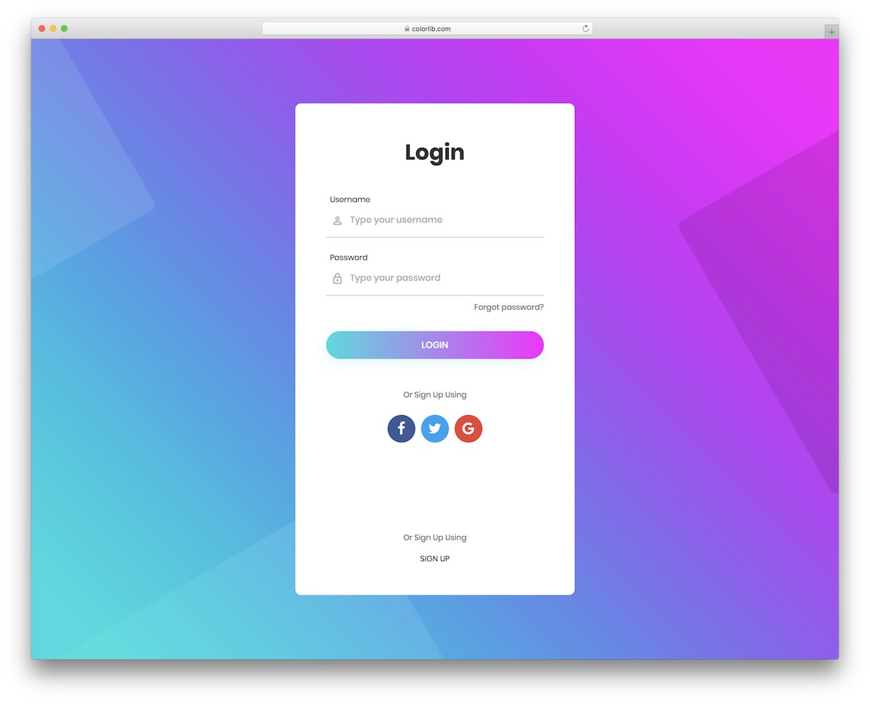check that an inputted password matches the hashed password the input will be hashed also then the two values compared. For security questions the inputted value will be converted to all lower case and remove any punctuation before being hashed. This means if the person trying to input their security questions types a slightly different grammar the database will still match the hashes and grant them access.

The image above in an example of a login page I will used as a template for designing my own page. My own version will not have options to login using other methods. This template is good as the fields are obvious and the UI is easy to understand will still being visually interesting.

When a user creates an account, they will be prompted with a variety of questions which will be stored in a database. The answers to the questions will be used by an algorithm to make a tailored plan for the user. Information provided by the user will be editable at any time via the account section later. Some possible questions are below:

* How many days a week are you available?
* How many hours on each day are you available?
* What is your current training focus/goals?
* How much training experience to you currently have?
* What equipment do you have available?

Users will also be prompted to input data such as current weight, height and also current PBs and records they have is certain lifts/exercises.

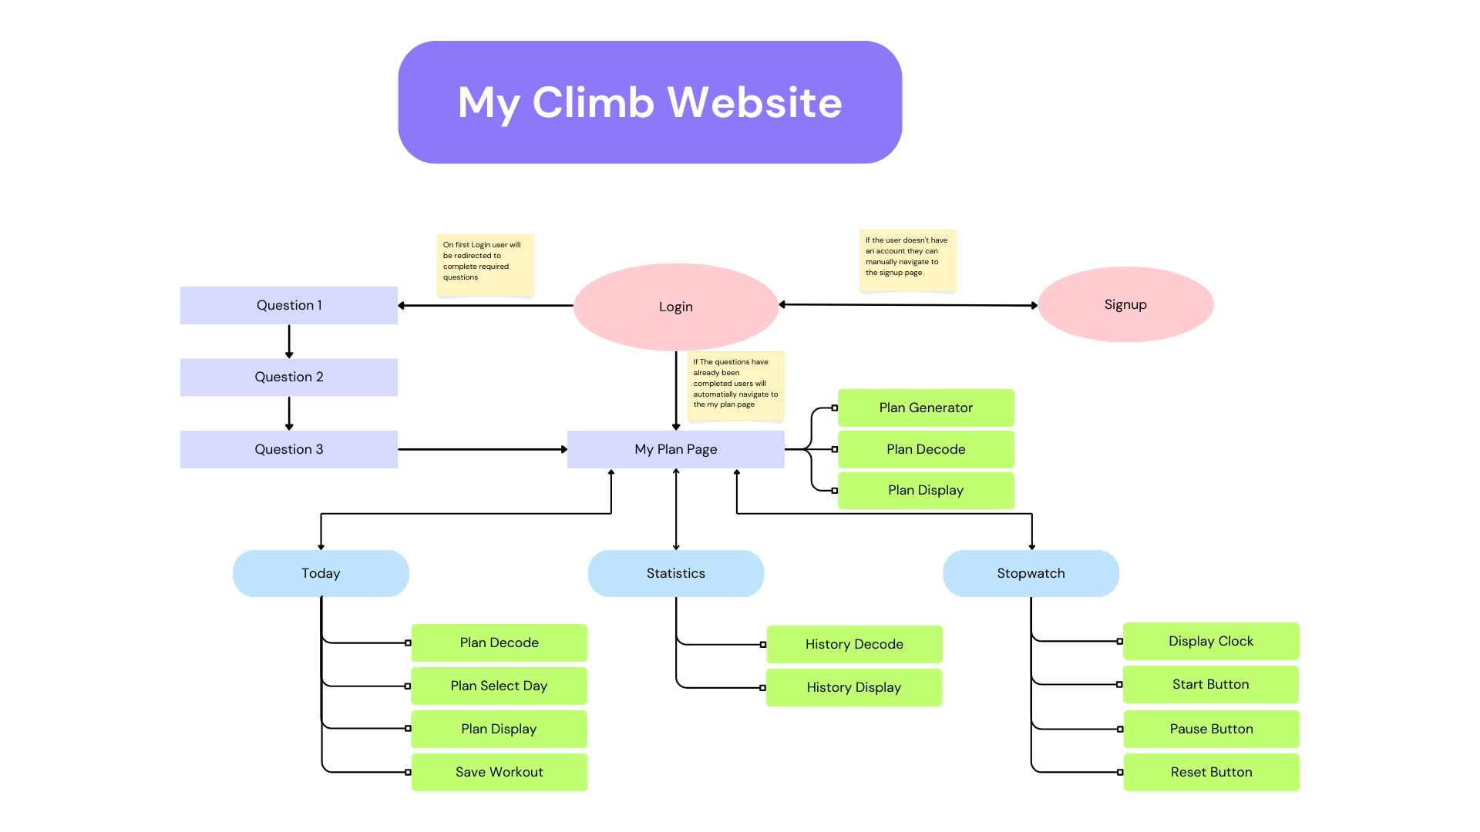

## The Website Flow Chart:

Above is my website walk through. Users will also be able to logout at any stage of the website. This will redirect you to the login page. The green boxes show what must happen upon loading the page.

## Question Pages:

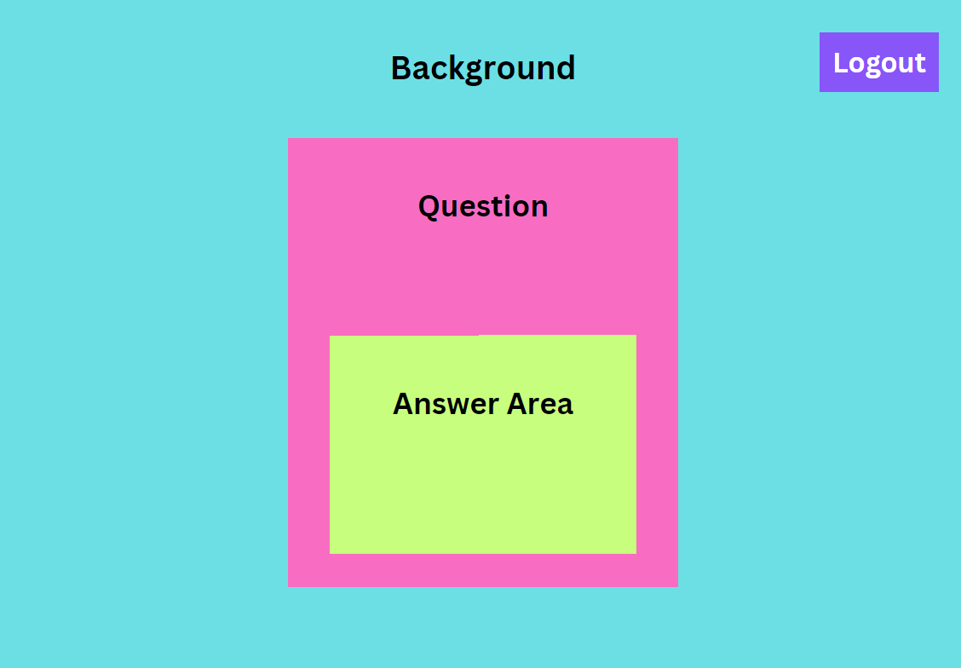The question pages will be very simple with the focus being on the question. To apply this the question pages will have similar appearance to the login page with a simple background and a content section in the center where the question and an answer area are displayed.

A logout button will also be in the corner so that users can logout during the question answering process an come back to it later. If the user clicks this button they will be redirected to the login page.

## Fitness App Review: My Workout Plan by Sosis Apps - Dammit Karen

## My Plan:

Users will have access to their plan to view or edit details. In this area, they are presented with a calendar on which are events for workouts. When selecting an event, they can edit manually or run the workout manually which directs them to the start exercise page.

In this area options selected for the plan creator can be edited also.

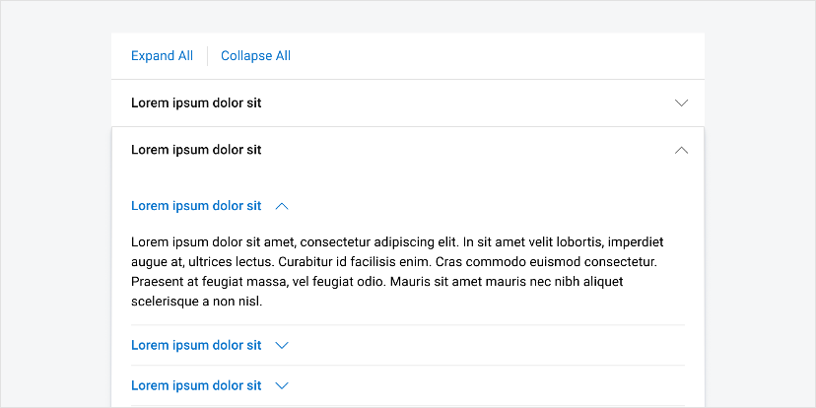Similar to the example on the right where each day is displayed in a list style for users to see. I will design a similar solution for this page that will allow the user to easily understand their plan.

In this area users will also be able to expand exercises to get a description and more detail. An example of how this will work is in the lorem Ipsum example on the left. Using an accordion style bar for each exercise the user can click on an exercise and then any additional information can be displayed in the expanded accordion.

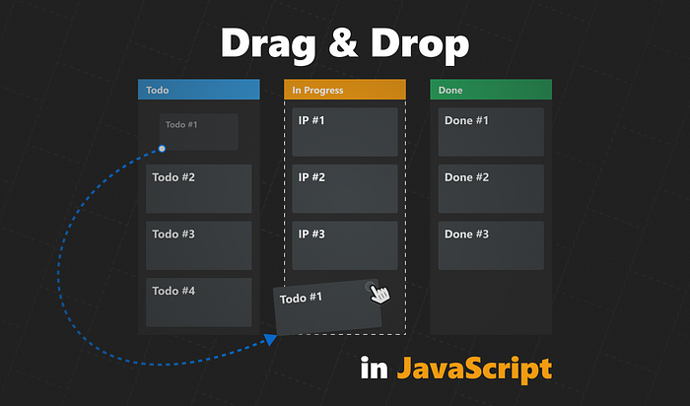When a user edits their plan manually the json file containing the plan will have to save these changes so that they will be kept upon a refresh. If the user changes two days around they can be swapped in the json file. If the user swaps out an exercise or adds a new on the exercise must be located in the exercise directory json file and then all its details can be added to the training plan in the correct place.

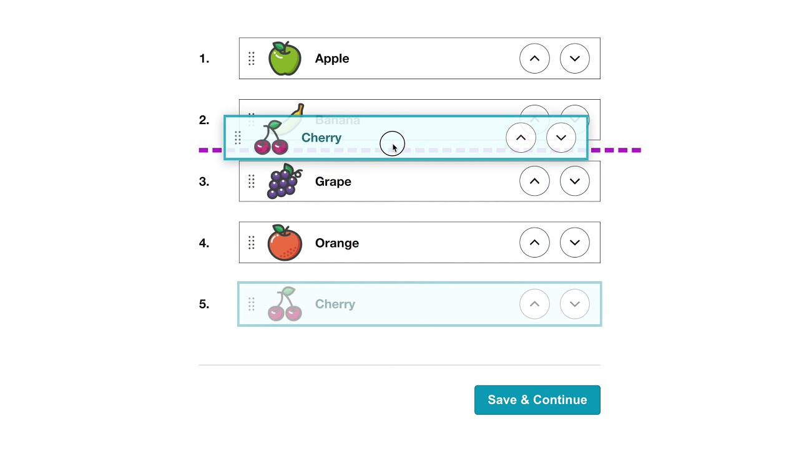To move exercises and items around the plan users ideally will be able to drag and drop individual items and move them to the desired location. However, the implementation of this will be difficult and if this becomes too difficult to code another solution will be for users to select two exercises or two days and select a swap button to swap their positions. Similarly, to add exercises users can select a location and select an add exercise button. The idealistic solutions are shown in the pictures above where users can drag and drop items to rearrange them.

## My Progress:

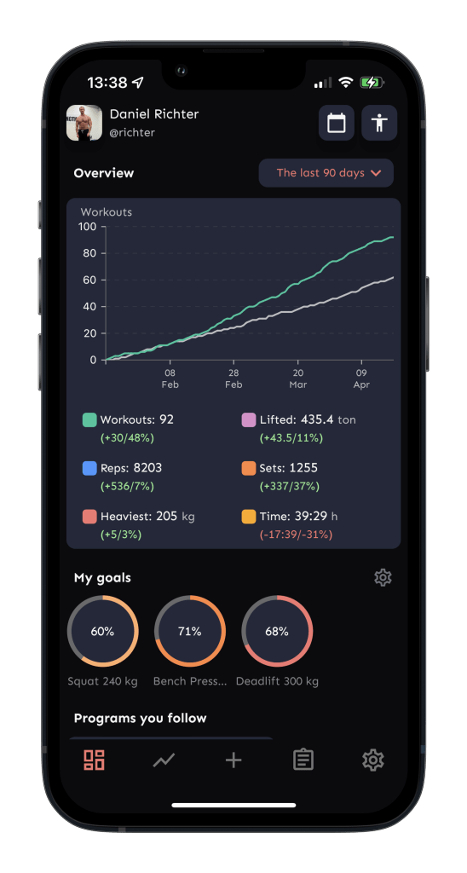This area will present statistics in the form of various charts. These can display work out details such as workouts per week and details such as workouts for strength or endurance. Progressions can also be displayed using data collected at the end of workouts and on monthly standardized evaluation days.

This area is useful for users to visually see them progress which is important for motivation. This data is also useful to the program to continually update the plan and suggest improvements.

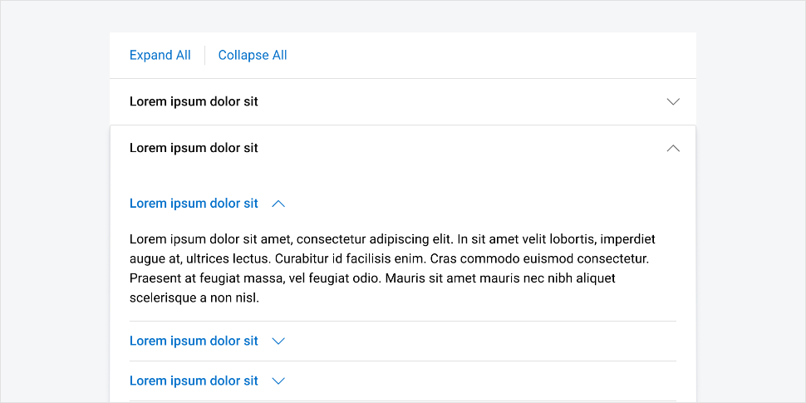My design will be similar to the solution on the left however my solution will additionally show the progress users make on individual exercises.

Simularly to the My Plan page each exercise will be expandable via a accordian menu. Each exercise will have an accorian item and when clicked on will open to display the progress information about the exapanded exercise. The expanded info will contain the graphical data and or a list alternative. An accordian menu is the best solution for this since over the course of training plans the user will collect information about many exerices and displaying all exercises graphs and data at once will be overwhelming and hard to understand for users.

Another solution would be to display the most frequently erformed exercises and add a search bar for users to find their desired exercises if they are no aready displayed.

## Start Exercise / Today:

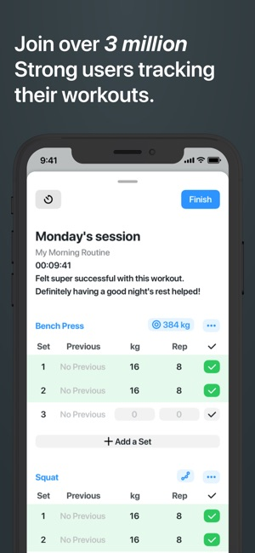This page will show the exercises that will be done today and allow the users to log the difficulty the exercises were completed at, this can be stored and pulled up later in the progress section.

The example solution on the right is from a generic gym workout tracker this will be similar to my solution.

This area will also give more in-depth explanations on each exercise including a description, sets and reps for each exercise. This will be displayed in a table where each exercise can be expanded for more details.

To submit the exercise difficulty the user can click a button that will submit the individual exercise once submitted and sent to be stored the option to submit will be greyed out and users will not be able to submit and more of the same exercise unless it is planned to be in the day more than once.

On the ‘My Plan’ page the user will be greeted with a day by day breakdown of their plan in a list style layout. This is simular to the strong app example on the right. Strong allows users to log workout info and change sets and weight in this area, however I will have this functionality on my ‘Today’ page. The ‘My Plan’ page is purely an area to view the overall plan and decide if you like it. Upon loading this page for the first time the users plan will be generated and saved. If the user doesn’t like their plan they can choose to regenerate the plan via a button at the bottom. Alternatvley will be able to manually edit exercises or move days around to fit their needs.

### 

## Stopwatch:

There will also be a simple stop watch page which the users can use to assist in tracking exercise performance. The stop watch will have large numbers for readability, there will be a start, stop and reset button to control the functions on the stopwatch.

## Navigating The Website:

The website will be navigated via a hamburger navigation bar which will open to the center of the screen and cover hide the rest of the website behind. Page navigation options will be similar to the presentation below. The logout option will also be available here.

When hovering on the hamburger icon the icon will change colour to show the user that it is a clickable button. The user’s username will also be on the navigation bar the user knows what account they are logged into. When clicking on the users name it will relocate the user to the main ‘My Plan’ page.

## Logout Button:

On every page in the website apart from the login and signup page there will be a logout button or option. This will allow users to end their session, this is important for the user’s data protection.

On the question pages a logout button such as on the left will be displayed in the corner, this can be clicked to log the user out.

On other pages such as ‘My Plan’ the user can logout via the navigation bar. The last option in the navigation bar will be a logout option that will end the user’s session.

After logging out the user will be redirected to the login page.

# IMPLIMENTATION STAGE

## Processes in the website:

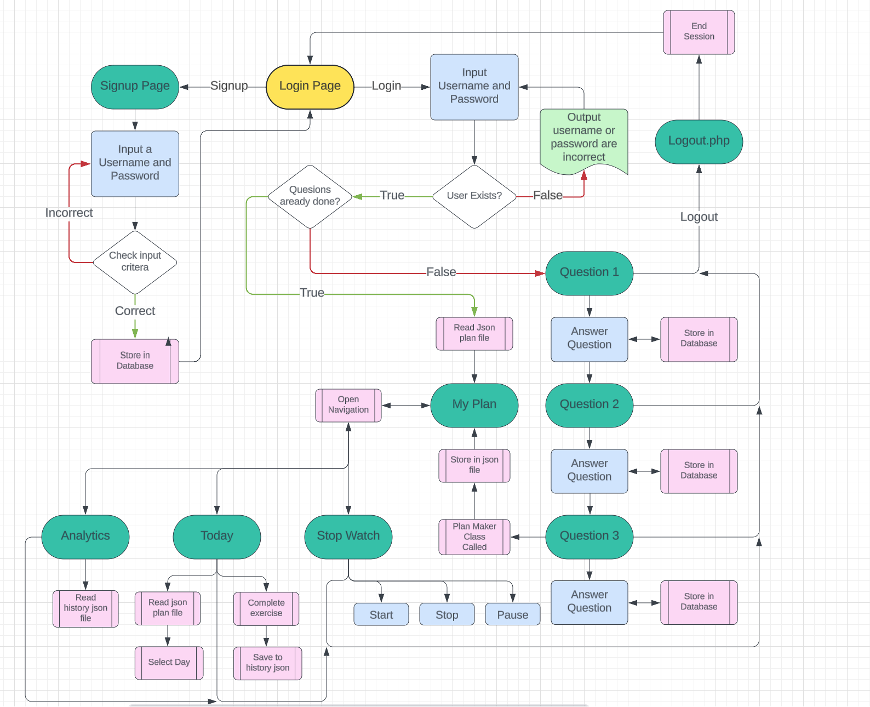Below is a more in-depth map / flowchart for the processes inside the website this shows decisions and subprograms that will be run at different points throughout the website. Users will start at the index page that is the login page. Here users can login or navigate to the signup page.

## Git Repository:

For my project I decided to use git as a way of managing versions and being able to keep track of my decisions and progress over time. I created a GitHub Repository that stores all the fields from my project. This also allowed me to roll back to previous versions easily if things break during coding.

## Initial Approach:

My initial solution for my website was to use flash which is a web framework built around python. I chose this since I had experience and knowledge of python and would not take much learning to adapt to flask.

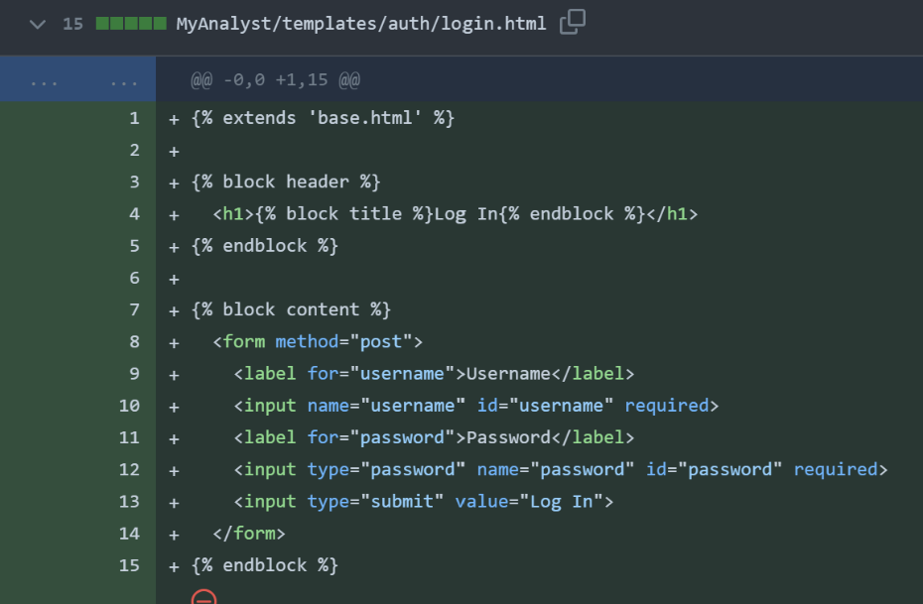After experimenting with flask and building some basic pages to experiment with flask I decided that my original approach discussed in the analysis was better and I switched back to the normal web stack.

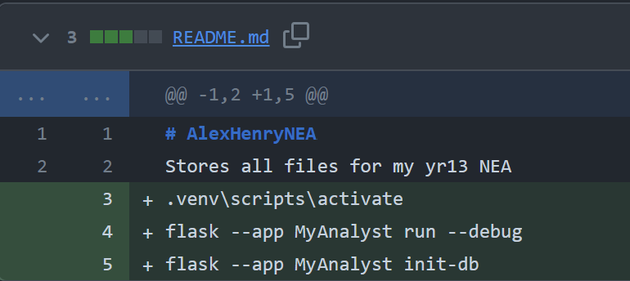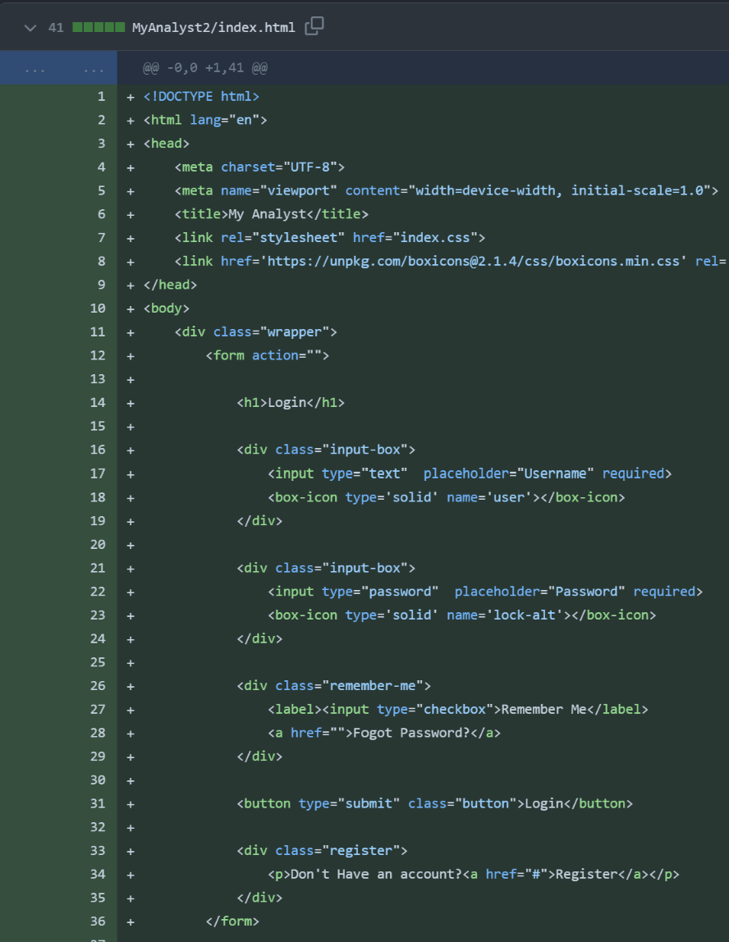On the left was my basic login page created using flask. This worked as intended but lacked functionality. After this experiment and also creating a signup page is decided php and normal web stack was more suited to my design needs.

During using flask as a solution I saved all he commands I frequenty needed to run my project into the readMe file for ease of use.

Now using the standard stack, I created the first design on my index page which is my login page. The focus of the page is a form where users can enter their username and password and submit using a button.

Since this was the most important action of the page I focused on this first.

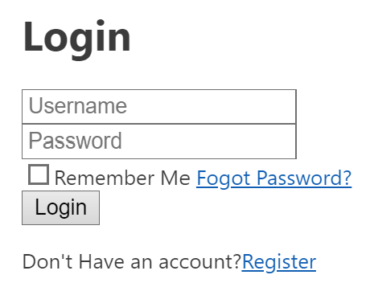This currently looked like the form on the left.

I also uploaded a background image that I can add to the login page later on. Mountains seemed appropriate since they reflect climbing.

The blue and green palette also reflected the colours I wanted to use throughout my website.



## External Style Sheets:

I decided to use an external style sheet that would allow me to use icons I wanted to use for the username and password input boxes. The external style sheet allows icons to act as text instead of images. This makes aligning the icons easier and it is repeatable throughout the website where icons are used.

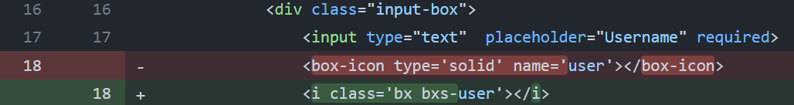I added basic CSS for the login page now, this included making the background image visible.

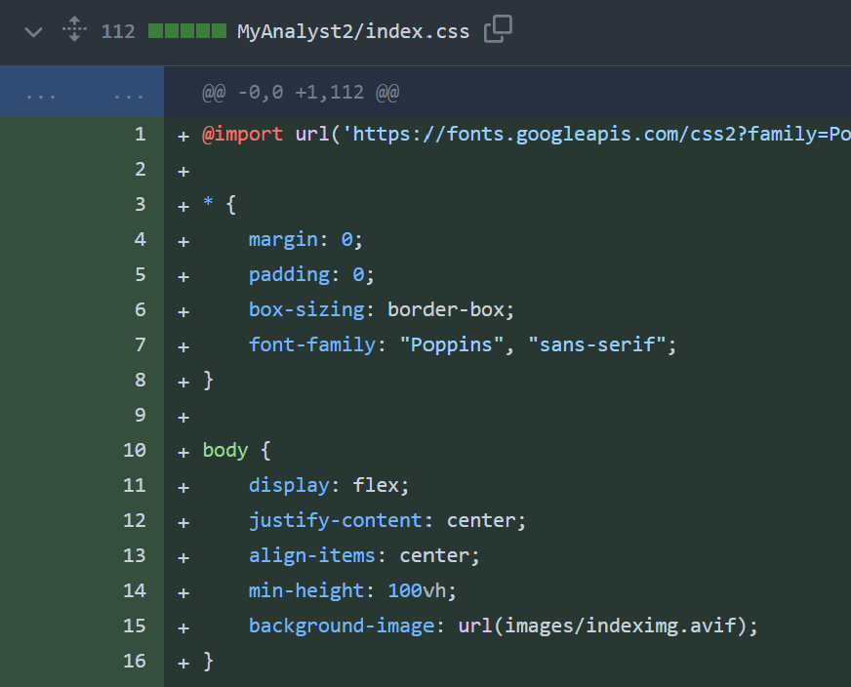Now that all the items on the page are in the correct location, I can begin getting the links and buttons to function correctly.

## Switching between Login and Signup:

When users arrive at the website, they are brought to the index page which is my login page. Users that don’t already have an account will need to create one.

My first method of switching to the signup process was to have the form required for signing up hidden initially and when clicking the signup button on the login page the login forms will be hidden and the signup form becomes visible.

I attempted to do this by giving the login and signup forms IDs in html and then when the button is clicked it will call a JavaScript function that will hide the one currently visible and show the one currently hidden.

To do this I had to change my hyperlink tag in html to a button tag as show above, this is because hyperlink tasgs cannot be used to call javascript functions.

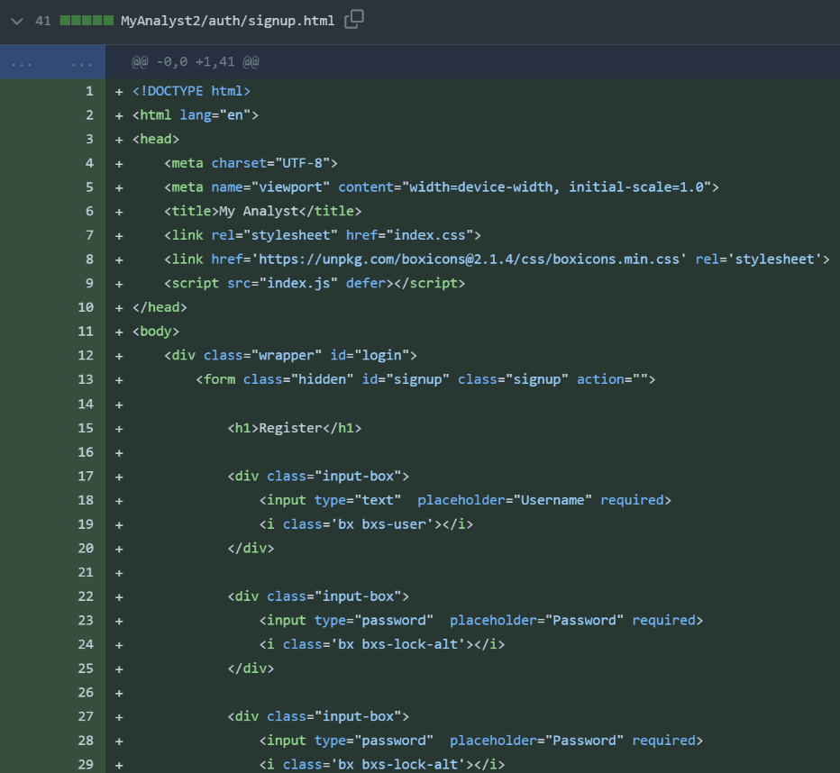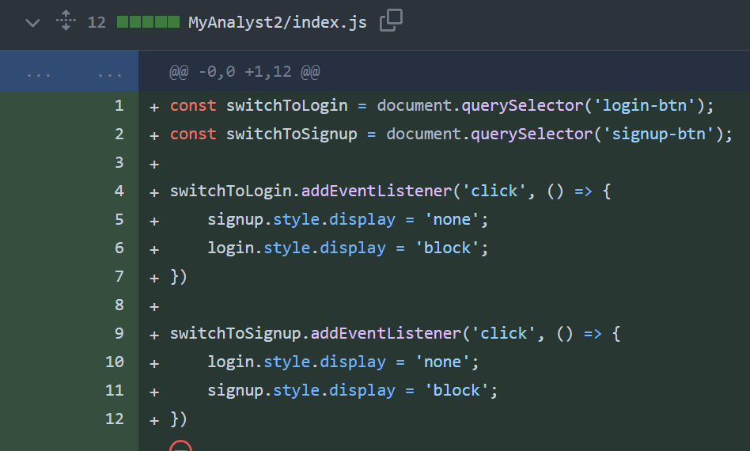The JS used is on the left, each button is made a constant and given an event listener which looks for a button click. Upon the click the JS will apply either a hidden style or block style to the form which should mean the forms can swap place without having to reload the site. This would make the user experience smoother especially for users with slower internet since once the webpage is loaded they will be able to login or signup without having to load another page.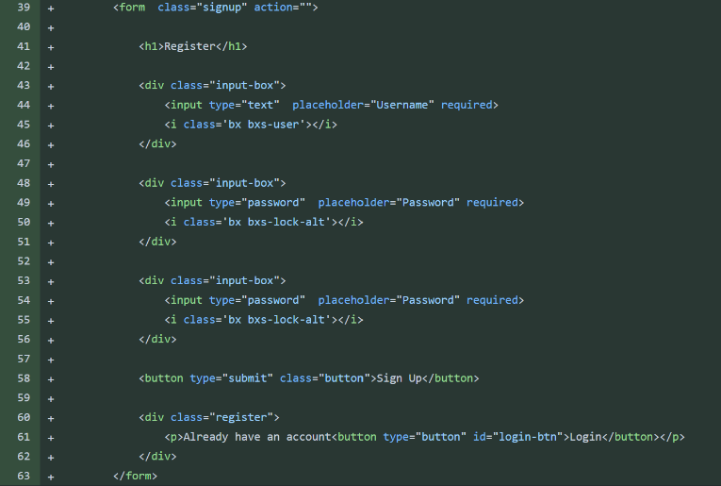

On the left is the form for the user to signup, this is on the same html file a the login form currently.

After experimenting with this method and trying to get it to work I decided the easier option was to make the signup form on a different page that the signup button can redirect the user too.

The first approach didn’t work since when hiding elements in htm using CSS they still interact with other elements on the page. For this reason when hiding the login form it still caused the signup form to be pushed off the page.

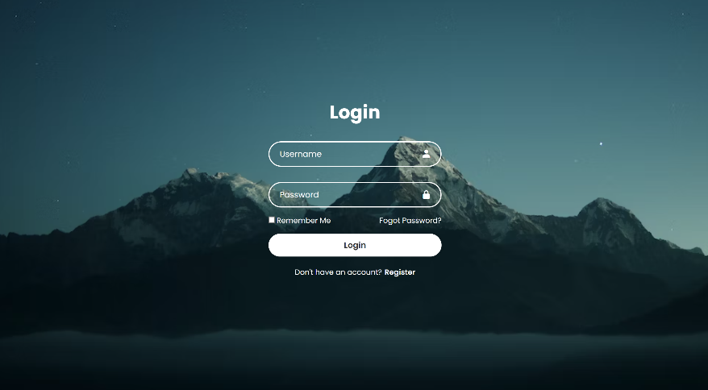On the left is the new signup html page which is linked to on the index page via a hyperlink.

The main difference between the signup and login page visually is that the signup page has an extra input box where the user confims their password.

Each page also deals with the inputted data differently.

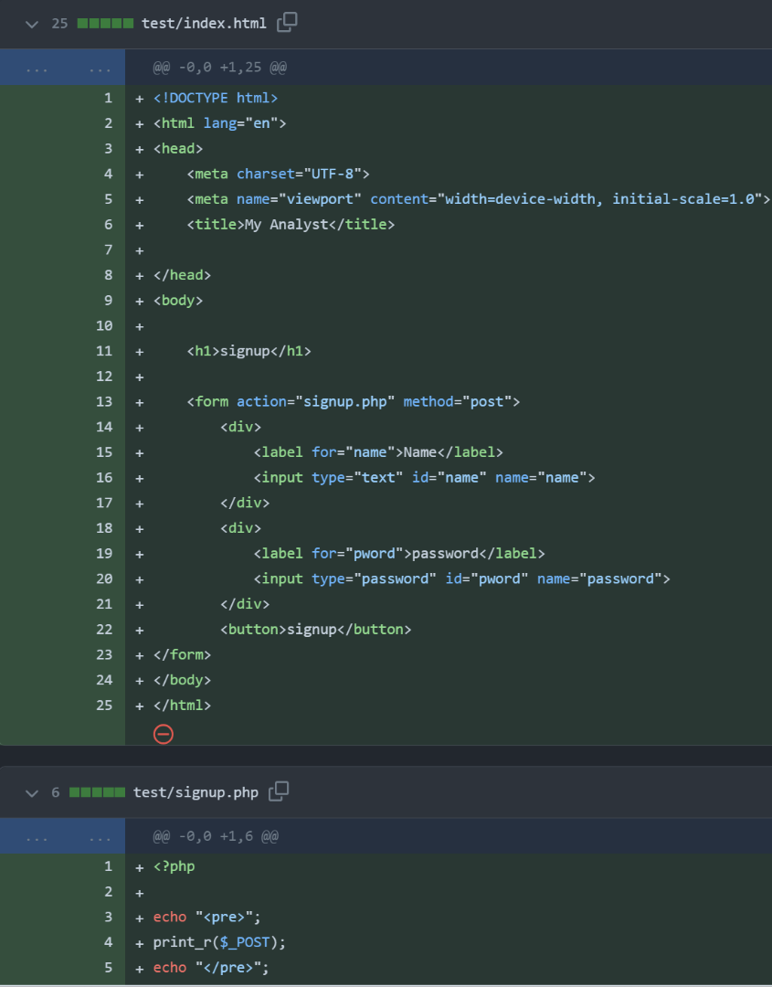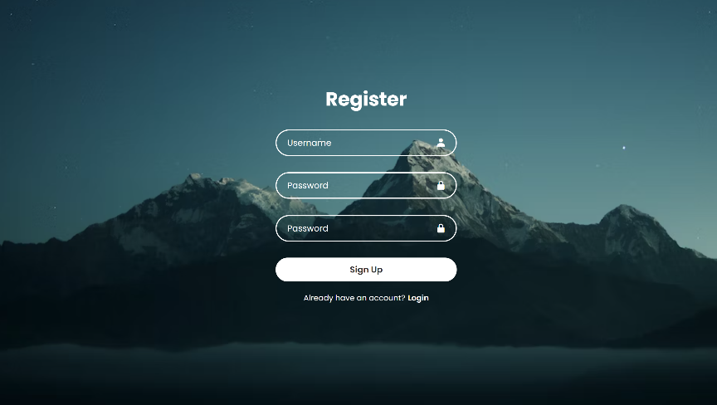The Styling for both pages is now also complete. On the login page the user can click on the register link that is Bold as to be obvious it is a link. A simular solution is found on the signup page also.

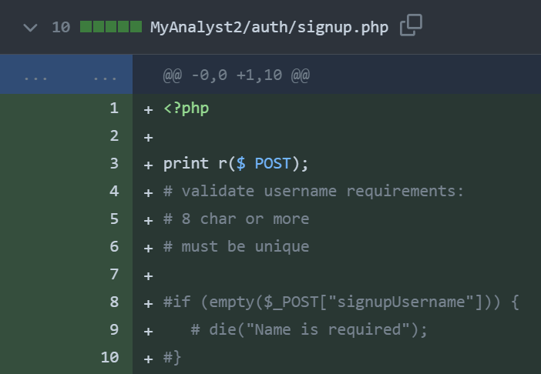I created a php file that can store all the functions and methods that will be used to handle the data submitted in the forms. To test the file is being called I got the php to print the post sent from the form. The form is setup with a method of post and the action is the php file.

Using comments I also structured out the validation steps I would need to add later on to validate the users inputted data. This would also require that I remove the built in html form validate method by adding the novalidate tag inside the form tag.

Since I couldn’t get the form to post correctly to the php file I created another similar html file with no additional styling or functions to test that my method should be working.

Currently the php file is correctly called when the form is submitted but instead of running the php code the contents of the php file are printed at face value to the webpage.

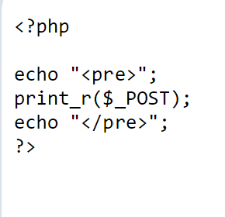I tested this got the same outcome.

On the left is the outcome of the test. Printing the contents of the php file.

I realised my problem was that without running a server to host the webpage php isnt run. This is because php is a server side process so having a purley client side method means the php is no handed correctly.

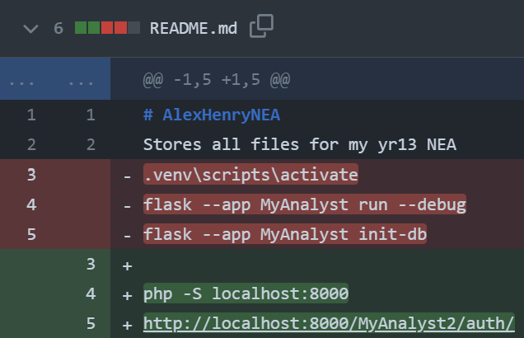To fix this I ran a php server after installing php to my machine. I added these commands to my ReadMe file. I also removed the flask commands as I am nolonger using flask.

Now that my php is working I deleted the test file and continues coding the data handling for the signup page.

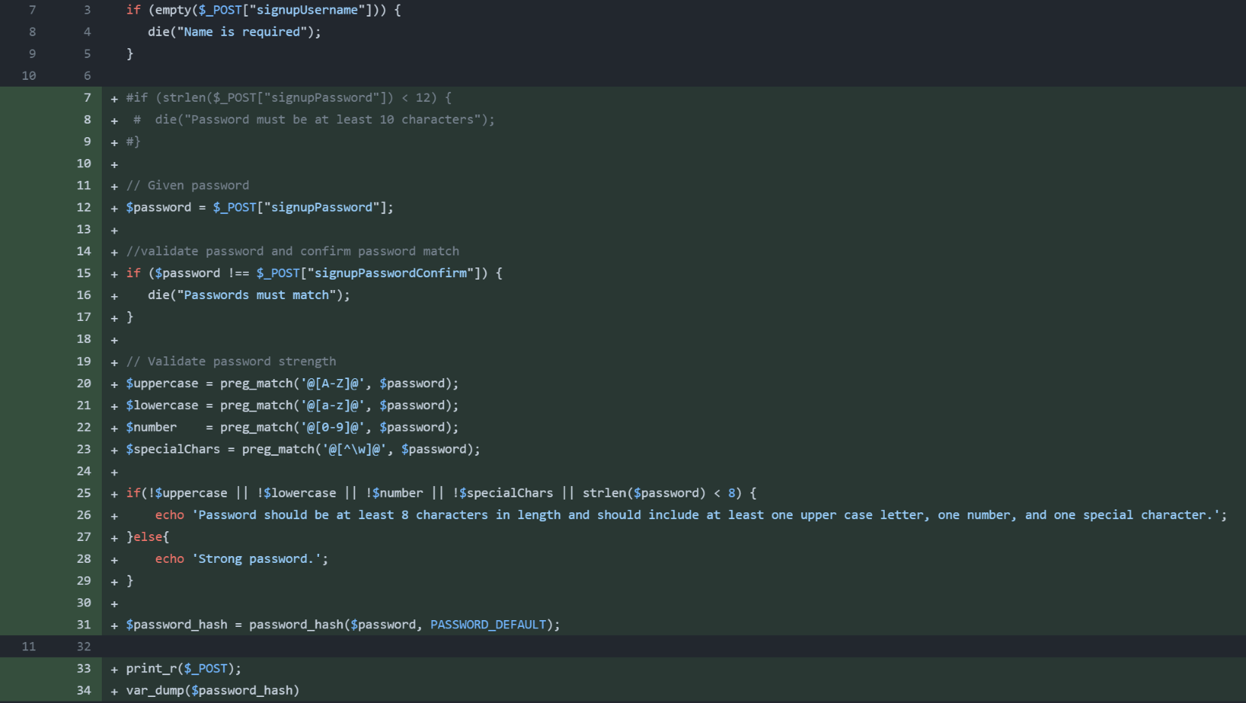When the data is submitted I run a series of checks to confirm it meets the requirments I have set. The first check is that the user didn’t submit an empty form or only half the form. If this is the case the php will return a message informing the user and stop running until its called again.

The second check is to confirm the password the user wants to use is strong enough. After letting the inputted password be a variable it is checked by an if statement that it meets all the requirments ( contains a capital, lowercase, number and special character. Must also be 8 or more characters )

After this is checked the password is hashed using phps built in hash algorithm. This is then stored in a variable to be used later.

To confirm this process worked I returned the post data and the hashed password after the php has been executed.

## XAMPP:

I realized that the solution I had for running my webpage server was not the best solution. The current method was hard to integrate with a database and also required manually running upon every change to the code.

I decided to use a popular webserver host XAMPP. This uses an Apache webserver to host the webpage on a localhost domain. This is updated live which makes debugging easier and general coding easier. XAMPP also provides a MYSQL server which can be managed via PHPMyAdmin.

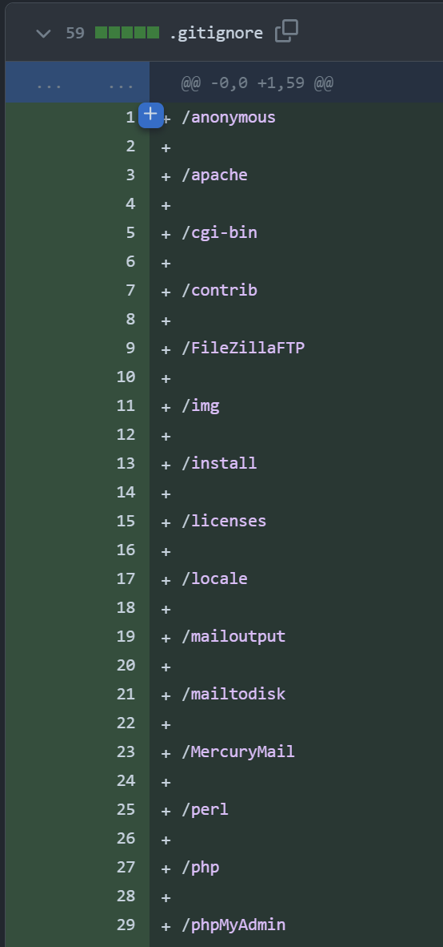I setup XAMPP to run Apache and MYSQL upon startup so I don’t have to worry about starting my server every time I boot my computer.

Due to XAMPP having a large folder structure I created a .gitignore file that would tell my git pushes to ignore certain files. I also created a separate repository that would store the database files.

## Database:

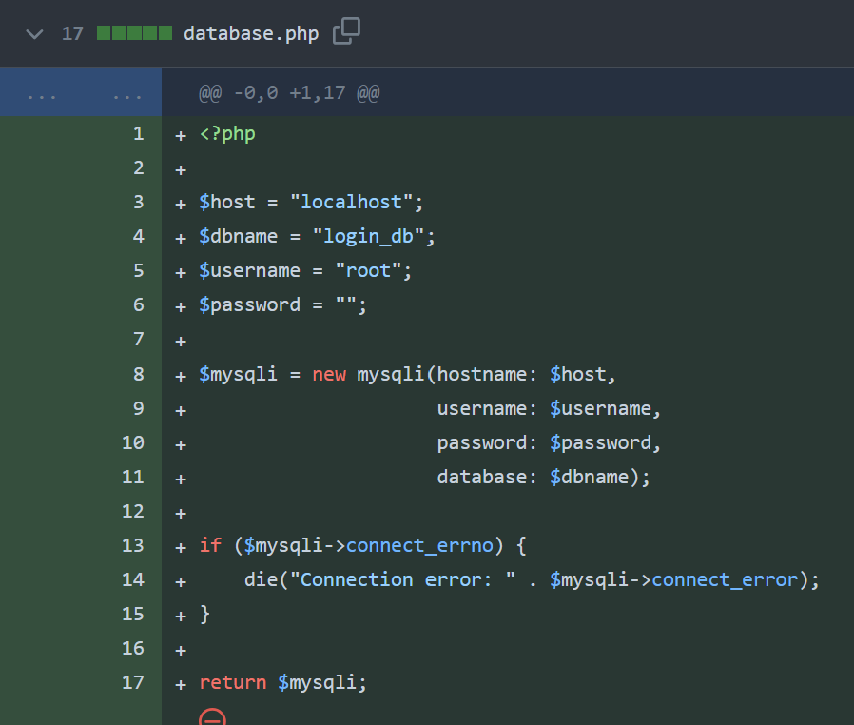I created a separate PHP file for connecting to the database, by having it in a separate file I can include it in and future files that will need a database connection. This will reduce the need for repeating code.

I decided to use an OOP approach for the connection since error the library of commands for dealing with a database with OOP is simpler than with a procedural approach.

When the class tries to create a new object of the connection if the connection has an error, it should print the error and stop executing the php.

However, I found that if there is an error connecting to the database the default error is returned rather than the correct error number and message from my code.

After some research I found that this is due to the recent php version changes, in the update engine warning are now fatal. This means when there is an error creating the new object the code will experience a fatal error and not run my own error handling method.

The first solution I found for this would be to modify the error handling in PHP 8 manually using the error_reporting(); This function can change the severity of errors in php, the default will make many errors fatal but by setting error_reporting(0); Errors will now no longer be reported at all. However, this is a bad solution since errors are an important as it helps you understand a fix the problems quicker. Without error reporting many errors may go unnoticed and/or will take longer to fix or find where code is causing errors.

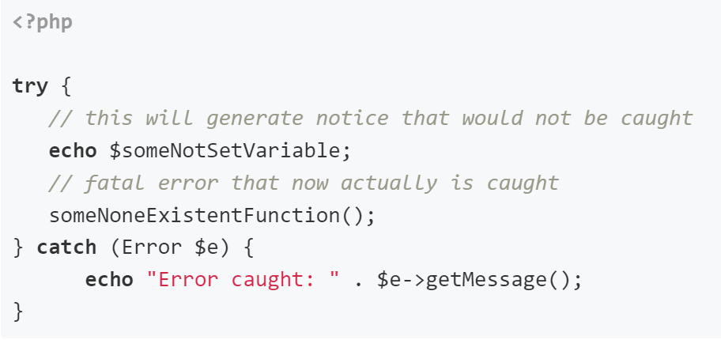The second solution is to use try and catch statements. This method it prefered since it will still produce error reports but in instances where errors need to be collected manually like here they can ignore the fatal error and catch exceptions.

I used this solution in my database php file to catch connection errors.

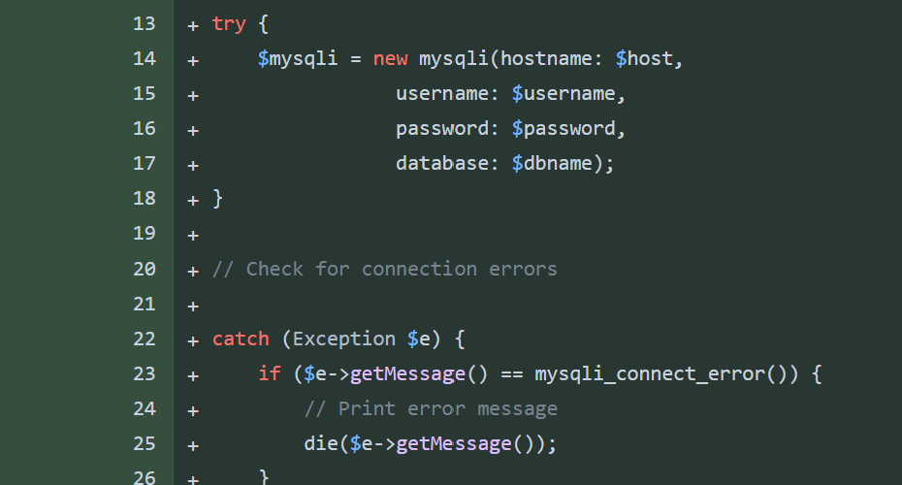This method will catch exceptions $e and get the message from the mysli error. This error will return more detail than the defualt error reporting will and can help me fix issues quicker.

I used a die statement when outputting the error as I still want the error to stop the execution of php code.

Above is the error produced when using the original code. This prints an error that is hard to understand and contains lots of extra useless information.

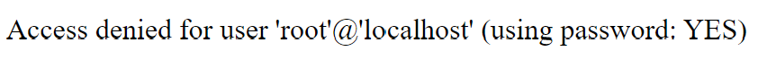This is the error produced from the try catch method. This is much easier to undertand since there is no extra useless infmation. From this error, it is quick and easy to undertand that the password used to connect to the database is incorrect.

## The User_Table:

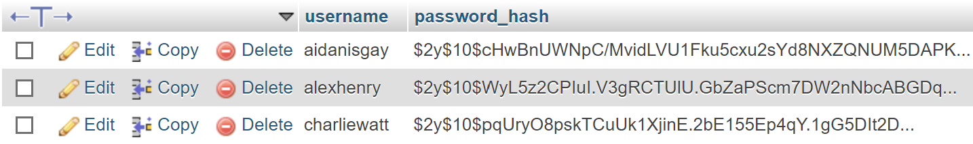

Above is the table used for storing users hashed password along with their usernames. In this table the username is a primary key.

## Signup:

Below is the php file for signing up, when user submut data in the signup form it is posted to here. At this point the username and password have already been verified to check they meet the requirments.

The new code in green now connects to the databse and will store the data. Line 33 requires the database.php file which contains the methods for connecting to the database as show above.

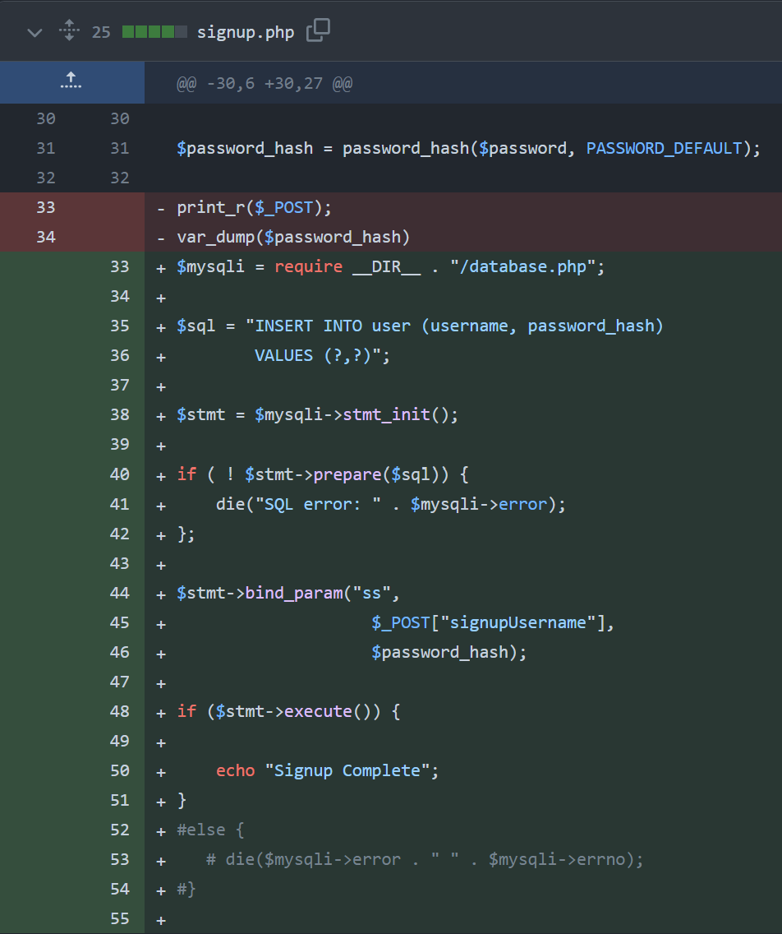Line 35 is the actual SQL query that will be run later on in the database. This statement currently has ‘?’ place holders instead of actual values. The actual values will be passed through to replace there holders when its nessicary. This protects against SQL injection attacks making the signup process more secure.

Line 40 prepares the sql statement to be executed and if this process doesn’t work then it will return the error. Errors in sql mostly occur from incorrect syntax.

Line 44 binds the parameters to the ‘?’ placeholders in the sql statement. We bind the posted username and the hashed password.

Line 48 will now execute the sql command and the users data will be stored in the databse above. If this process is sucsessful the user will be given a signup complete message.

After I confirmed this was working and added the first users to the database I needed a method of checking that a username isnt already taken. The two methods of doing this are to either do a try catch statement when executing the query to store the username and password in the database. If the username is already taken the execute will return a error since the username is the primary key in the table. There can only be 1 of any primary key in a table.

When the catch statement catches the exception I can read and compare this error so that if it is the error corresponding to the username being taken already I can return a message to the user informing them it is taken. If the exception is not for the username being taken I can return the error mesasge as normal.

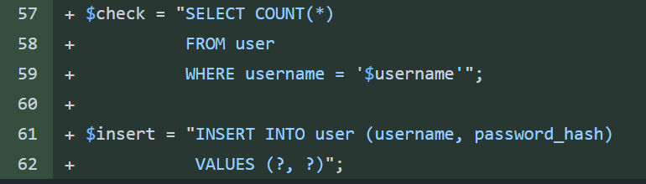The other approach which I decided to use was to read the contents of the database and check if the username is already in the database. This was my prefered method since deliberatley using errors in php is not good practice.

The best method I found for doing this is using the sql statement $check show above. This statement will read the whole database where the username matches the inputed one. A count method is used aswell so that the statement will return the number of times the same username pops up.

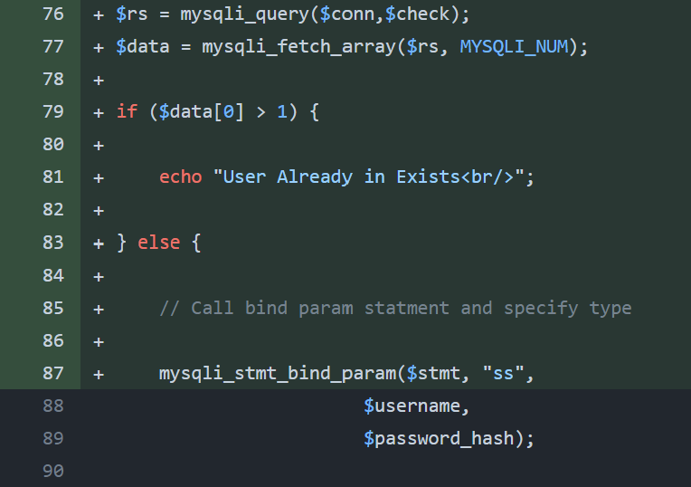Line 76 will run the query $check and store the returned database array in a variable called $rs. Since the number of occurances cannot be compared when its stored in an array on line 77 I use the mysqli_fetch_array method which will convert the database array into a format php can understand.

This array storing the interger representing the number of times the username appears In the database is stored in the variable $data. This value theoretically should only ever be 1 or 0 since the same username should not occur more than once in the database.

Using an if statement I check if the array $data contains a value greater than one in its first index. Im not sure why but when using this SQL query when no matching usrnames are found the count method will still return one. When 1 matching username if found the query will return 2. For this reason I check if the index is greater than 1. If this is true the username is taken and a message is sent to the user.

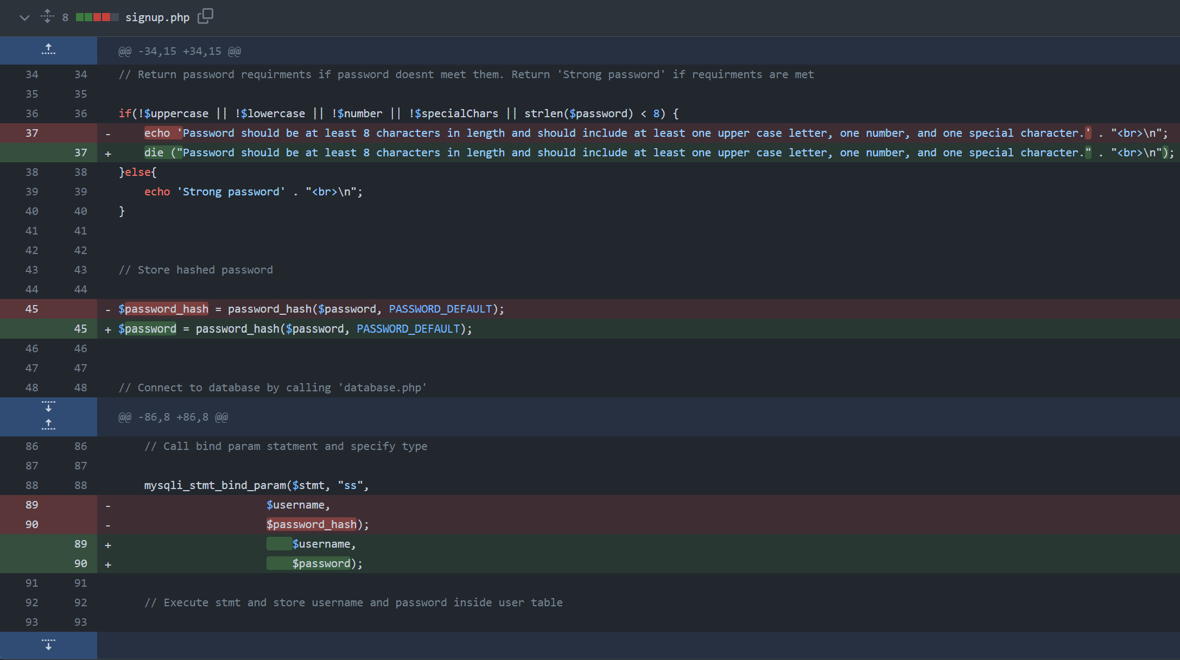If the username is not taken the program continues executing and the parameters are bound to the storing sql statement like normal.

I also went back through the signup.php file and fixed a few logic and security issues.

The first was that the code would continue running even after the algorithm has found the password doesn’t meet the verification standards. This is fixed by running a die command when returning the issue with the password to the user. This will cause the php to stop executing once the message has been outputed.

The second error was a security error since the password was being stored in a variable then when hashed this was stored in a new variable. This ment the password was stored in a variable that was not needed anymore. I fixed this by storeing the hashed password in the same variable the original password was stored. This mean the password is overwritten whn the hash is stored.

The last error was a logic/type error caused by changing the hashed password variable name in the fix above. To fix this I changed all the instances of using the password_hash variable to be using the password variable.

## Login:

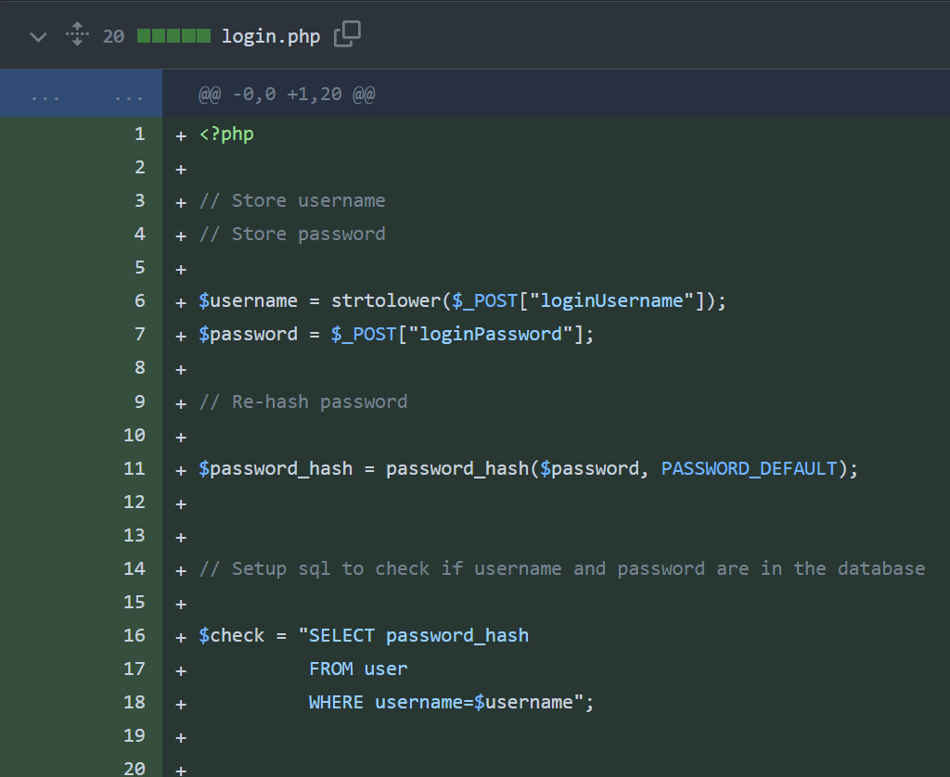I started the baseline for the login.php file similar to the signup.php file by storing the posted username and password as variables then hashing the password.

I then created the $check SQL query which should select any passwords from the database where the username matches the posted one. There should only ever be one password returned since the username is a primary key.

I also created a function to run this SQL. The function will require the database connection then run the SQL query. This will return an array and will be stored in the $rs variable to make the array understandable to php the mysqli_fetch_array method is used again.

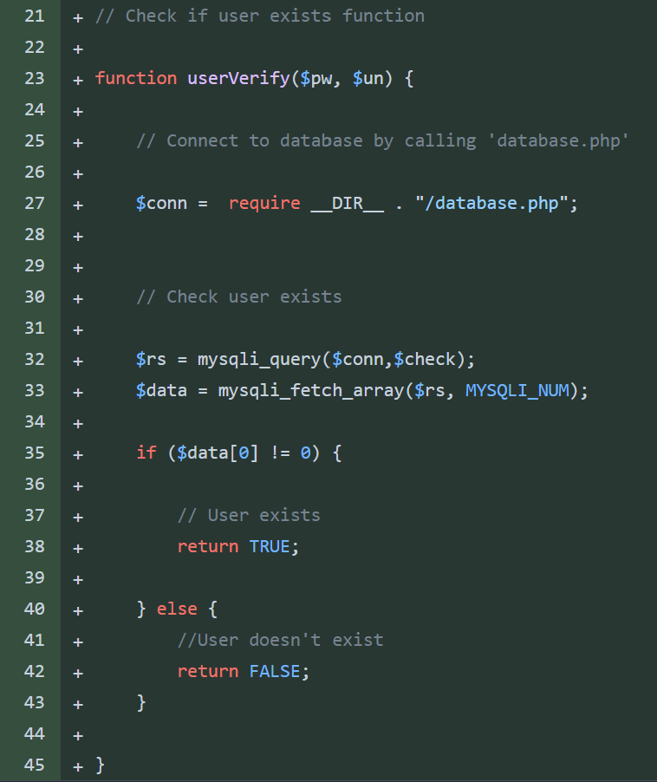To check if the user exists, I check if the $data variable is 0 or not. If the array contains the integer 0 the user doesn’t exist since their username cannot be found in the database. If the username is found the user exists but the password will still need to verified.

I also added some protection to my code for accidental submissions and to avoid code running for no reason. When the PHP file is called it will first check the server method is post. This means the program will only continue if the server has received a post from the form.

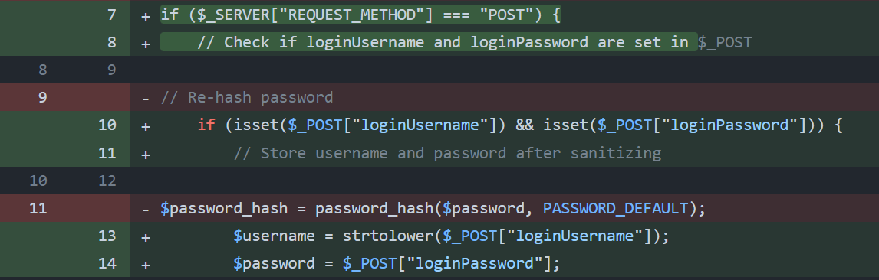The second layer of protection is to check the username and password have both received data in the post. The code will only continue if there is data in the post. If this step wasn’t included the username and/or password could be set to nothing which would cause errors later on.

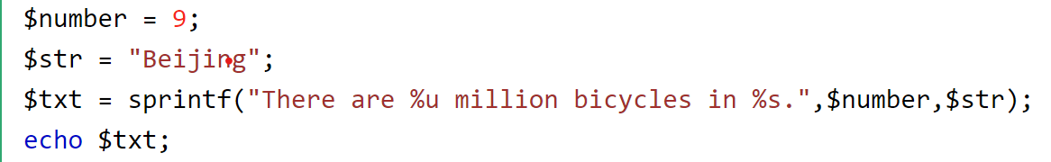I also added this layer of protection to the signup page and will use it for any further forms that have posted data.

The current method I was using to check the username was venerable to SQL injection so I used a sprintf function.

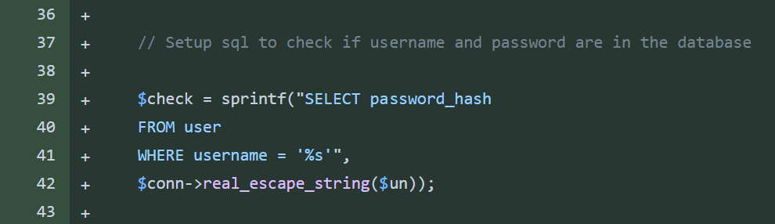The sprintf function is a way to input data securely into strings of data. By using % symbols followed by different letters to show the location and data type that will be submitted. Different letters are used to represent different datatypes. E.g. %s is a string and %b for a binary number. The data that will be used is written after the string.

The real_escape_string() function escapes special characters in a string for use in an SQL query, taking into account the current character set of the connection.

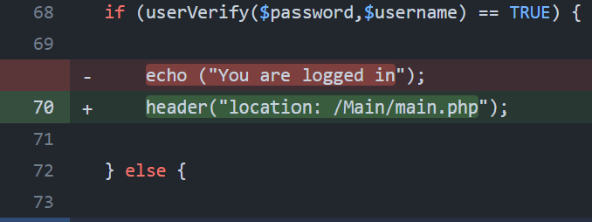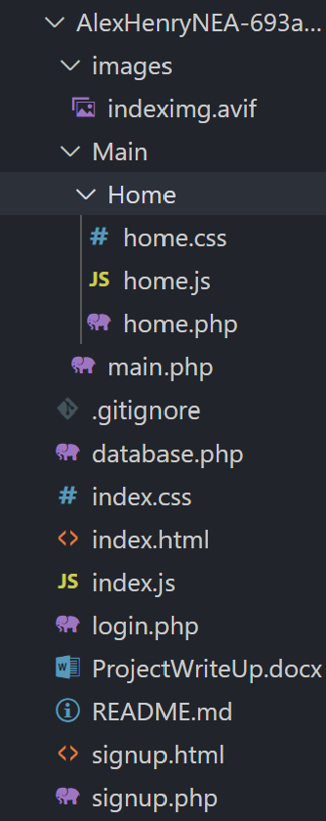I also changed the response of logging in to redirect the user to the login page instead of outputting a message.

My current folder structure looks like this on the right. I created a black page that will eventually be a question page. The login page currently redirects the user to here if there is a successful login.

## Question Pages:

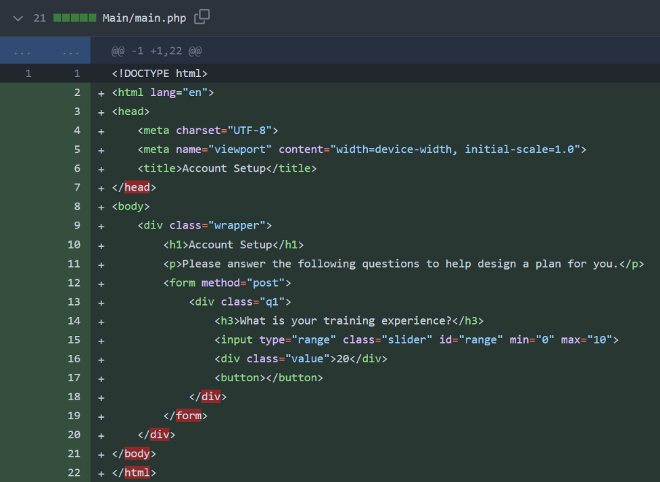I added the backbone for the question page. I decided to write my html code inside the php file instead of having a separate html file.

I decided to use a range slider for the input for answering a question. This means I can dictate the values the user can input. This means I will need to do less verification of the posted data when the form is submitted.

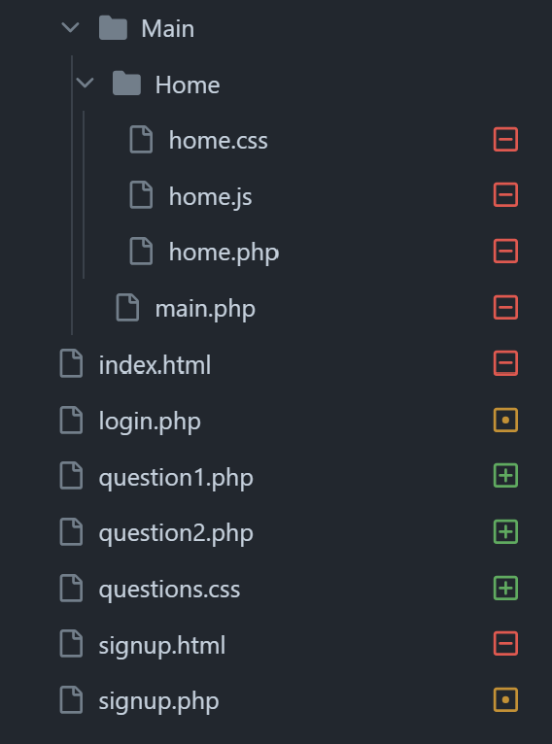After using the same file for html and php I realised it was a lot easier to track the functions and prcesses of the website so idecided to change all my html files to php. This ment I could move my php form management code into the same file as the html. The only downside I found of doing this was that autocompletion of code didn’t work as effectivley for html anymore.

At this point I also created a generic css file for styling all the question pages this can be linked in the head of the html on att the question pages.

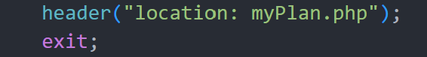I also decided to create a functions PHP file that can store a lot of the subprograms and functions that I call throughout the website. This improves the readibilty of the page PHP files. I can include the functions.php file at the start of every page and then use the functions stored in the file easily. If I choose descriptive names for the funtions it should be obvious what each subprogram is doing without needing to read the actual function.

I also went through my code and added exit commands after every header tag this ensures the code after the header is not ran.

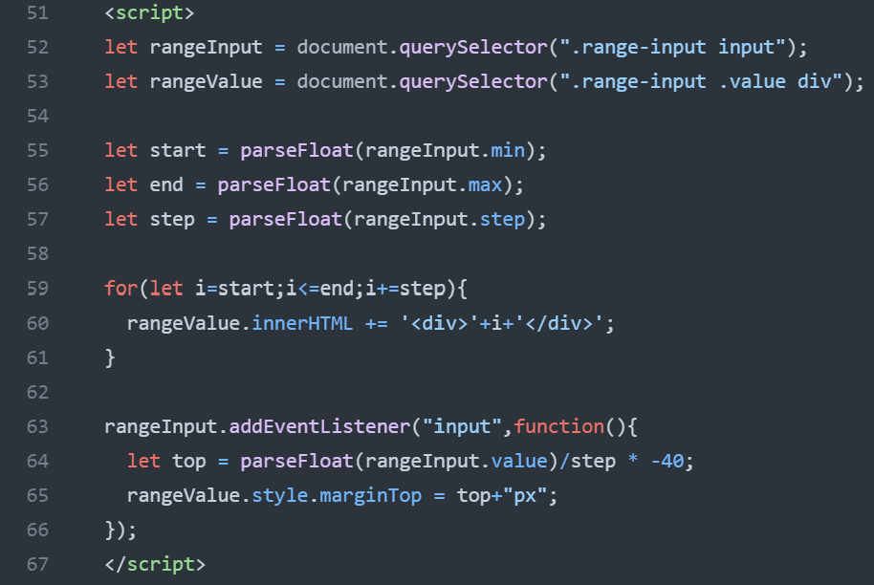 On each question page I added JavaScript that would model the range slider to display the value currently selected. (explained below). I also used css to make this look nicer.

Left – Range slider set to value of 7, Right – Range slider set to value of 0 (default).

The JavaScript starts by selecting the range input element and the div element where the range values will be displayed using the querySelector function. Then, it extracts the minimum, maximum, and step attributes of the range input and converts them to floating point numbers.

Next, a for loop generates the range values between the minimum and maximum values with the specified step size. Each value is appended as a div element to the container for displaying range values.

Then, an event listener is attached to the range input element to respond to changes in its value. When the input value changes (i.e., when the slider is moved), the event listener function calculates the top margin of the range value container based on the current input value. This margin adjustment causes the displayed range values to move up or down within the container, providing visual feedback to the user as they interact with the slider.

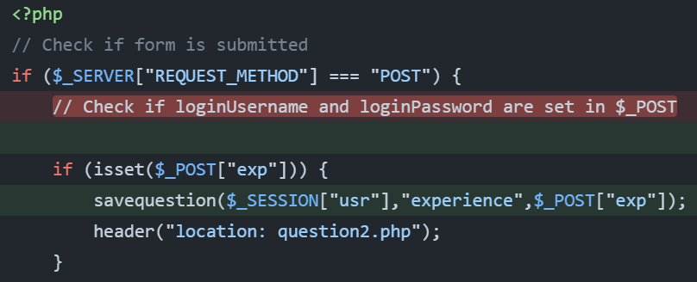When the form is submitted the code on the left will run since the server request method will now be post. After checking the variable that the question is about is set ( in this case the users experience) the code will call the savequestion function. This function is stored in the functions.php file since it is called by all the question pages. After the function has ran the user will be redirected to the next question. If it’s the last question they will be relocated to the myPlan page.

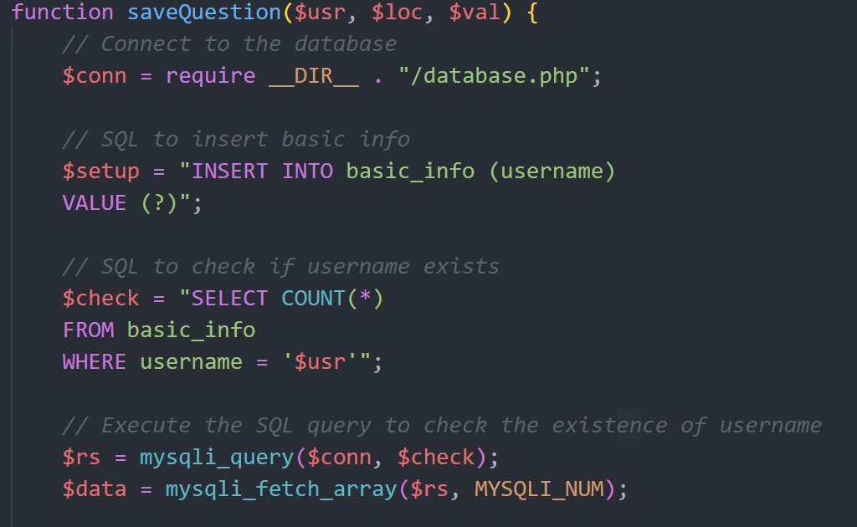The function commences by establishing a connection to the database using a separate PHP file called database.php. This connection is established via the require __DIR__ . "/database.php"; statement.

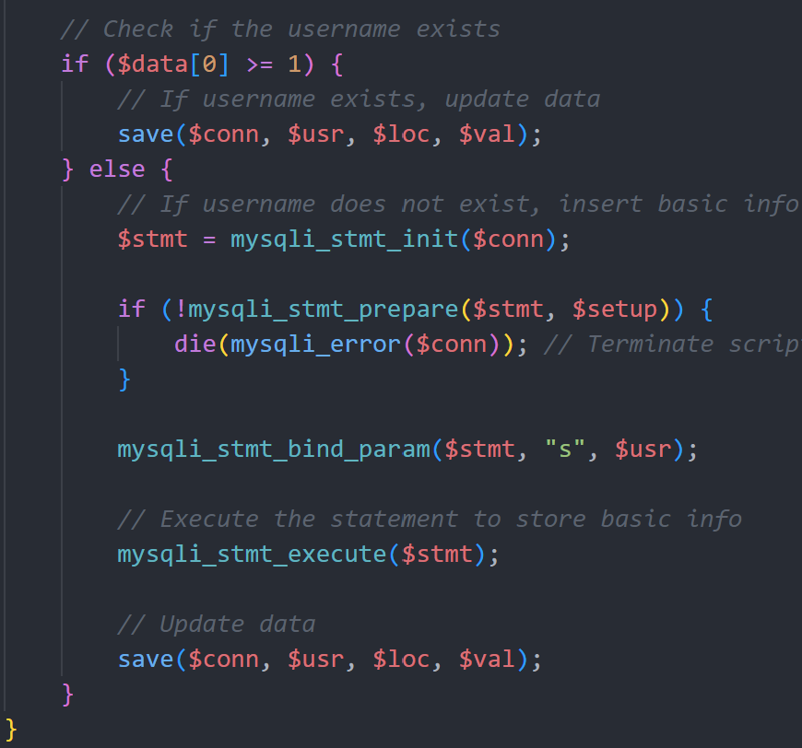

Then two SQL querys are setup as strings that will be needed later. The first query $setup will insert a value into the basic_info table. The second query $check which has been used before if used to check for the existance of the username (primary key) in the table.

If the username is already found in the table the save function is called.

If the username isnt already setup in the datbase the first query is used to store the username in the database.

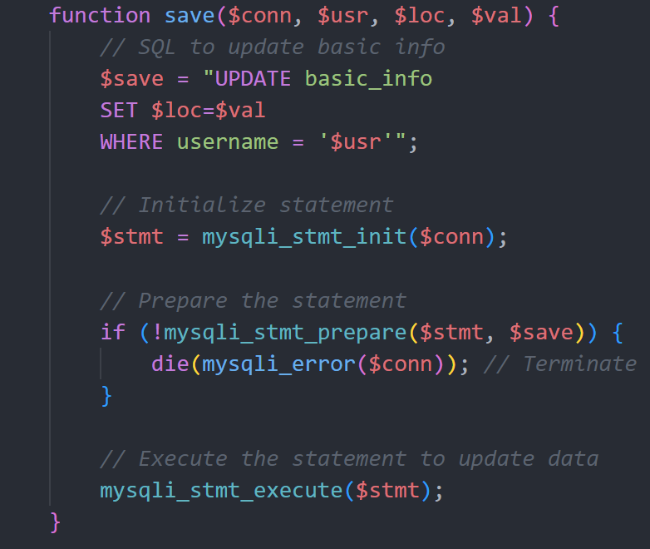This is nessicary since all the question pages will call this function but the username only needs to be stored once.

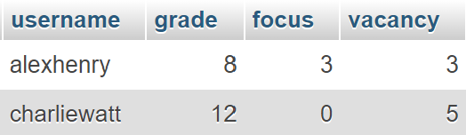The Table is shown below:

The save function takes the connection to the database, the username, the location (coloumb), and the interger value to be stored as parameters.

First the SQL query needed to save the value is setup as a string and saved to a varible $save. The query will update the basic_info table and set the passed location to be the passed value. This is set where the username is in the table.

Next the $stmt is setup using the mysqli_stmt_init() function that initializes a statement and returns an object suitable for mysqli_stmt_prepare().

Then the mysqli_stmt_prepare() function finishes preparing the statement. If there is an error at this stage the if statement will catch it and the php will die returning the error.

Finally the query is executed and the value will be stored in the appropriate location in the database.

## Sessions:

I needed a way to track users being logged in, this is important so that they don’t access pages without having an account since the pages won’t work.

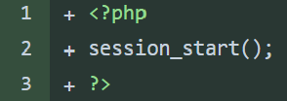The two ways to do this are SESSIONS and COOKIES in php. The main difference is that session is server side and cookies are client side. I decided to use sessions as they suited my use case better. On every page the session_start() command needs to be called. This will start or resume a session. This allows session variables to be kept throughout the session.

The session variable I use to check the status of a session is the ‘usr’ variable. When a user logs in their ‘usr’ session variable will be set to their username. This will be useful throughout the program to access the database since the primary key is the username.

When users wish to logout they can click a button, this will unset the session ’usr’ variable and redirect users to the login page.

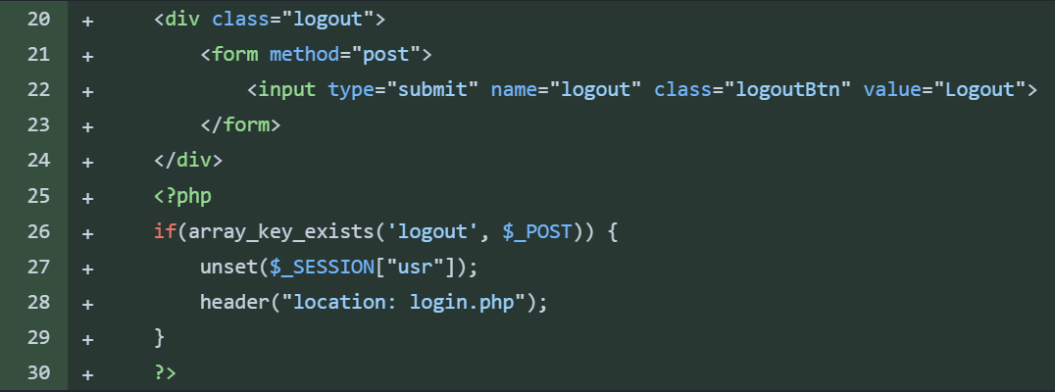On every page when a session is started I will check that the ‘usr’ variable is set. If it isnt then the user isnt logged in and they will be redirected to the login page.

On the question pages there is a dedicated logout button in the top right this will not need users to be redirected to the logout page. Instead the button is setup as a form and when the form is submitted php runs that performs the steps needed to logout.

## Login Bugfixes:

While testing the login process, I found that the login process didn’t work. The current method (left) took the username and password as parameters and then searched the database for where the username was the same and the password was the same. However, this didn’t work and even with the correct username and password the user would not be logged in.

This was because the hashing algorithm used before storing the user’s password used more variables to create the hash than just the password itself. This meant every generation of the hash using the algorithm would produce a different hash even when hashing the same password.

This meant when searching the database for a matching password there would be no results since the hash is unique every time.

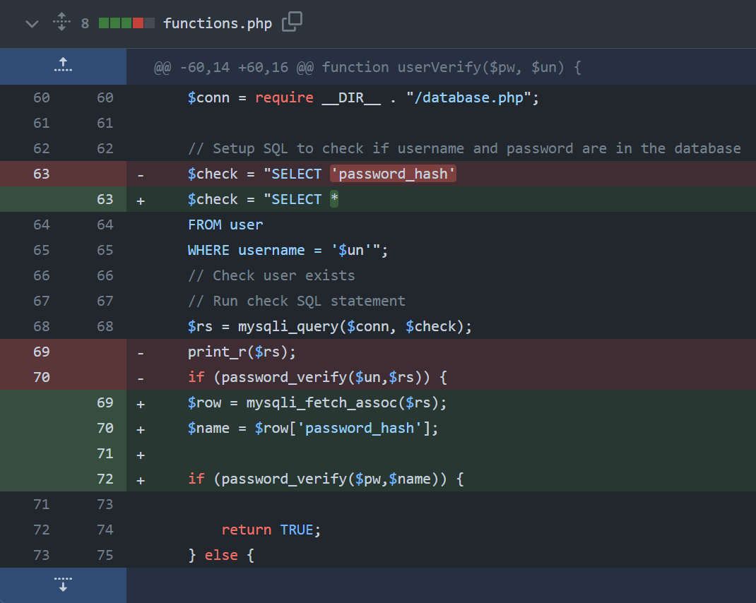The solution (right) was to use a built in php function password_verify(). This function will take two hashed passwords and return true if they match and false if they do not.

So, the fix was to read the hashed password from the database where the username matches and store this as a variable then use an if statement that would check if the function would return true or false. If the function returns true the username and password are correct and the user will be logged in.

I also added protection for if the user doesn’t input a username or a password with a simple if statement that will die if there isnt both inputs.

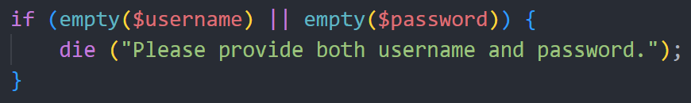

## My Plan Page:

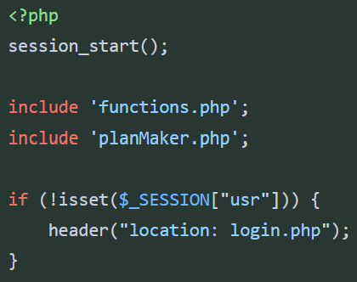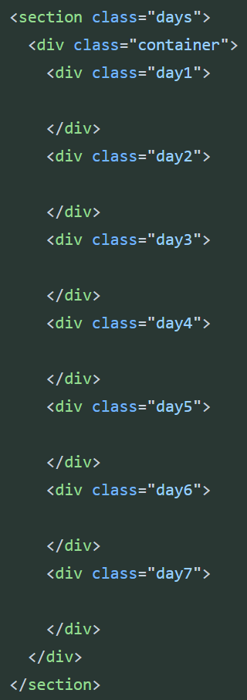I created a PHP page that will display the users training plan. This includes the normal head metadata and also the necessary php inclusions and commands at the start also.

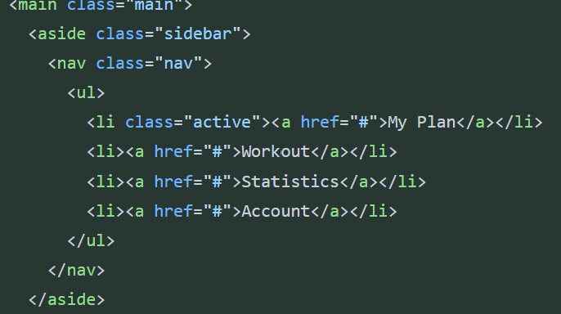On the right is the template for how the days in the plan will be layed out. This is in its own section. The other section shown below is for the sidebar.

The navigation sidebar is layout in an aside tag with a list inside each list element is a href link to the other pages.

## Plan Maker Attempt 1:

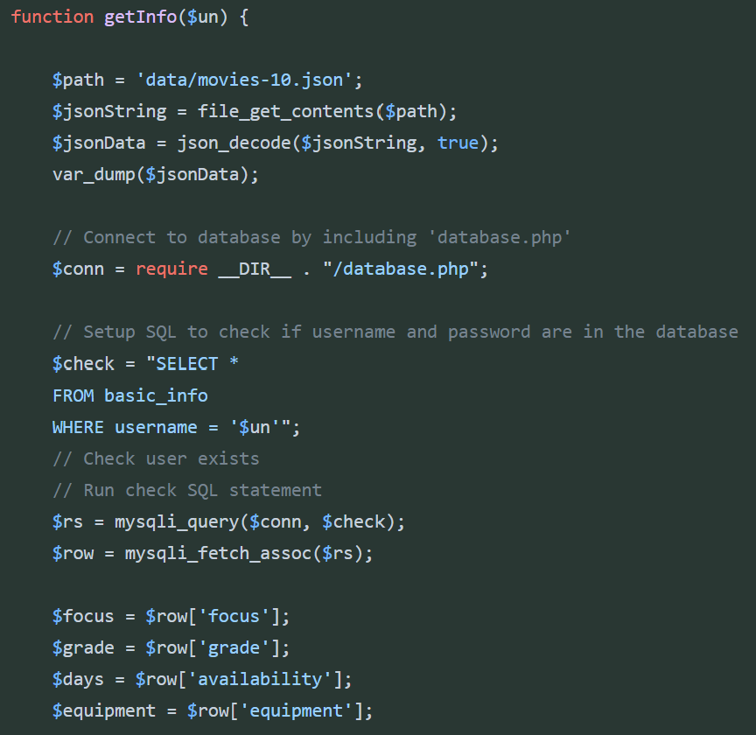I created a separate PHP file to store the algorithm to make the users plan this is because I predicted the algorithm will be long and it will made readability easier on my plan page if the algorithm is stored in its own file.

I used a function to store the algorithm since this can be called at any point where its nessicary.

To allow the function to be ran in other files I included it in nessicary files such as the my plan page.

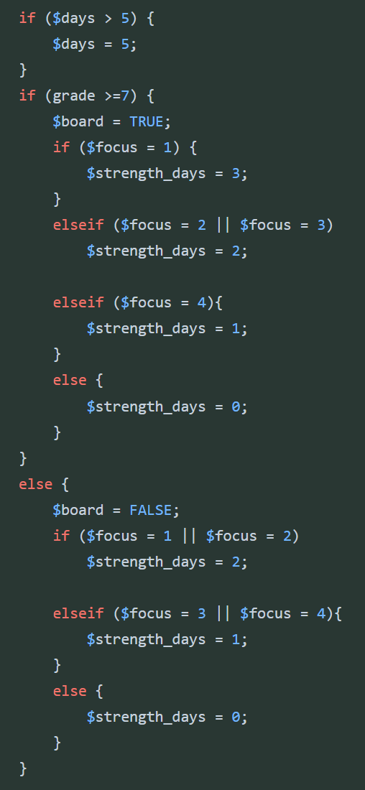The first step of the function is to get the execises from the json file they are stored in. They are stored in a json file therefore they must be decoded into a format that php can understand.

Firstly, I stored the path variable as a variable. I used a place holder since I havent made the json file yet. Then I read and save the contents of the file as a variable. Finally, I decode the data using the json_decode function. I’ve also included a var_dump funtion to return what we have decoded, this is purely for testing.

The second step of the function are to get all the users details needed to model the plan. These are stored in the database. Using a simular setup to previous I read the database where the username (which is stored in the session variables and will be passed in as a parameter) matches the databases primary key. Using this I can assign the users focus, grade and days values to variables. I also included the equipment variable which hasn’t been setup in the database yet.

The next step to was to use the data to create a plan. My first attempt as shown on the left was to use a series of if statements to setup new variables such as $strength_days. These variables would be used later to assign exercises to each day.

I realised this method was going to be highly inefficient and hard to understand so decided to try a new approach before finishing.

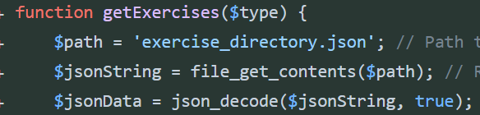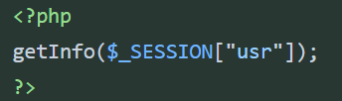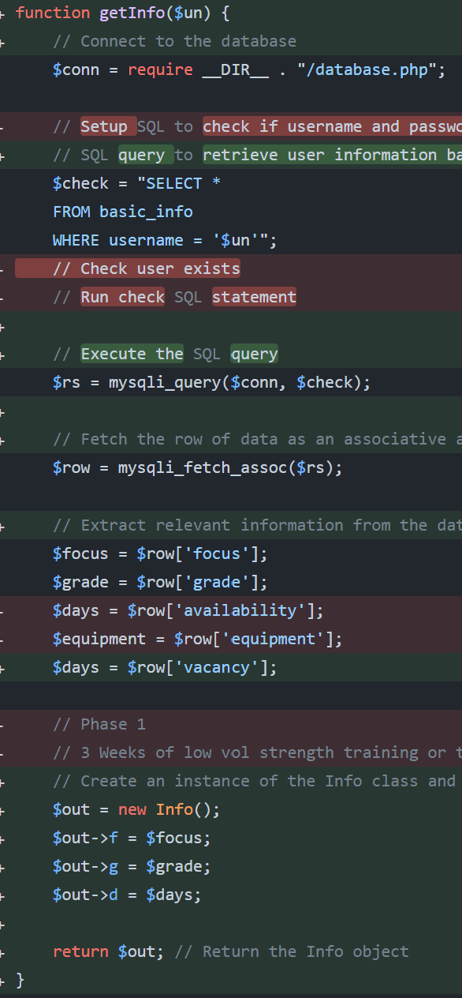I also removed the template I has made in the my plan page for displaying the users plan as I decided it would be easier to display it using php. It now look like the code on the left.

My second attempt was to use a procedural style approach and make functions that would be responsible for induvidual tasks. The first was to retrieve the exercises from the json file as before (above). However a new feature is that the function will return the exercises that are of the type specified in the parameter.

The next function was the original function which would return the users info. This is done via the same method as before. However since multiple values cannot be returned out of a php function I used a class to store the values as an object. Then I could save the values of the object to variables outside the function after.

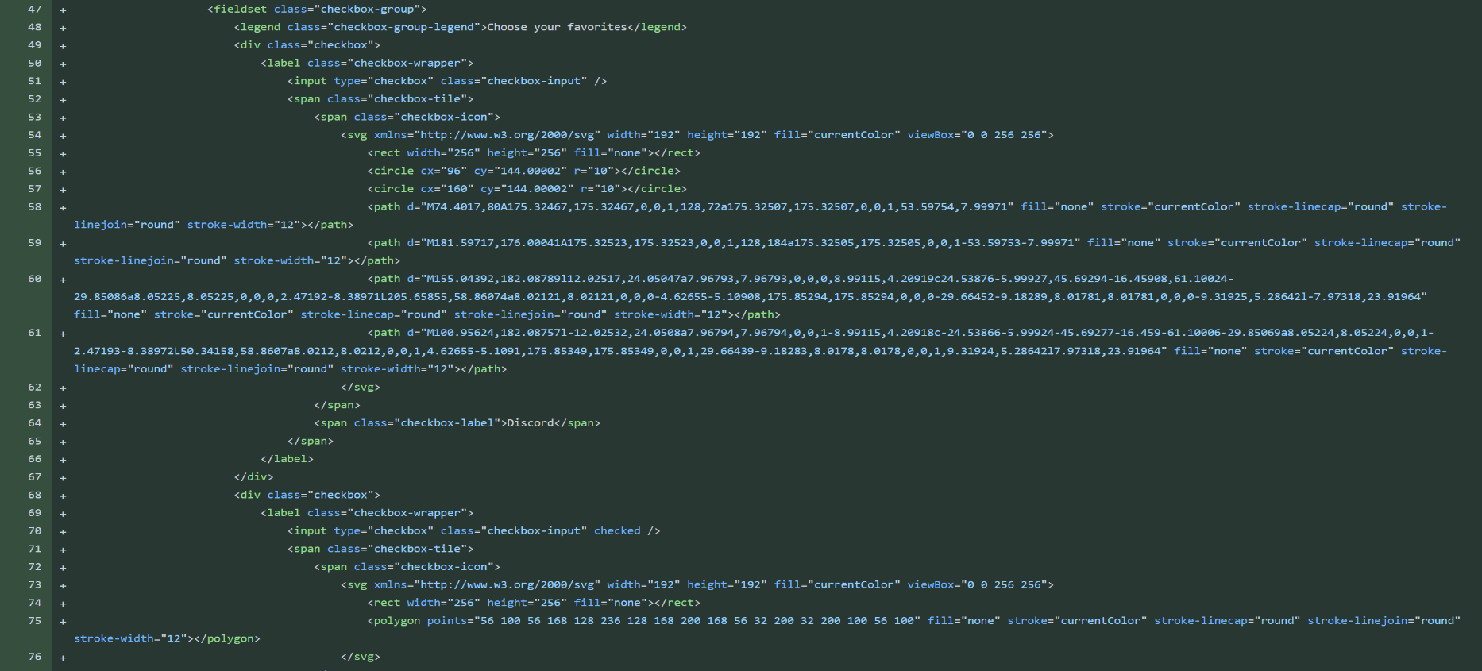At this point I also tried to create the 4th question page that would store what equipment the user has. I wanted to do this using checkboxes with online css styling. I tried this below but could not get the form to submit correctly. I also realised after talking to my stakeholder that this feature was not essential as Ben liked to manually add of change exercises himself when equipment wasn’t avaliable. I decided to stick with 3 questions for my algorithm.

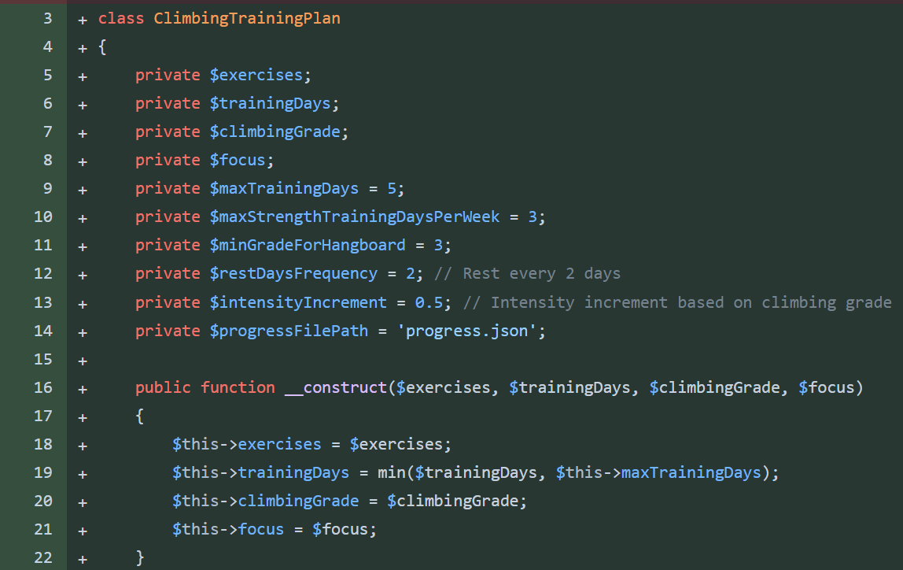With the plan algorithm I decided to switch to using a combination of OOP and procedural. This will encourage encapsulation aswell as make it possible to create multiple plans. This will help later on when the user will be able to interact with the plan and manually change aspects.

This is the start of the class used for creating the plan. All the variables are private. All important constants are also stored as variables to make understanding code easier.

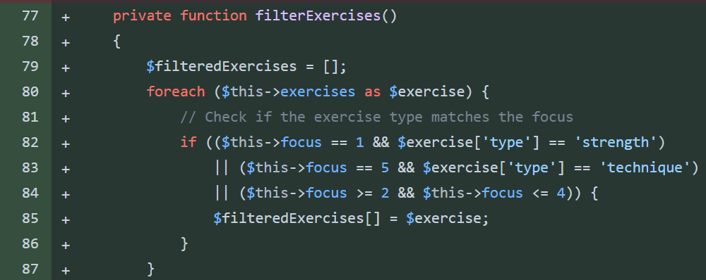The constructor method will take all the outside input needed for the plan and store then in variables.

The filterExercises function will return an array of exercises that are to the users focus. Eg a user focusing on strength will be given more strength exercises in their filtered array.

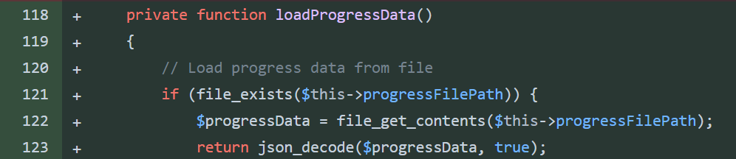The loadProgressData will load the progress data from the progress file. This is a work I progress part and I’m not sure if it will be included in the final algorithm.

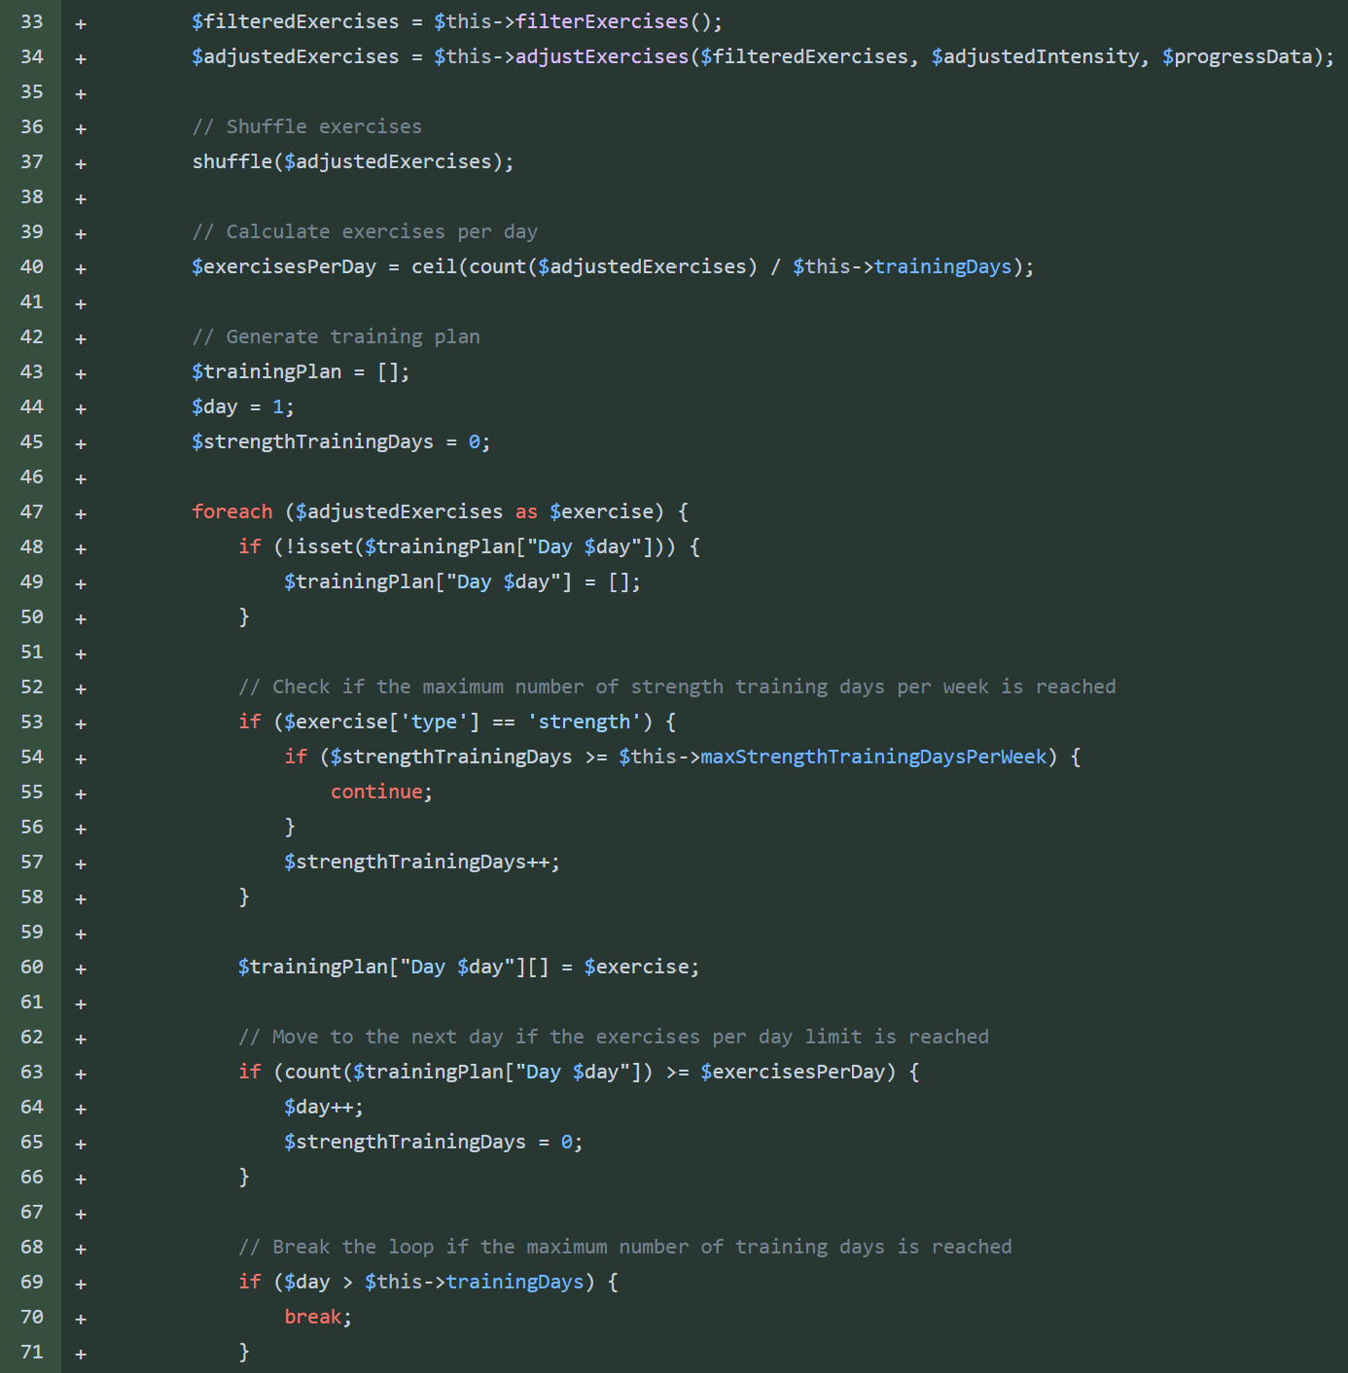This is the main bulk of the algorithm so far. The filtered exercises are received from the function. These will be sent through another function that will adjust the sets and weight needed for each exercise. Then the array is shuffled.

Line 40 ensures the exercises are spread evenly throughout the days of training.

Then the algorithm uses a foreach loop to append exercises to the training plan array. This is done day by day. When the number of exercises per day is reached the day is incremented. Inside the loop there is also a chek for the number of strength days in the whole plan. This cannot exceed the man number of strengthTrainingDays which was defined in at the start of the class.

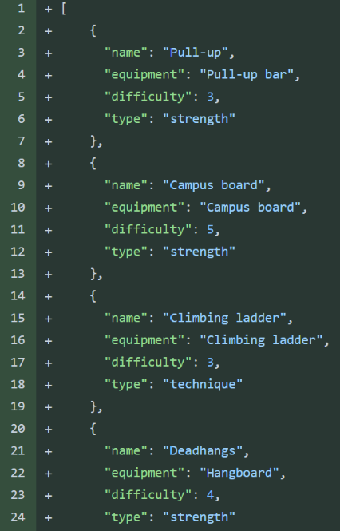I created the json file to store all of the exercises. Each exercises is given required equipemnt a difficuty and a type. The tye can either be strength or technique.

The first difficulty scale I used was a 1 to 5 scale where 5 is the hardest exercises. After experimenting with comverting the users climbing grade to a measurable difficulty I realised the scale was not precise enough and that using a different scale for difficulty of exercises to the performance of a climber was not nessicary.

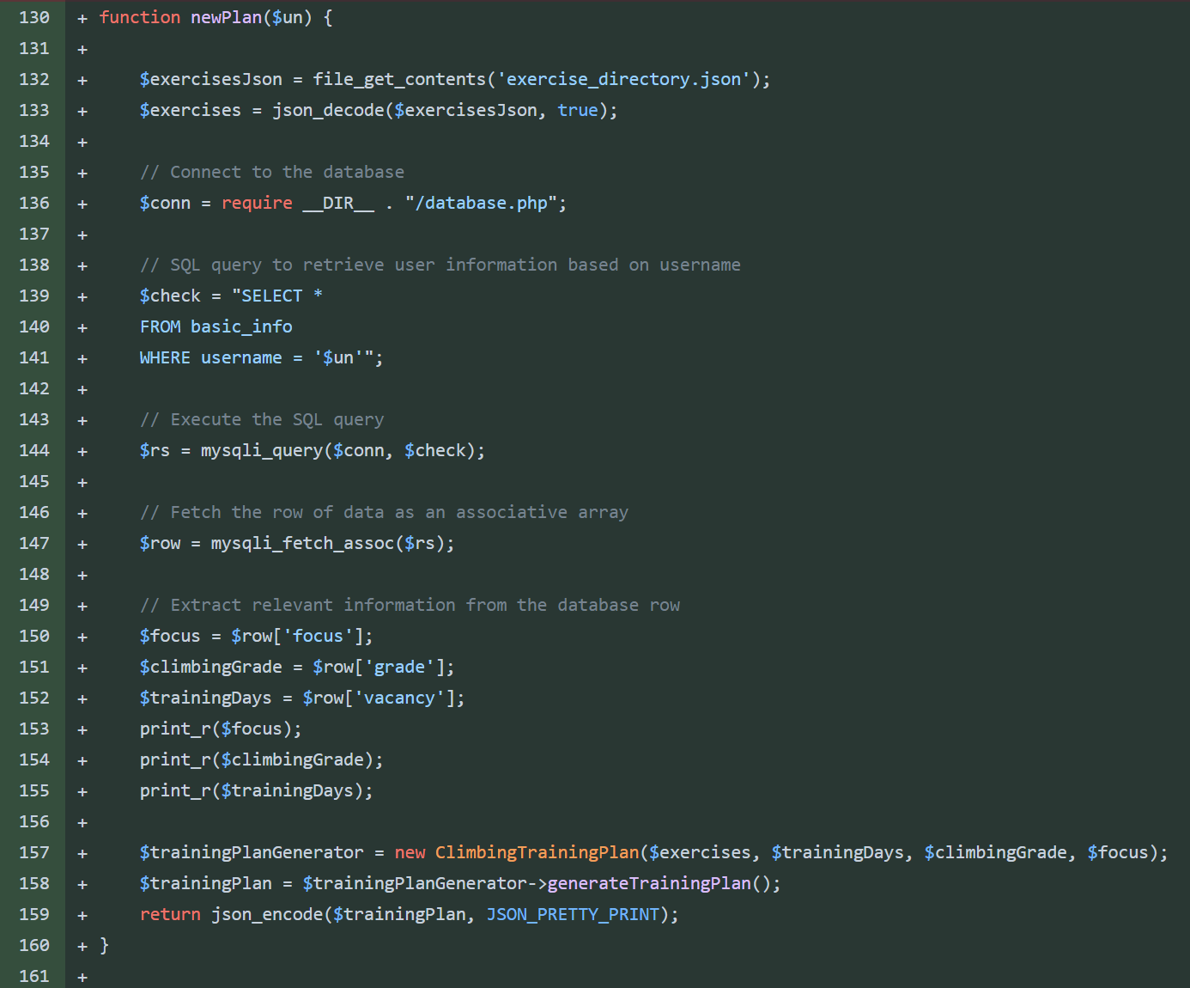I changed the difficulty scale to be based on the grade of the a climber. For example a exercise with a difficulty of 3 should only be given to climbers who climb at a grade 3 level or above.

I created a function that would call the class and return a new plan when called. This could be called from the my plan php page. This function also contained all of the code needed to get the data needed for the class.

The function gets the users focus, grade and avaliability from the database. It also reads the json file to get all the exercises in a format that php can model. These are passed into the constructor class then the object of the class is made.

I realsied my algorithm lacked depth and was missing many important elemnts for a complete training plan such as:

* Exercises only used once
* All training days one after another
* Users were either given a technique or strength only plan
* Simular exercises could be chosen one after another

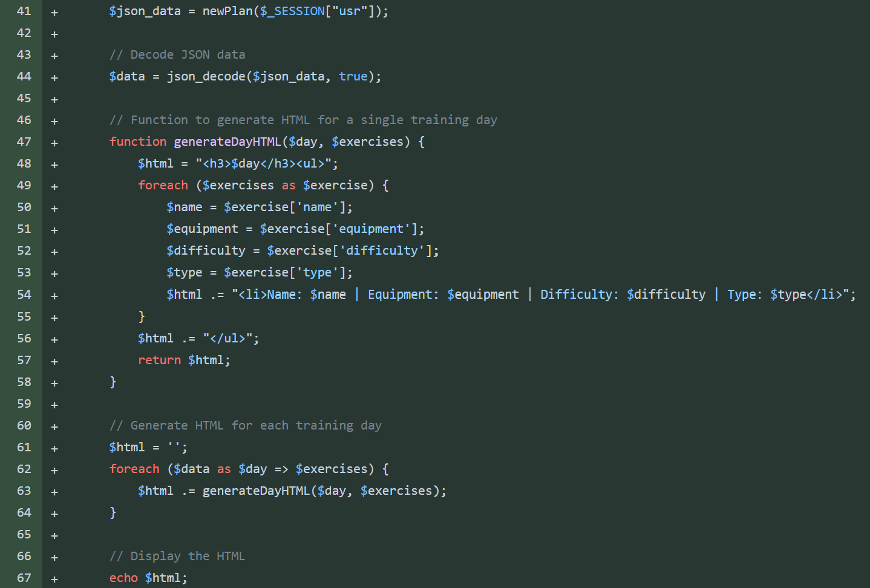To decided to try from the start again to fix these issues since adding this many new functions to the current code would make it very cluttered.

I also added a display method for the plan to the my plan page.

When the newPlan function returns a json array of the plan it is first decoded and stored in a variable.

Then for each day I call a function that will print the day name followed by the exercises and its details. The function is called for each day in succession. The function returns html for the day of training and this is appended onto the end of the current html.

After all days have been gone through the html is echo’d and displayed on the page.

## Plan Maker Attempt 3:

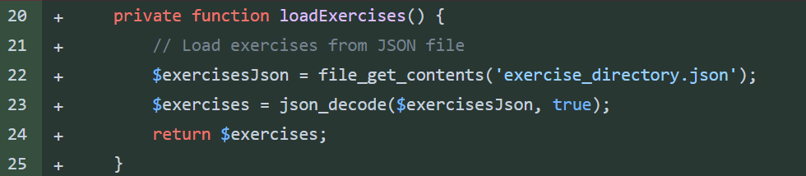The constructor on the new solution was simular but I fixed a logic error with the focus. The javascript I wrote for the range slider for the focus input starts at 0 and will not work when it starts fro 0. Therefore my focus range is actually 0 to 4. In my algorithm I use the values 1 to 5 so I increment the focus in the constructor.

Another change is that the exerises are not passed in when making the object. Instead a new function loadExercises() in the class will read the json file and return the exercise array.

The final change is that I am actually using the $maxTrainingDays variable before I was using the interger 5 instead of the variable setup already. This should make the logic easier to follow since before it wasn’t obvious why we were limitng the avaliability to 5.

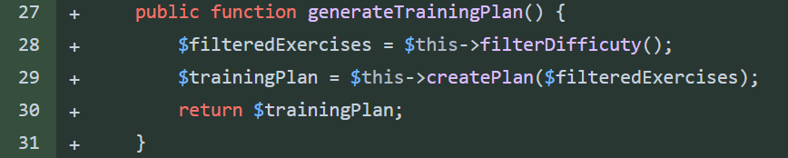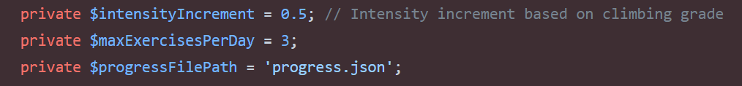I also removed the variables on the left.

I decided to adopt an even more procedural approach inside the class, there in now a function that will call each of the other functions in the correct order and then return the training plan. As the functions have descriptive names this should mean looking at this function should make the order of processes obvious. This is what the function currently looks like above.

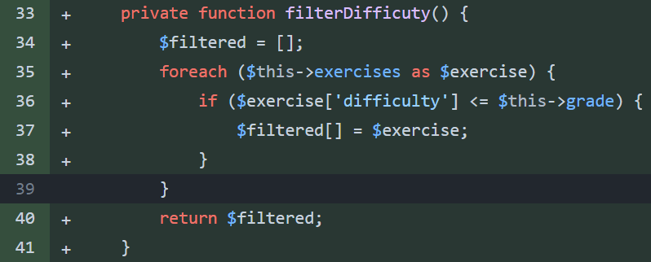The filterDifficulty function will return an array of exercises that will suit the users grade. By going through each exercise in the exercise array and appending, any exercises with a difficlty less than or equal to the user grade, to a new array called $filtered. This array is returned after all exercises have been filtered.

The numOfDays() function will setup variables the algorithm need in order to create the plan. The variables are:

* $strengthDays
* $techniqueDays
* MixDays

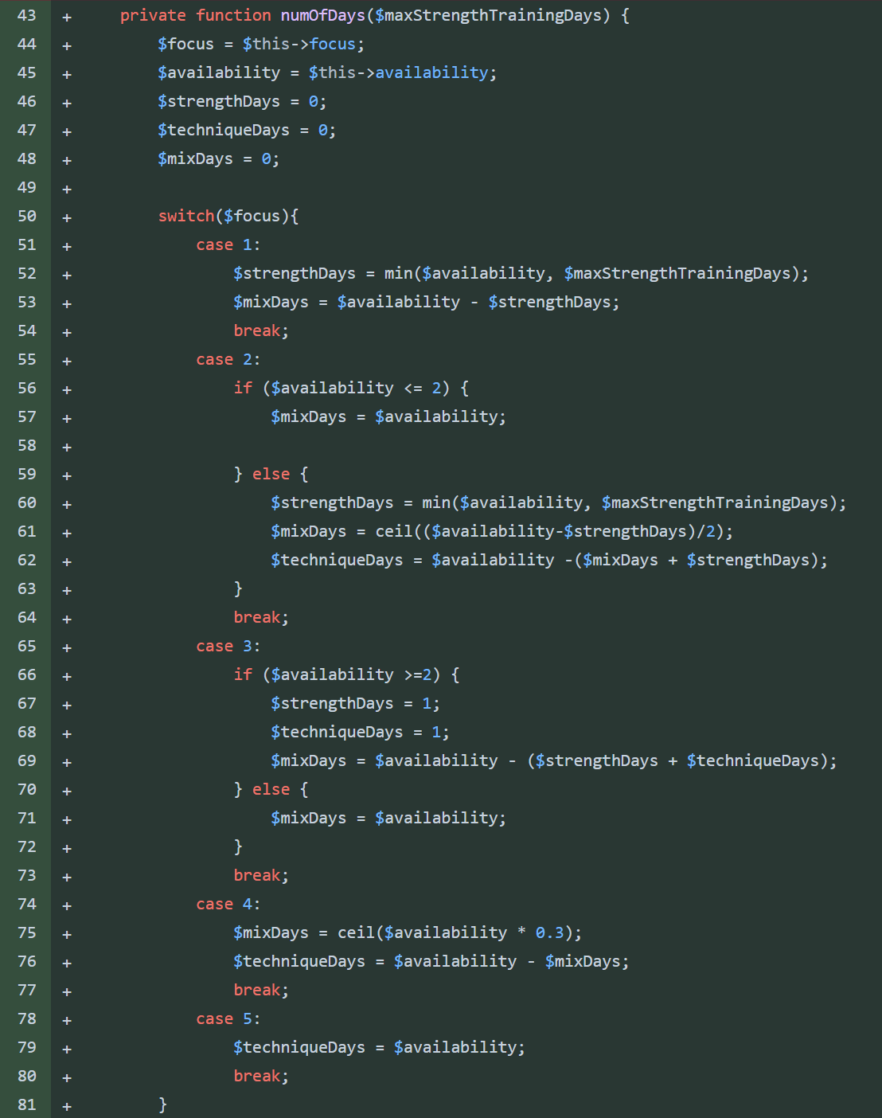These are each assigned an interger value depending on the users focus and avaliability. If a user has a high strength fous they will be given more strength days and less or no technique days. A user with a balanced focus may have a mix of all 3 days. A user with 5 days avaliabilty and a max strength focus will still be given mixed days since there is a constant of 3 max strength days a week.

I decided to use a switch since they are slightly more optimised vs multiple ifelse statements. Personally switches are also cleaner and easier to read also.

The switch will choose the corect case depending on the users focus and then using the case and the users avaliabilty the number of each day is worked out.

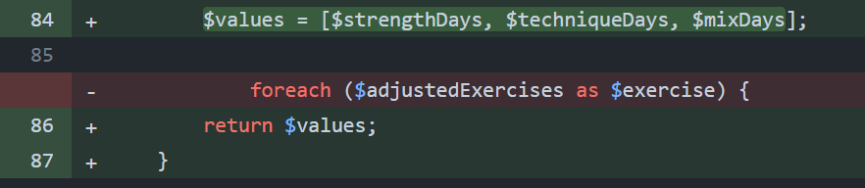To return the values I added them to an array and returned the array. This is the procedural solution to the problem I had above with returning multiple values from a function.

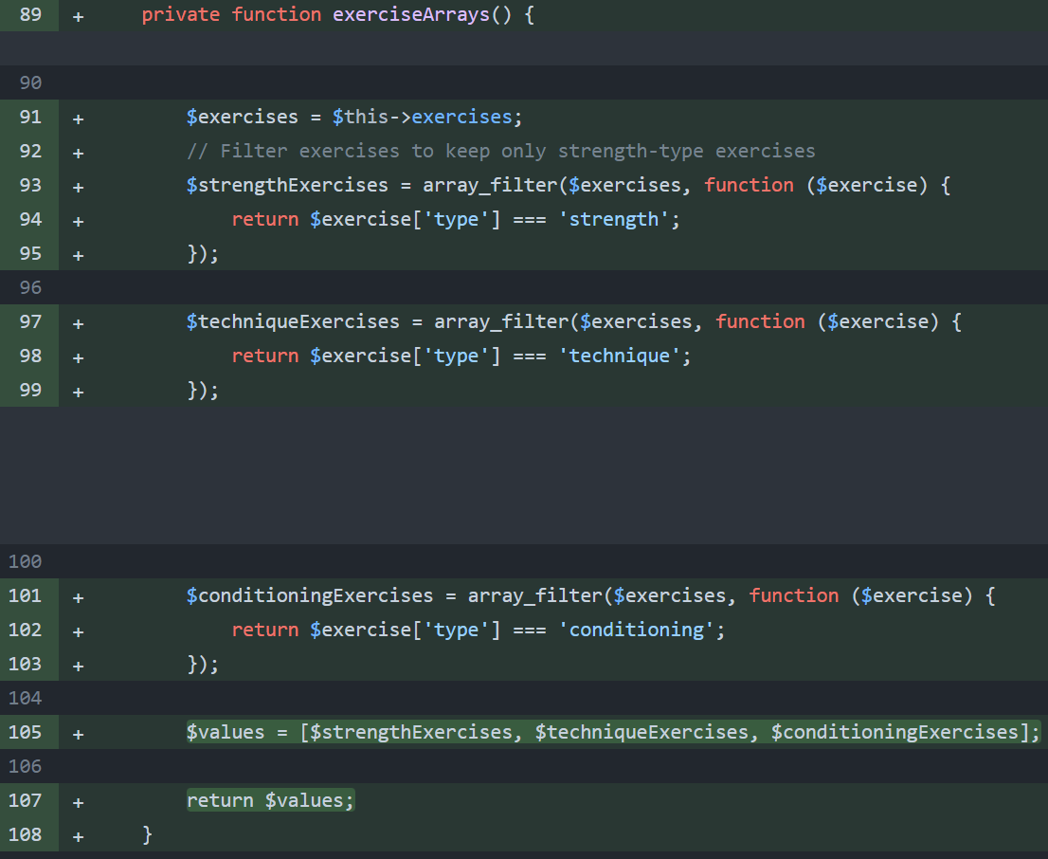The exerciseArrays() function will return 3 separate arrays each with different exercises. For example array 1 could contain only strength training exercises.

The function uses the exercises in the $exercises variable and uses the built in php function array_filter(). The function takes the array, a callback function and the flag as parameters. The callback function in my example is directly below. For each array it searches for where the flag is strength, technique or conditioning respectivley.

The funtion will then return an array with any items that were seected by the callback function.

I then use the same method detailed above to return the arrays.

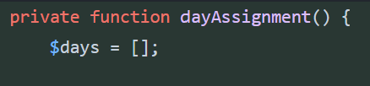I then created the dayAssignment() function. This function should return a 7 long array with each index containing a string about what type of day should occur. Since I wasn’t sure about how to go about this yet I left the function blank.

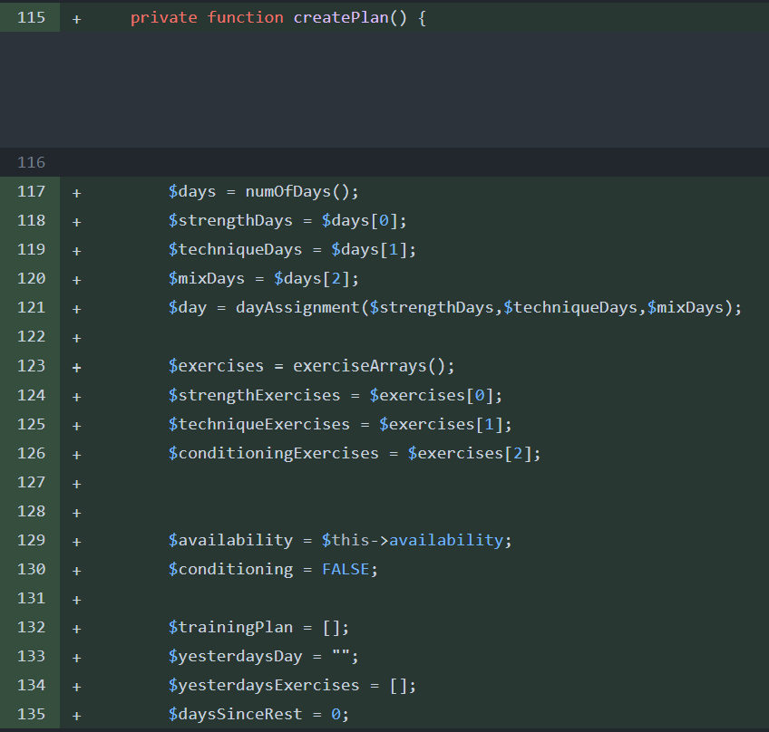I then made the createPlan() funtion this will unify all the functions and call them in the correct order to create a plan.

First it gets the number of each type of day by calling the numOfDays() function.

Then it gets the different exercise arrays by calling the exerciseArrays() function.

Then it initialises the trainingPlan, yesterdaysDay, YesterdaysExercises, daysSinceRest and conditioning variables to their correct datatype.

I moved on from this step since I couldn’t continue without finishing the dayAssignment() function.

I then made the first day builder function. Each of the days will have a day builder that will add different exercises to the day depending on the users preferences and the exercises already added to the plan.

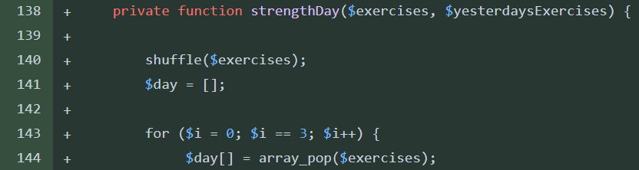This is the strengthDay() function that will shuffle the exercises and then add strength exercises to the day from the strengthExercises array passed in as a parameter.

This is done using the array_pop() built in php function that will remove the top item from a stack / array and return it. I used this since it will return a individual exercise aswell as removing it from the array so the same exercise isnt added twice in one day. This is why the array needs to be shuffled every day otherwise the same exercises will be added to every strength day.

## Plan Maker attempt 4:

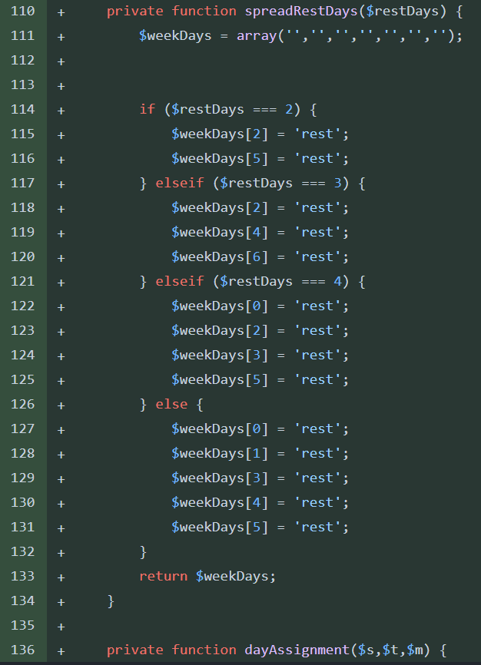I decided the dayAssignment() function needed to be decomposed into two separate functions.

The first function (left) spreadRestDays() would take the number of rest day as a parameter. This is calculated by doing 7 minus the number of training days a week.

The function initializes an array called weekDays.

Then using elseif structure to assign rest days to different indexes in the array. For example, if the user has 4 rest days, they will be assigned rest days on the first, third, fourth and sixth day of the week.

The function will then return the array. Any days that are not assigned to rest are left as empty strings.

I then finished the dayAssignment() function.

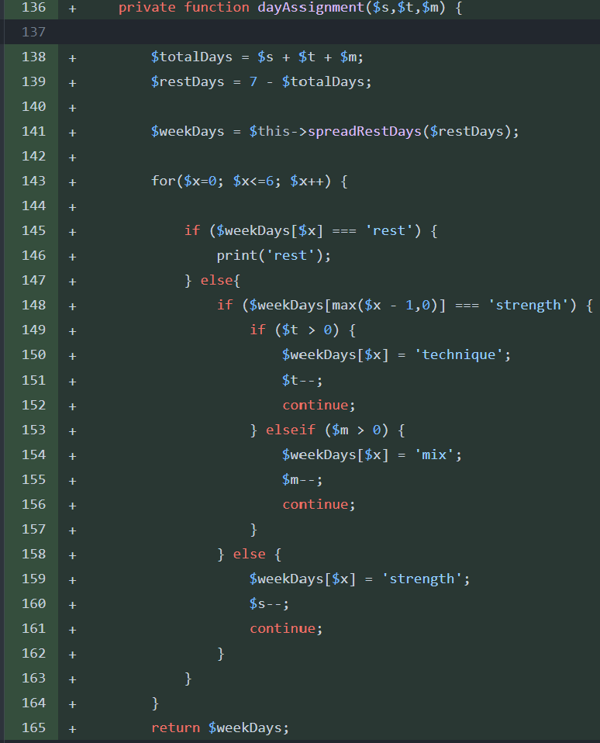First the function calls the spreadRestDays() function detailed above and sets the returned array to a variable called $weekDays.

Then using a for statement, the function goes index by index through the array. If the index contains ‘rest’ then the function prints ‘rest’. Else the function will assign either technique, mix or strength to the index in the array.

When assigning the day type the correct amount of each day are accounted for as they have already been passed in as parameters.

However, after testing a problem with this algorithm was that it placed all of the technique days first rather than evenly spacing all the different day types evenly. This was one of the issues mentioned in the previous iterations of the plan maker algorithm.

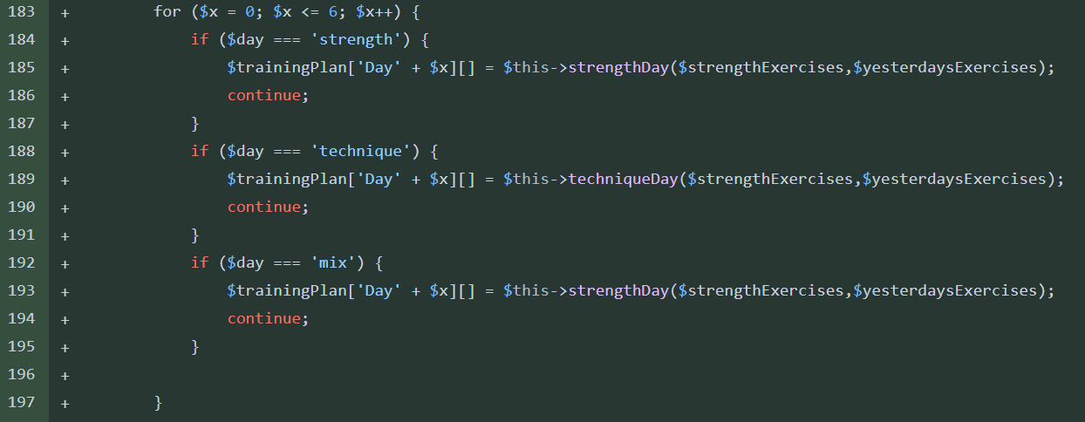I also finished the code to assign the exercises to each day given its type. Using an if statement the array containing each day type is read. If they day type is strength the strengthDay() function is called. This function that has already been described will assign exercises to the day and return them as an array.

This array is appended onto the $TrainingPlan array. This array has names for its indexes. Each index is called ‘day n’ where each day has an incremented n up to day 7.

This is continued for the whole 7-day plan.

After the training plan has had all its exercises added it is returned.

## Bug Fixes:

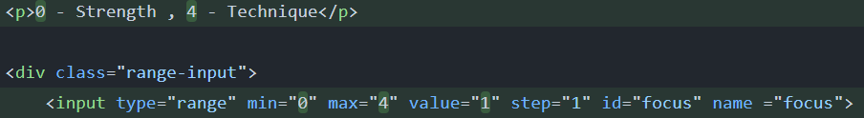After testing my code, I found bugs and logic errors that I had to fix before being able to test the algorithm properly.

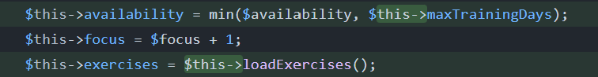The first was that I forgot to change the values for the range slider to start from 0, I fixed this logic error in the php plan algorithm earlier but forgot to fix the html side or the error.

A type error that was stopping my constructor method from working was that I had forgotten to add $this when calling functions and variables inside my class. This was a simple fix but did occur multiple times throughout my class.

Another error I found was that I never assigned the previous days exercises to the $yesterdayExercises array. This meant the same exercises could occur 2 days in a row. This was also one of the problems with previous implementations of the algorithm. To fix this I assigned $yesterdays exercises to the index of n – 1 of the day I was currently working with.

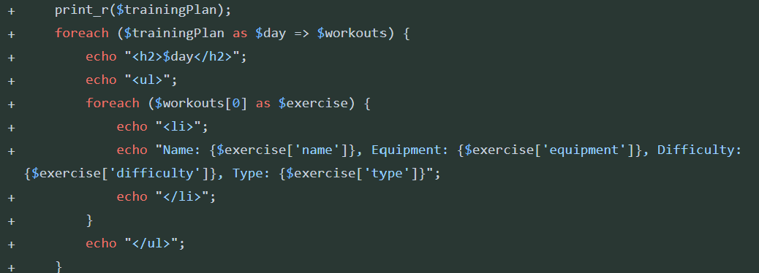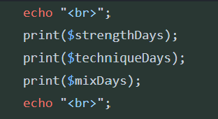I was getting unexpected results and errors due to values out of range so I decided to print my values at different stages on the program. At the start of each function, I printed any parameters or variables that were being used. This was useful to track the variables changing while the program ran.

I also found that my code to print the users plan was not working anymore. This was because the array being returned now was different to the array structure being used previously. I updated the code and now am using the code above. I also print the array above the html print to check for any info that is missed or other errors in printing in html.

I fixed a issue with the day numbers in the trainingPlan array. Currently the days would start at 0 and go to 6. This is because I was naming the days using the indexes they were stored in. To fix this I used the index plus one. This is only a quality-of-life change since humans tend to start counting at 1 vs computers starting at 0.

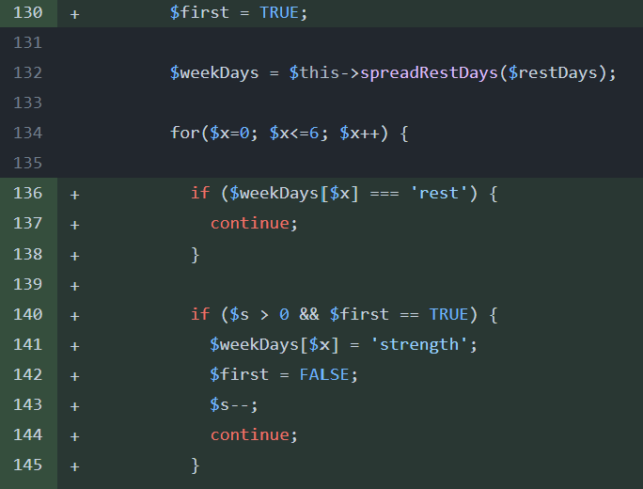I fixed the logic error causing all the technique days to be put at the start of the training plan. To do this I forced the first day to be strength if there were any strength days. Then for every concurrent day the algorithm would check if the previous day was a strength day. If it wasn’t and there were still strength days to assign then the day would be assigned as strength else a technique or mix day would be assigned.

This guaranteed that strength days would only occur when users were well rested as well as spreading out the types of day throughout the week.

I fixed an error that caused the html print of the training plan to return errors on rest days. Currently the array was laid out as [[day 1 array], ‘rest’, [day 3 array], [day 4 array], ’rest’, [day 6 array], [day 7 array]]. The current method was searching for an array where there was the string ‘rest’. This caused an error. To fix this I added the code above when the exercises are being added. When the day is ‘rest’ the string ‘Rest Day’ will be added inside its own array.

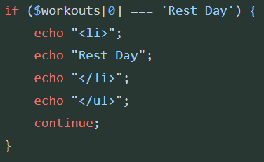This fixed the error and the new training plan array looked like: as [[day 1 array], [‘rest’], [day 3 array], [day 4 array], [’rest’], [day 6 array], [day 7 array]].

I also added the code on the left to the html printing code. This would output when it’s a rest day rather than leaving it blank.

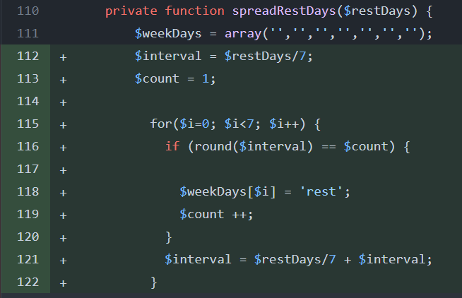I improved the code used for the spreadRestDays() function to be more efficient than having ifelse statements fir every possibility.

Inside the function, an array named $weekDays is initialized with seven empty strings, each representing a day of the week. This array will hold the status of each day, indicating whether it's designated as a rest day or not.

To calculate the interval for distributing the rest days, the total number of rest days ($restDays) is divided by 7, representing the number of days in a week. This interval determines how many rest days will be allocated per interval.

A for loop is then used to iterate through each day of the week. During each iteration, the code checks if the rounded interval value matches the current count. If there's a match, it designates that day as a rest day by setting the corresponding element in the $weekDays array to 'rest', and increments the count.

After each iteration, the interval is updated by adding the original interval value to itself. This ensures that the rest days are evenly distributed across the week without skipping any days.

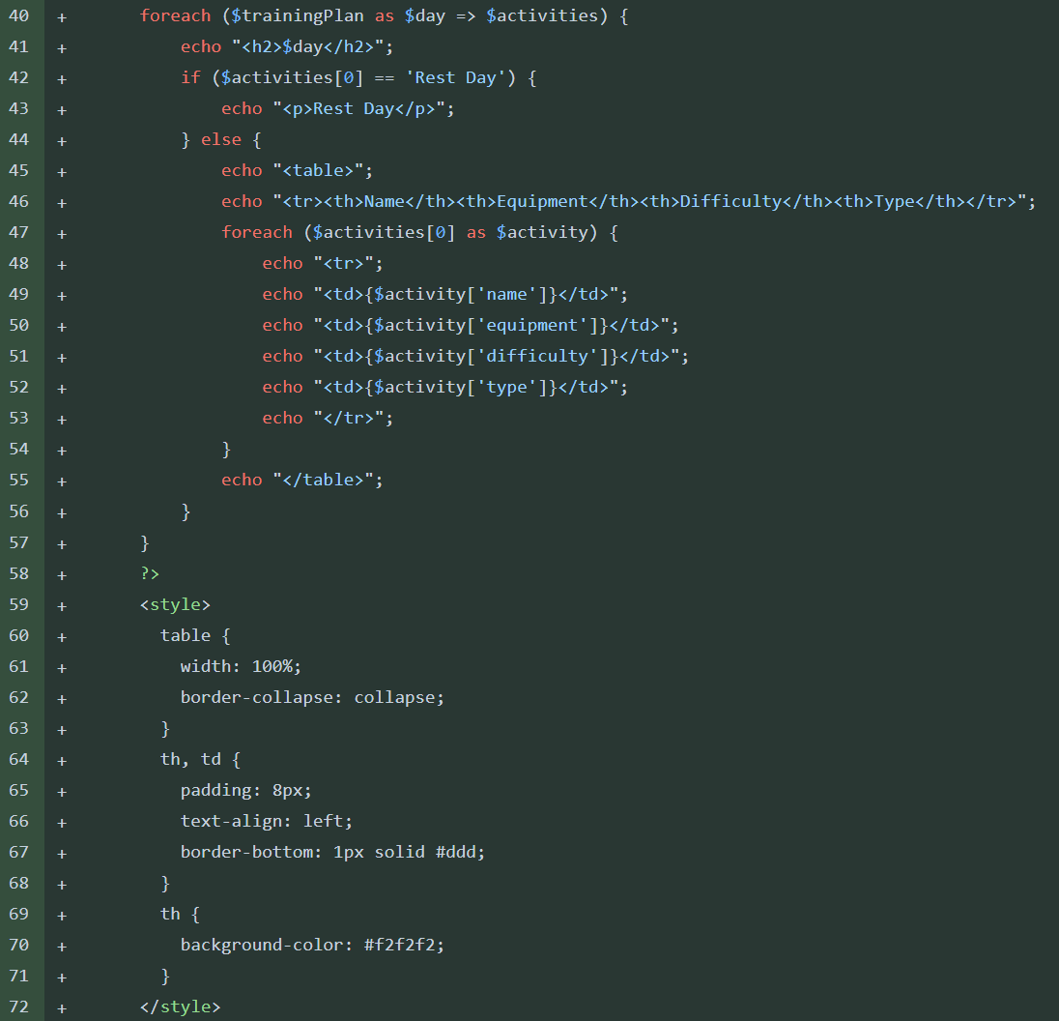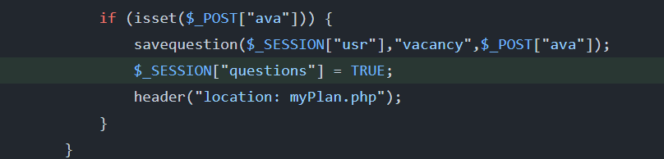I also added a new session variable that would be set when the user has completed all the questions for setting up an account since they should not need to redo this every time, they login.

I updated the method of displaying the training plan to be as a table.

The new method uses a foreach loop to iterate over the $trainingPlan array with each iteration, the loop processes a single day of the training plan.

Within the loop, the code starts by echoing an <h2> element containing the day of the training plan currently being processed. This header serves to provide context for the activities to follow, helping users understand which day's activities are being displayed.

Following the day header, the code checks if the first activity for the current day is labeled as a "Rest Day". If this condition is met, the code echoes a simple paragraph indicating that it's a rest day. This provides users with clear information about the nature of the day's activities without needing to delve into further details.

However, if the first activity is not designated as a rest day, the code proceeds to construct and display a table to present the activities scheduled for the day. It starts by echoing the table headers, providing column headings such as "Name", "Equipment", "Difficulty", and "Type".

The code then enters a nested foreach loop to iterate over each activity scheduled for the current day. Within this nested loop, the code echoes each activity's details, such as its name, required equipment, difficulty level, and type. Each activity's information is displayed within a table row, with corresponding cells for each detail, ensuring a structured and organized presentation of the day's activities.

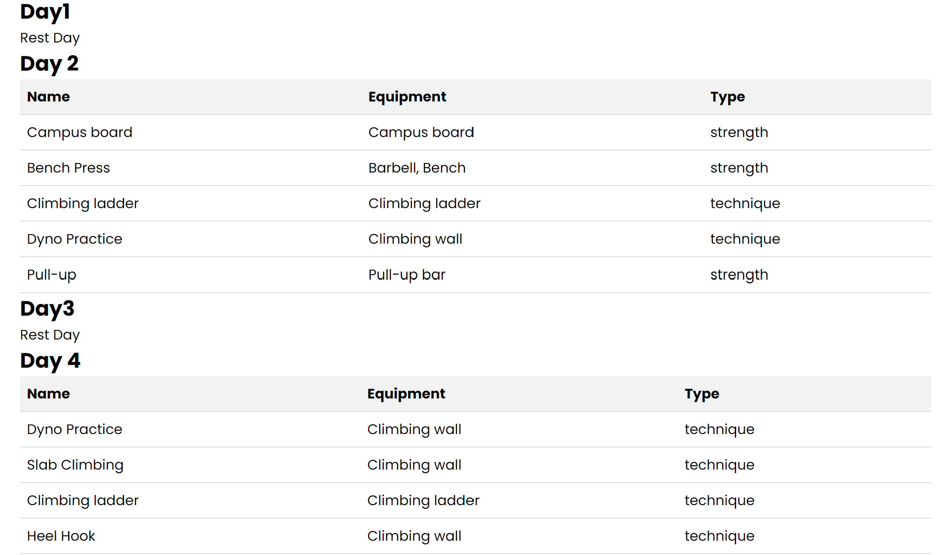This looked like the example below:

I also fixed an error that wasn’t currently causing any errors but may cause errors with indexing in the future.

The current way of appending the exercises for a day to the training plan array would make the exercise array inside an array for no reason. This doesn’t cause any errors right now but is bad practice.

The previous method would make an array like the one below:

[Day1: [ [ exercise array ] ] ,Day2: [ [ exercise array ] ] ….]

As you can see there is no need for the extra set of square brackets the ew solution doesn’t include these as seen below:

[Day1: [ exercise array ] ,Day2: [ exercise array ] ….]

## Storing The Users Plan:

My two solutions for storing the users plan array were to either store it in the database or to store each plan array in a json file.

Positives of storing in database:

* Data Integrity: Ensures consistency and reliability of stored data.
* Querying Capabilities: Allows efficient searching and manipulation of data.
* Scalability: Can handle large volumes of data and scale as needed.
* Concurrency Control: Manages simultaneous access to data, preventing inconsistencies.

Negatives of storing in database:

* Performance Overhead: Access and manipulation of large arrays can impact system performance.
* Complexity: Managing large arrays introduces complexity, especially with nested structures.
* Limitations in Manipulation: Database optimization may limit flexibility in array manipulation.

Positives of storing in json file:

* Simplicity: JSON files offer a straightforward way to store structured data.
* Portability: JSON files are platform-independent and can be easily transferred between systems.
* Suitability: JSON supports complex array structures and are designed around storing arrays.
* Ease of Use: Reading and writing JSON files is relatively simple

Negatives of storing in json file:

* Scalability Concerns: As JSON files grow in size, read and write operations may become slower, impacting website performance.
* Concurrency Issues: Handling simultaneous access to JSON files by multiple users can lead to data corruption or loss if proper precautions are not taken.
* Data Integrity: JSON files offer no built-in mechanisms for enforcing data integrity or ensuring consistency, requiring manual validation and error handling.

I decided to try storing my json file in the database first. I immediately was met with difficulties with storing such a large array in the database. The arrays were multiple dimensions and had many datatypes. Due to this the MYSQL database would return many errors constantly. I decided to use a json file to store the data now. This would be a lot easier since json files are easy to write to and are designed to store large array structures.

An example array is shown below this would be written into the json file. The json file would be named as the user’s username. This is safe since the username is a primary key in the database there will only ever be one of each username.

Array ( [Day1] => Array ( [0] => Rest Day ) [Day 2] => Array ( [0] => Array ( [name] => Campus board [equipment] => Campus board [difficulty] => 5 [type] => strength [reps] => 8 [sets] => 4 [measurement] => weight ) [1] => Array ( [name] => Bench Press [equipment] => Barbell, Bench [difficulty] => 2 [type] => strength [reps] => 10 [sets] => 3 [measurement] => weight ) [2] => Array ( [name] => Climbing ladder [equipment] => Climbing ladder [difficulty] => 1 [type] => technique [reps] => 0 [sets] => 0 [measurement] => time ) [3] => Array ( [name] => Dyno Practice [equipment] => Climbing wall [difficulty] => 4 [type] => technique [reps] => 0 [sets] => 0 [measurement] => difficulty ) [4] => Array ( [name] => Pull-up [equipment] => Pull-up bar [difficulty] => 3 [type] => strength [reps] => 10 [sets] => 3 [measurement] => weight ) ) [Day3] => Array ( [0] => Rest Day ) [Day 4] => Array ( [0] => Array ( [name] => Dyno Practice [equipment] => Climbing wall [difficulty] => 4 [type] => technique [reps] => 0 [sets] => 0 [measurement] => difficulty ) [1] => Array ( [name] => Slab Climbing [equipment] => Climbing wall [difficulty] => 1 [type] => technique [reps] => 0 [sets] => 0 [measurement] => difficulty ) [2] => Array ( [name] => Climbing ladder [equipment] => Climbing ladder [difficulty] => 1 [type] => technique [reps] => 0 [sets] => 0 [measurement] => time ) [3] => Array ( [name] => Heel Hook [equipment] => Climbing wall [difficulty] => 3 [type] => technique [reps] => 0 [sets] => 0 [measurement] => difficulty ) [4] => Array ( [name] => Mileage Climbing [equipment] => Climbing wall [difficulty] => 1 [type] => technique [reps] => 0 [sets] => 0 [measurement] => difficulty ) [5] => Array ( [name] => Running [equipment] => none [difficulty] => 1 [type] => conditioning [reps] => 0 [sets] => 0 [measurement] => distance ) [6] => Array ( [name] => Core Exercises [equipment] => none [difficulty] => 2 [type] => conditioning [reps] => 15 [sets] => 3 [measurement] => weight ) ) [Day5] => Array ( [0] => Rest Day ) [Day 6] => Array ( [0] => Array ( [name] => Dyno Practice [equipment] => Climbing wall [difficulty] => 4 [type] => technique [reps] => 0 [sets] => 0 [measurement] => difficulty ) [1] => Array ( [name] => Heel Hook [equipment] => Climbing wall [difficulty] => 3 [type] => technique [reps] => 0 [sets] => 0 [measurement] => difficulty ) [2] => Array ( [name] => Mileage Climbing [equipment] => Climbing wall [difficulty] => 1 [type] => technique [reps] => 0 [sets] => 0 [measurement] => difficulty ) [3] => Array ( [name] => Slab Climbing [equipment] => Climbing wall [difficulty] => 1 [type] => technique [reps] => 0 [sets] => 0 [measurement] => difficulty ) [4] => Array ( [name] => Climbing ladder [equipment] => Climbing ladder [difficulty] => 1 [type] => technique [reps] => 0 [sets] => 0 [measurement] => time ) [5] => Array ( [name] => Core Exercises [equipment] => none [difficulty] => 2 [type] => conditioning [reps] => 15 [sets] => 3 [measurement] => weight ) [6] => Array ( [name] => Push-ups [equipment] => None [difficulty] => 2 [type] => conditioning [reps] => 20 [sets] => 3 [measurement] => weight ) ) [Day7] => Array ( [0] => Rest Day ) )

Below is the array when it has been stored in the json file:

{"Day1":["Rest Day"],"Day 2":[{"name":"Campus board","equipment":"Campus board","difficulty":5,"type":"strength","reps":8,"sets":4,"measurement":"weight"},{"name":"Bench Press","equipment":"Barbell, Bench","difficulty":2,"type":"strength","reps":10,"sets":3,"measurement":"weight"},{"name":"Climbing ladder","equipment":"Climbing ladder","difficulty":1,"type":"technique","reps":0,"sets":0,"measurement":"time"},{"name":"Dyno Practice","equipment":"Climbing wall","difficulty":4,"type":"technique","reps":0,"sets":0,"measurement":"difficulty"},{"name":"Pull-up","equipment":"Pull-up bar","difficulty":3,"type":"strength","reps":10,"sets":3,"measurement":"weight"}],"Day3":["Rest Day"],"Day 4":[{"name":"Dyno Practice","equipment":"Climbing wall","difficulty":4,"type":"technique","reps":0,"sets":0,"measurement":"difficulty"},{"name":"Slab Climbing","equipment":"Climbing wall","difficulty":1,"type":"technique","reps":0,"sets":0,"measurement":"difficulty"},{"name":"Climbing ladder","equipment":"Climbing ladder","difficulty":1,"type":"technique","reps":0,"sets":0,"measurement":"time"},{"name":"Heel Hook","equipment":"Climbing wall","difficulty":3,"type":"technique","reps":0,"sets":0,"measurement":"difficulty"},{"name":"Mileage Climbing","equipment":"Climbing wall","difficulty":1,"type":"technique","reps":0,"sets":0,"measurement":"difficulty"},{"name":"Running","equipment":"none","difficulty":1,"type":"conditioning","reps":0,"sets":0,"measurement":"distance"},{"name":"Core Exercises","equipment":"none","difficulty":2,"type":"conditioning","reps":15,"sets":3,"measurement":"weight"}],"Day5":["Rest Day"],"Day 6":[{"name":"Dyno Practice","equipment":"Climbing wall","difficulty":4,"type":"technique","reps":0,"sets":0,"measurement":"difficulty"},{"name":"Heel Hook","equipment":"Climbing wall","difficulty":3,"type":"technique","reps":0,"sets":0,"measurement":"difficulty"},{"name":"Mileage Climbing","equipment":"Climbing wall","difficulty":1,"type":"technique","reps":0,"sets":0,"measurement":"difficulty"},{"name":"Slab Climbing","equipment":"Climbing wall","difficulty":1,"type":"technique","reps":0,"sets":0,"measurement":"difficulty"},{"name":"Climbing ladder","equipment":"Climbing ladder","difficulty":1,"type":"technique","reps":0,"sets":0,"measurement":"time"},{"name":"Core Exercises","equipment":"none","difficulty":2,"type":"conditioning","reps":15,"sets":3,"measurement":"weight"},{"name":"Push-ups","equipment":"None","difficulty":2,"type":"conditioning","reps":20,"sets":3,"measurement":"weight"}],"Day7":["Rest Day"]}

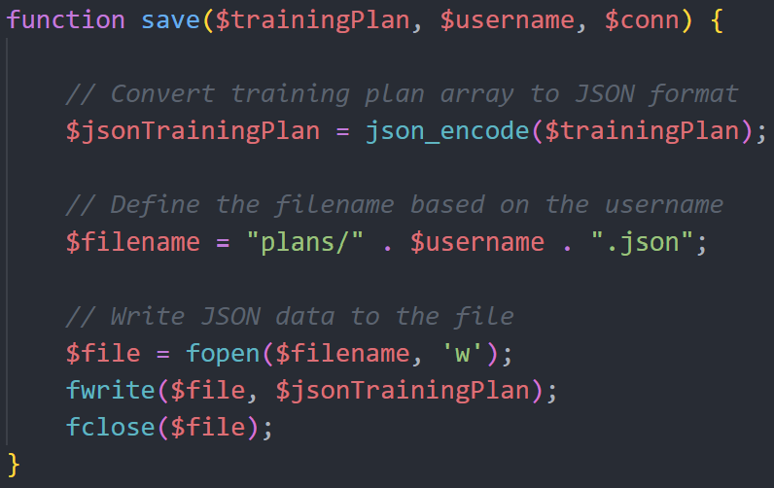To store the plan in the json file I made a new function in the class called save().

The function converts the provided training plan array into JSON format using the json_encode() function. This conversion transforms the array into a string representation suitable for storage in a JSON file.

Following this conversion, the function constructs a filename for the JSON file based on the username. This filename is generated by appending the username to the "plans/" directory path and adding the ".json" extension.

Subsequently, the function proceeds to open the specified file in write mode ('w') using the fopen() function. This prepares the file for writing data. It then writes the JSON-encoded training plan data to the file using the fwrite() function.

## New Navigation Bar:

I didn’t like the current navigation bar since I thought it didn’t suit the colour pallet I was currently using. It was also taking up a large portion of the page. I decided to switch the style of navigation bar discussed in the design section as this would take up less of the screen.

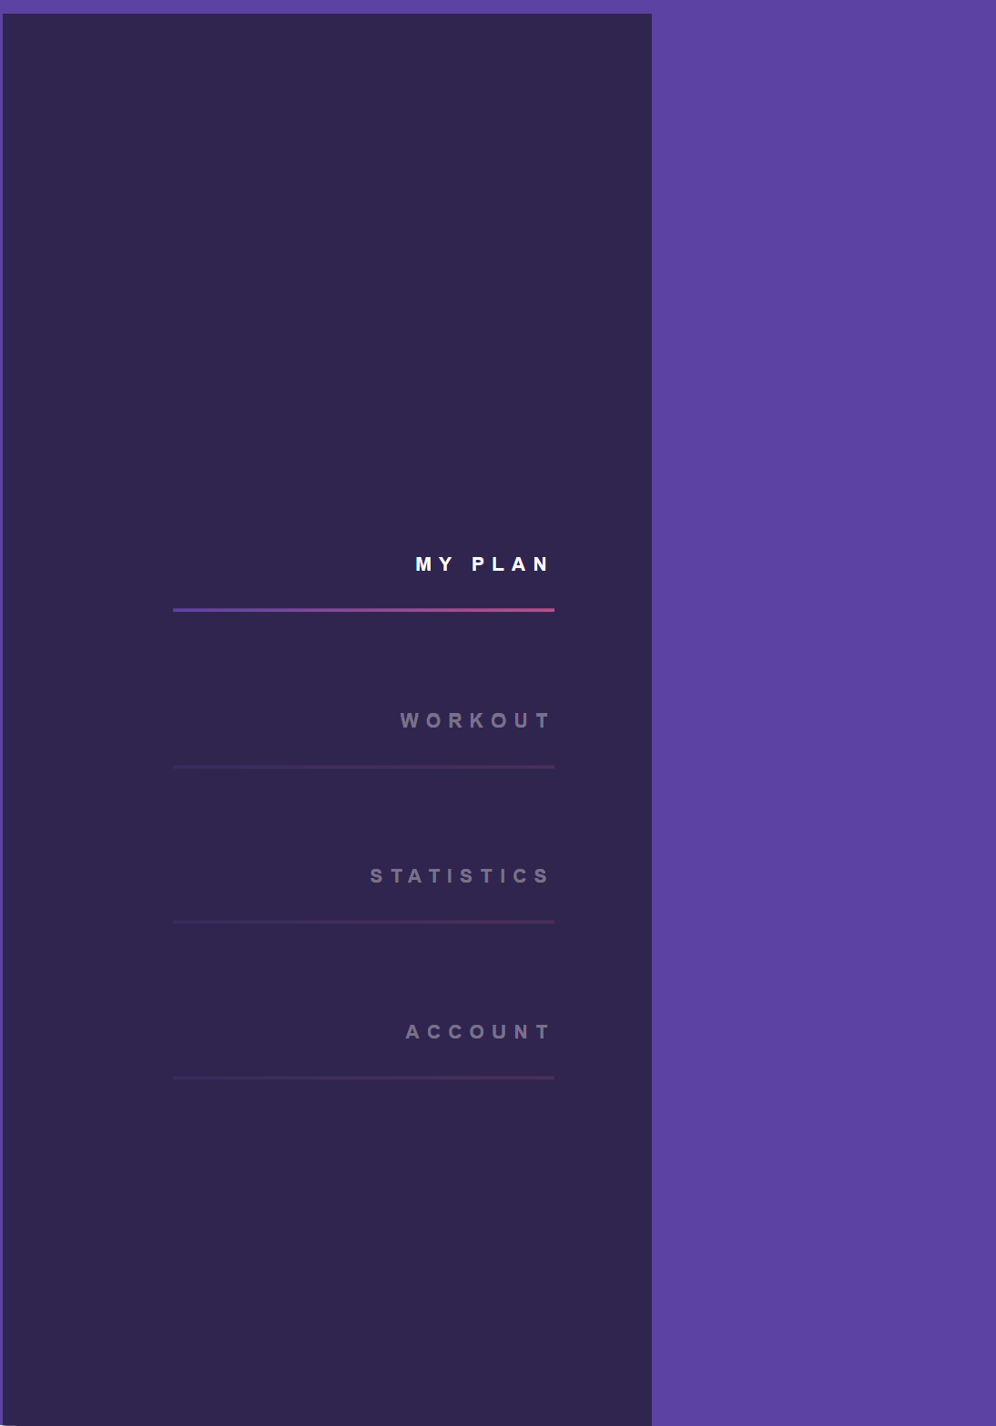This is the current navigation bar (left) the new one is shown below. The html is top right.

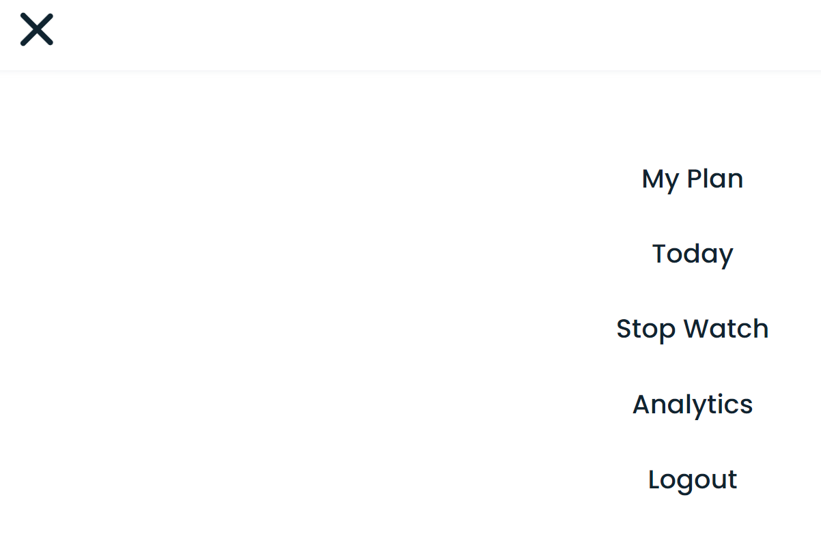When expanded it looked like the image below.

This new navigation bar looked much more appealing and was matching with the rest of the website.

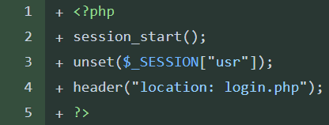I linked all the page to blank php pages that I can add stuff too later. I made a logout.php file that would run through all of the processes that are required to logout. I couldn’t run the php on the same page since the logout wasn’t a button but was a href link. However this solution is better since I can redirect to the logout page from anywhere to log the user out. This will reduce repeating code.

## Questions Finishing Touches:

I found an error with my method of stopping users from having to complete the questions every time they login. I was currently setting a session variable to true when the questions had been complete. This obviously wouldn’t work since every time the user logouts the session variables will get reset. This means my solution does nothing to fix the issue.

My new solution is to store the progress of completing the questions in the database, this will be better since the database will hold its data until its manually deleted. To make this work I added a new location to the database to store the questions status and I will have to write to this when the questions have been done. Upon every login this value can be checked and the user can be relocated to the correct question or to the ‘my plan’ page.

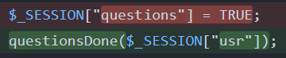The first thing I did was remove the questions variable and changed it to call a function. This function is in the functions.php file that has already been linked.

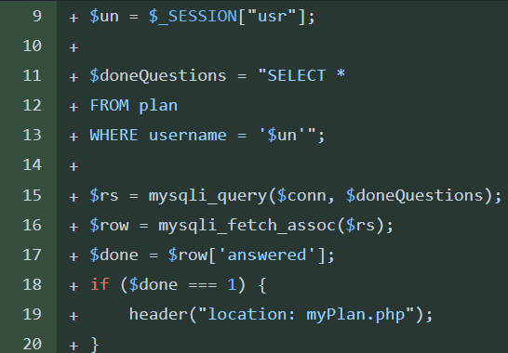On the question1 PHP file I wrote the code to read the database location. If this location has the value 1 then all the questions had been completed and the user would be relocated to the ‘my plan’ page.

After connecting to the database, the code retrieves the username of the current user from the session variable $_SESSION["usr"]. The retrieved username is assigned to the variable $un.

Next, the code constructs an SQL query stored in the variable $doneQuestions. This query selects all columns from a table named plan where the username column matches the username of the current user ($un).

The SQL query is executed using the mysqli_query() function, passing the database connection ($conn) and the query string ($doneQuestions) as parameters. The result of the query is stored in the variable $rs.

The code then fetches a single row from the result set using the mysqli_fetch_assoc function, which returns an associative array representing the fetched row. This array is stored in the variable $row.

The code then accesses the value of the 'answered' column from the fetched row using $row['answered'] and assigns it to the variable $done. The code checks if this value is equal to 1, indicating that the user has completed answering questions. If this condition is true, the code redirects the user to the myPlan.php page using the header("location: myPlan.php"); statement.

## Questions Database Logic Fix:

While making the previous step I realized that when was trying to save question answers to the database there would be errors. This was because when the queries were trying to save answers for the first time, they wouldn’t be able to find the username in the table since they haven’t been setup yet.

To fix this I added a new function that would create a new record in the table with just the primary key (username) setup. This function would be called first in every table before any more queries can be run.

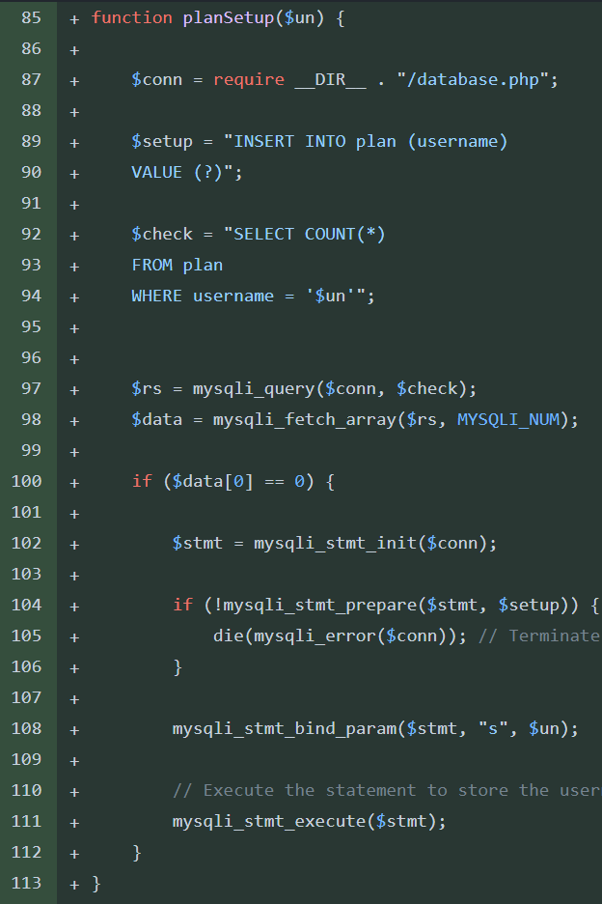The function then constructs an SQL query ($setup) to insert the username into a table named plan. This query will insert the username into the plan table.

A separate SQL query ($check) is formulated to determine whether the provided username already exists in the plan table. This check is to avoid duplicate entries for the same user.

The code executes the SQL query to check for the existence of the username using mysqli_query(), and retrieves the result using mysqli_fetch_array. If the count of rows returned from the query indicates that the username doesn't exist ($data[0] == 0).

To insert the username, the code initializes a prepared statement ($stmt) using mysqli_stmt_init(). If the preparation of the statement fails, the script execution is terminated and an error message is displayed.

The function binds the username parameter to the prepared statement using mysqli_stmt_bind_param(), and executes the statement.

## Created My Day Page:

I created a page for users to log their workouts. This page will display their current days activities. By reading the plan and selecting the day corresponding with the day of the week then printing the day in a similar style to the ‘my plan’ page.

This page will also have a suggested sets and reps for each exercise, a brief description of each exercise and a submit button to record the weight or difficulty of the exercise. This value will be stored to be used to suggest better weights in the future as well as to track progress in the ‘analytics’ page.

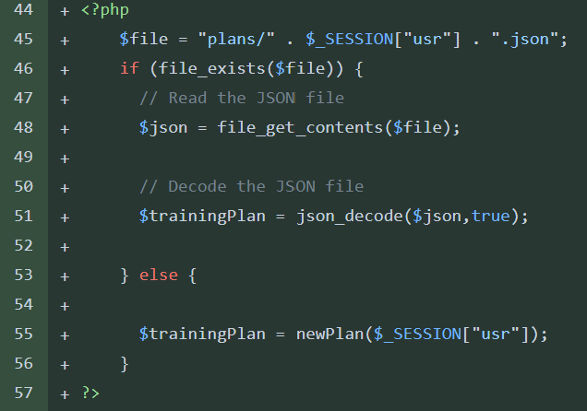I created this initial if statement to check the plan had actually been generated.

If the statement cannot find the file called {username}.json then it will call the newPlan() function and a plan will be made and saved.

This ensures the following PHP doesn’t try to print out of a file that doesn’t exist.

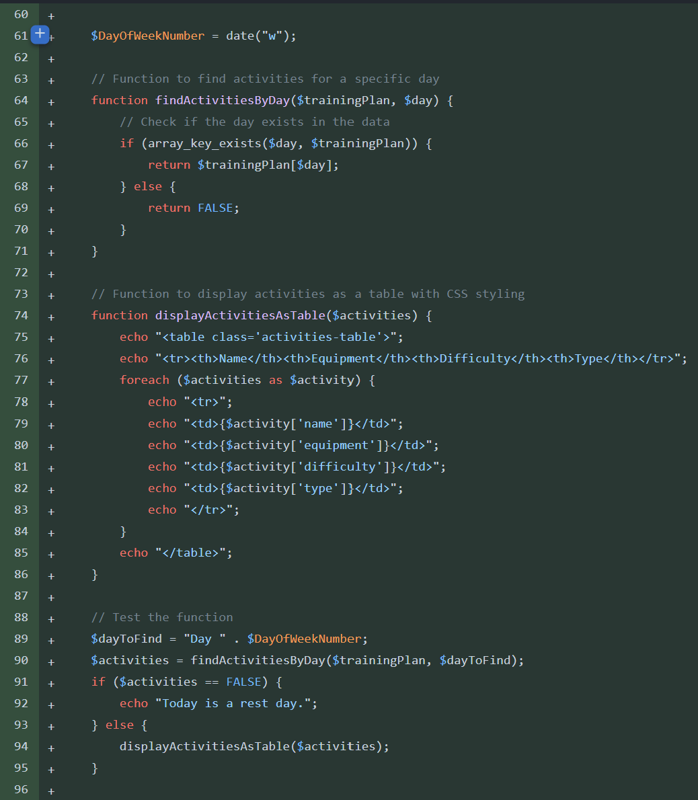I added this same statement to the ‘my plan’ page also.

The next thing to do was to display the singular day on the page in a table.

The code retrieves the current day of the week using the date("w") function and assigns the result to the variable $DayOfWeekNumber. This value represents the numerical index of the current day, where 0 corresponds to Sunday, 1 to Monday, and so on, up to 6 for Saturday.

The code defines a function named findActivitiesByDay($trainingPlan, $day). This function locates and retrieve activities associated with a specific day within the training plan. It takes two parameters: the $trainingPlan array, and the $day parameter specifying the target day to find activities for.

Within the findActivitiesByDay() function, an if statement checks if the specified day exists as a key within the $trainingPlan array using array_key_exists($day, $trainingPlan). If the day is found, the corresponding activities are returned from the array. Otherwise, the function returns FALSE to indicate that no activities are available for the specified day.

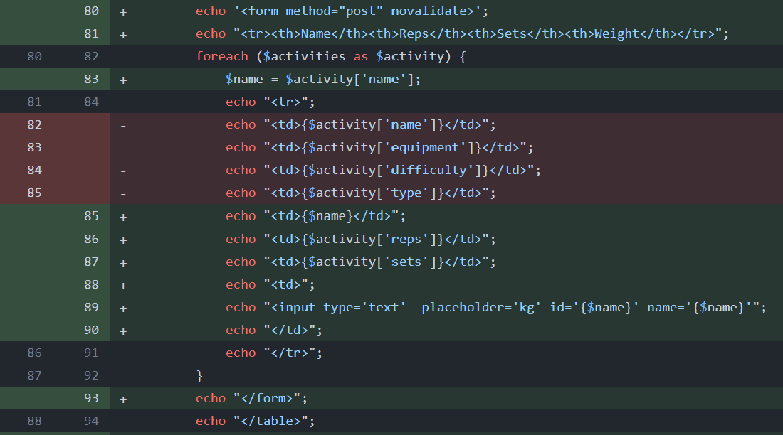The code defines another function named displayActivitiesAsTable($activities). This function is responsible displaying retrieved activities in a table format with CSS styling. It takes an array of activities ($activities) as input and generates an HTML table displaying each activity's name, equipment, difficulty, and type.

I updated the table for the ‘my day page to include the reps and sets for each exercise. I also removed the equipment and exercise type as this would be found in the exercise description that I will add later.

I also wrapped the whole table in a form tag, there is also a submit button at the end of the table. The idea is that when the user has finished all the exercises and filled out all the difficulty / weight boxed they can submit the form and it will save the values for each exercise.

Currently the sets and reps are defined inside the exercise directory json file but in the future the algorithm should be able to suggest more appropriate sets and weights for the user’s specific targets.

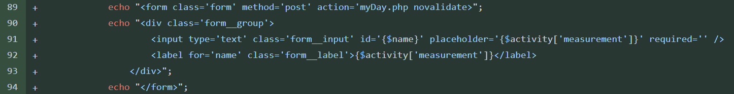I realized that submitting the whole exercise would be inconvenient for me and the user. This is because when completing exercises, it is more intuitive to submit the weight straight after finishing the exercise rather than the whole workout.

It would also make dealing with the data easier since instead of lots of form input arriving at once a form with one input is submitted and I have made the form name the same as the exercise this makes organizing and saving the data easier.

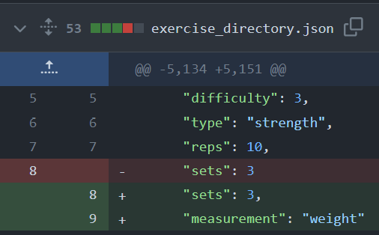I updated the exercise directory to also hold the measurement the that corresponds with each exercise, this is displayed as the placeholder before the user submits their difficulty / weight so that the user knows what difficulty scale is being used.

## Saving Users Exercise Data:

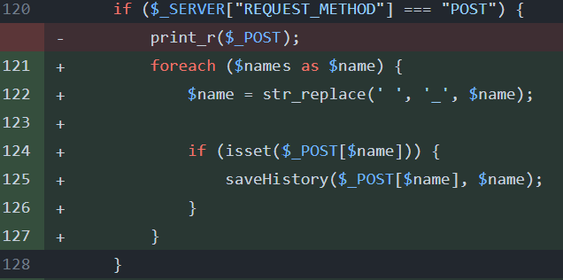I also created a check if statement that would check when a form has been submitted. When the server request method is post and there is a value for one of the names of the exercise the saveHistory() function is called.

The function constructs the filename for the JSON file using ($_SESSION["usr"]). This file path is stored in the variable $filename.

The function checks if the file exists using file_exists($filename). If the file exists, the file_get_contents($filename) function will read it’s contents. This gets the JSON data, this is decoded into a PHP array named $history using json_decode($json, true).

If the file does not exist (e.g. its first-time data is being saved) an empty array ($history = []) is initialized. This ensures that $history is defined regardless of whether the file exists or not, preventing errors during future operations.

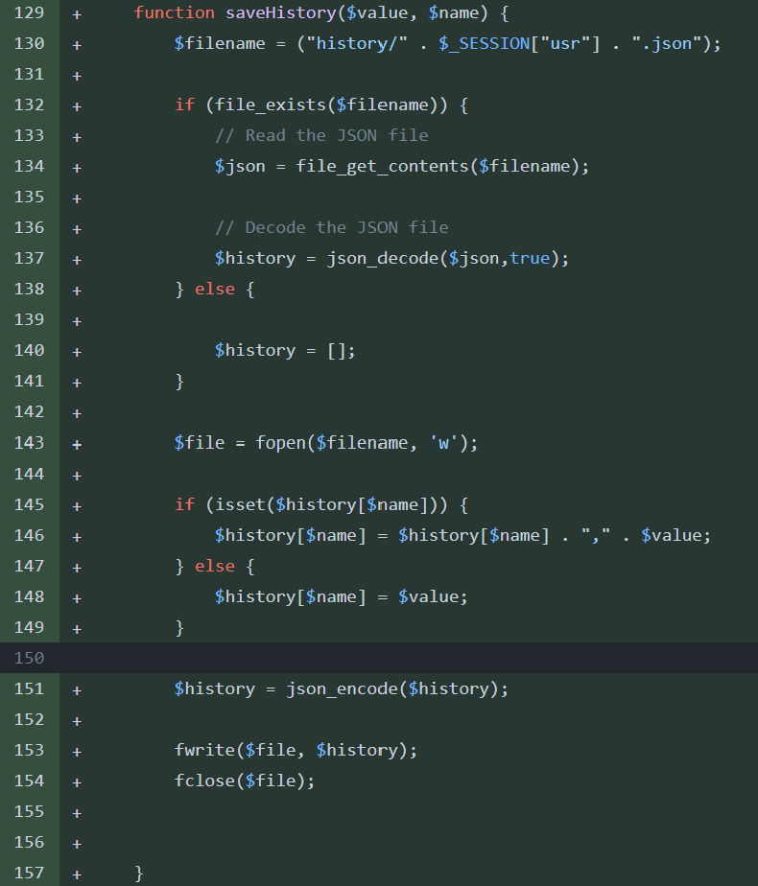The function then opens the file in write mode ('w') using fopen($filename, 'w').

If the $name already exists as a key in the $history array (indicating previously saved data for that particular exercise), the new $value is appended to the existing data using a comma-separated format. If $name is not yet present in the $history array, it is added with the corresponding $value.

After updating the $history array, it is encoded back into JSON format using json_encode($history).

Finally, the encoded JSON data is written to the file using fwrite($file, $history), and the file handle is closed using fclose($file).

This will save the user history in the format seen below. This user has project climbed with a difficulty of 5 twice and climbing laddered with a difficulty of 5 once.

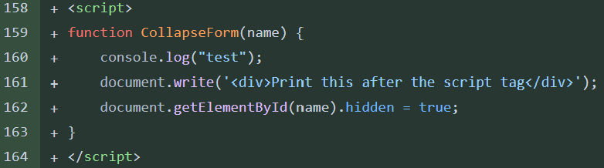I also wrote a JavaScript function called CollapseForm that would hide the exercise submit button when its difficulty has been submitted. This is done by getting the individual form for the exercise which is passed through as a parameter. When the function is called by the click of the button, they form is given the hidden class. This class is styled in CSS to have (display: none;) this will hide the whole form once it’s submitted.



## My Analytics Page:

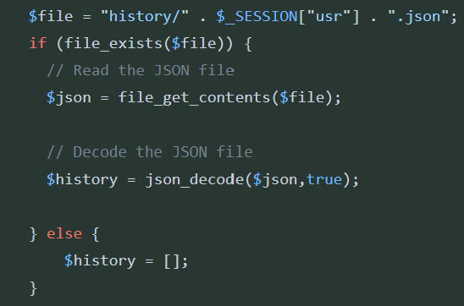First thing I did after setting up the Analytics page was to fetch the history array from the history file, if the file doesn’t exist, I initialize the history array at an empty array.

After saving the file path to a variable called $file I check if the file exists if it does then I get the contents using file_get_contents($file). Then I decode this into a php array from json formatting using json_decode().

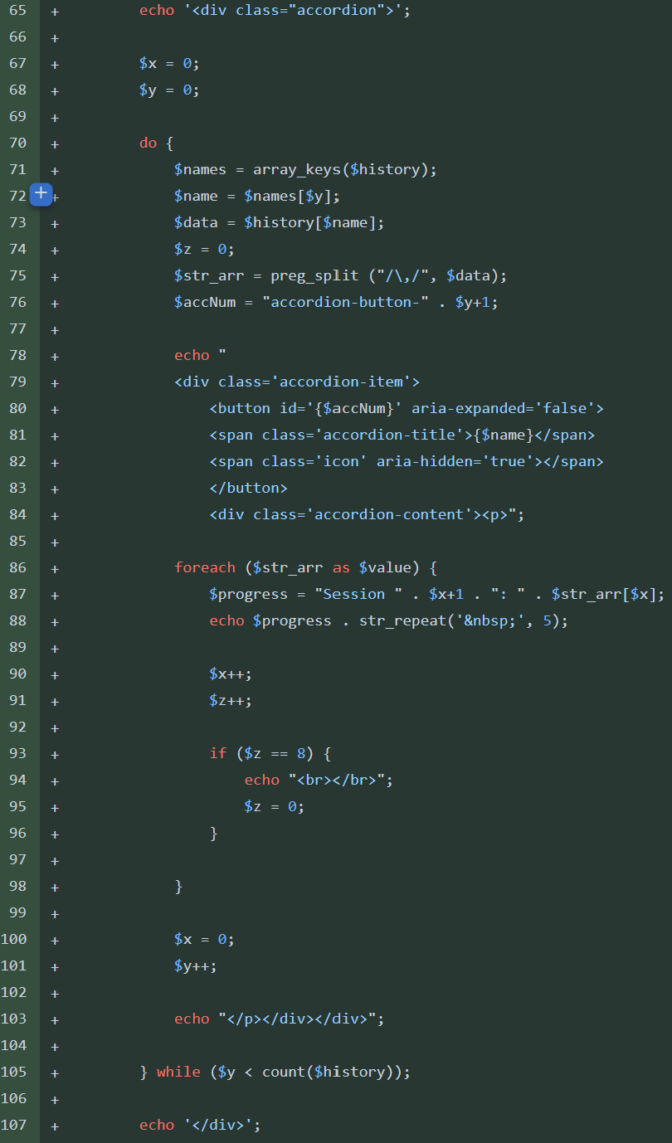I’m displaying the history as an accordion. Each exercise will have an accordion that can be expanded to show its history.

I begin by echoing an opening <div> tag with the class "accordion". This sets the stage for creating an accordion container.

Next, I initialize two variables, $x and $y, with values of 0. These variables are counters for the loop.

I use a do-while loop to iterate through each entry in the $history array. Inside the loop, I extract the keys ($name) and corresponding values ($data) from the $history array using the $y index.

I split the $data string into an array $str_arr using preg_split("/\,/", $data), organizing individual session values for the current exercise.

I generate an accordion button identifier ($accNum) using the current iteration index ($y) to create a unique ID for each accordion button.

For each entry in the $str_arr array, representing session progress values, I echo HTML markup to create an accordion item. Each item contains a button with an ID, a title ($name), and a content section ($progress). The progress for each session is displayed within the content section.

I increment the session counter ($x) and the history index ($z) within the loop. If the progress counter reaches 8, I insert a line break to keep all items on the page.

After processing all sessions for the current activity, I reset the session counter ($x) to 0 and increment the activity counter ($y) to proceed to the next activity.

Once all $history exercise have been processed. I echo a closing </div> tag to close the accordion container.

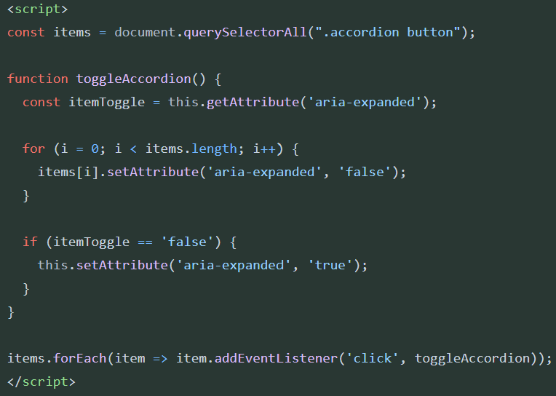I created a JavaScript method to open and close the accordions.

I select all elements with the class "accordion" that are buttons and store them in the constant items using document.querySelectorAll(".accordion button"). There will be many of these but they can each be uniquely identified by their IDs.

The function named toggleAccordion(). Handles the toggling of the expansion state of the accordion items when they are clicked.

Within toggleAccordion(), I retrieve the current expansion state (aria-expanded) of the clicked item using this.getAttribute('aria-expanded') and store it in the constant itemToggle.

Looping through all items in the items collection using a for loop. For each item, I set the aria-expanded attribute to 'false'. This ensures that only one item is expanded at a time.

After setting all items to a collapsed state, I check if the clicked item was previously collapsed (itemToggle == 'false'). If it was, I set the aria-expanded attribute of the clicked item to 'true', expanding it.

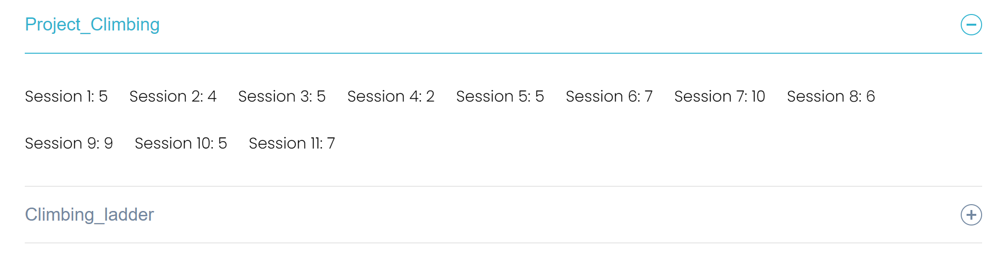When clicked, the listener triggers the toggleAccordion() function.

This is the outcome of my code. A toggliable accordian menu. For each session the value submitted is displayed.

## Stopwatch Page:

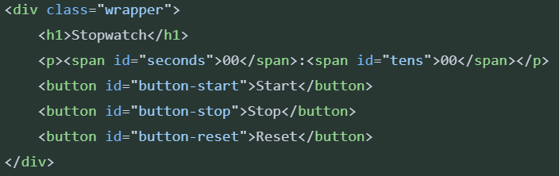Now, I created the stopwatch php page. This page was simple as the only elements other than the navbar was the stopwatch.

On the right is my html code in the stopwatch.php file.

I made a heading of ‘stopwatch’ and then using paragraph and span tags I make the stopwatch numbers. I also add 3 buttons. For starting, Stopping and resetting the stopwatch.

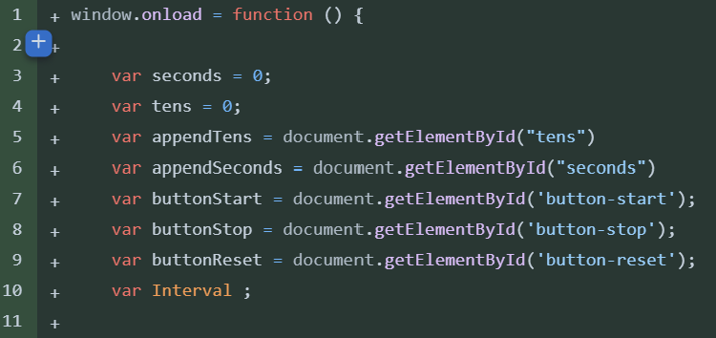Initialization:

* It sets initial values for seconds and tens to 0.
* It initializes variables to reference HTML elements (appendTens, appendSeconds, buttonStart, buttonStop, buttonReset) using getElementById().

Start Button Click Event:

* 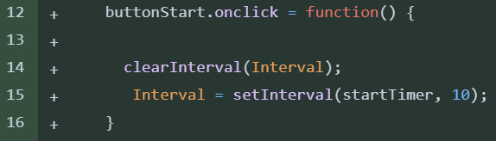When the "Start" button (buttonStart) is clicked, it clears any existing interval (if running) using clearInterval(Interval) to avoid multiple interval instances running simultaneously.
* It sets a new interval (setInterval(startTimer, 10)) that calls the startTimer function every 10 milliseconds.

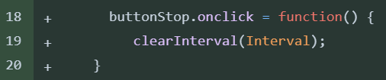Stop Button Click Event:

* When the "Stop" button (buttonStop) is clicked, it clears the running interval using clearInterval(Interval), effectively pausing the stopwatch.

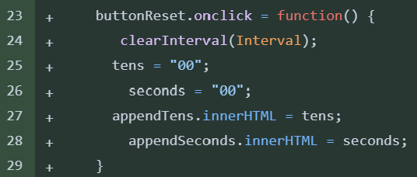Reset Button Click Event:

* When the "Reset" button (buttonReset) is clicked, it clears the running interval using clearInterval(Interval).
* It resets the seconds and tens variables to 0.
* It updates the HTML content of the elements appendTens and appendSeconds to display "00" for both tens and seconds.

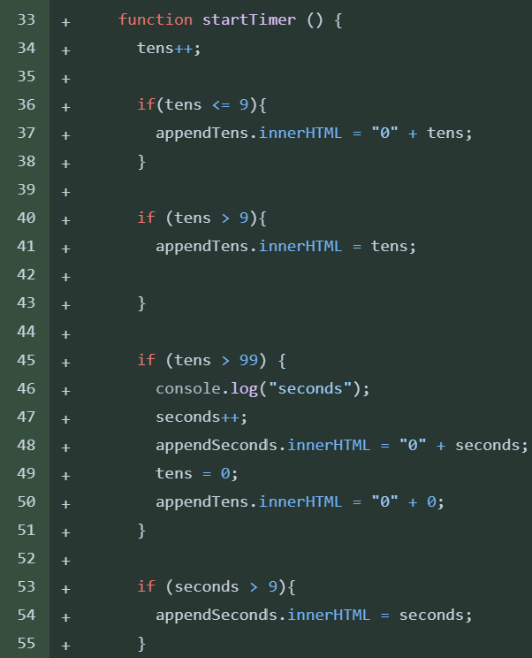startTimer Function:

* This function is called every 10 milliseconds by the interval set in the "Start" button click event.
* It increments the tens variable by 1.
* If tens is less than or equal to 9, it updates the HTML content of appendTens to display the current value with a leading zero.
* If tens is greater than 9, it updates appendTens with the current value without a leading zero.
* If tens exceeds 99 (representing 100 milliseconds), it increments the seconds variable by 1, resets tens to 0, and updates the HTML content of appendSeconds accordingly.
* 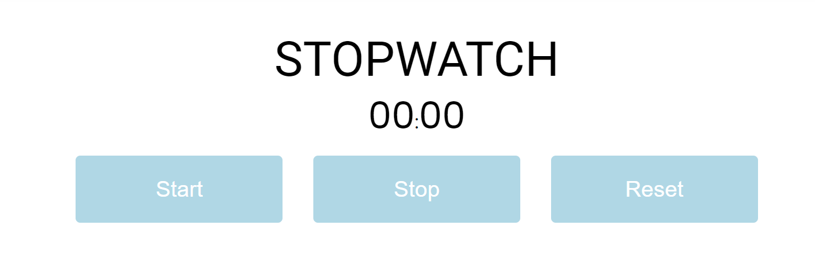If seconds is greater than 9, it updates appendSeconds with the current value.

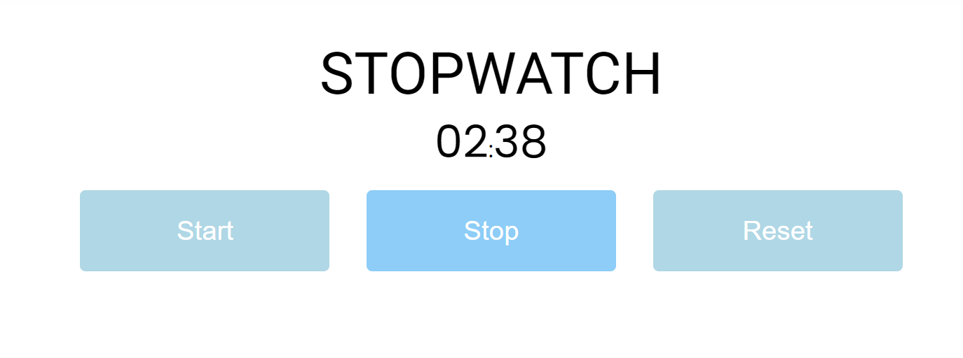This code along with some additional CSS looked like this, the stop watch was fully functional. I also added hover effects to the buttons to show the users that they were clickable. On hover the mouse pointer would change and the button background would change.

## Test New My Plan Page:

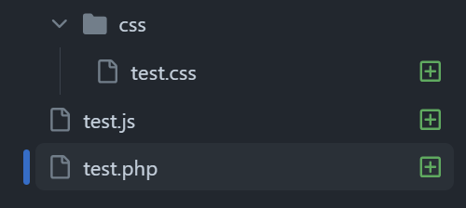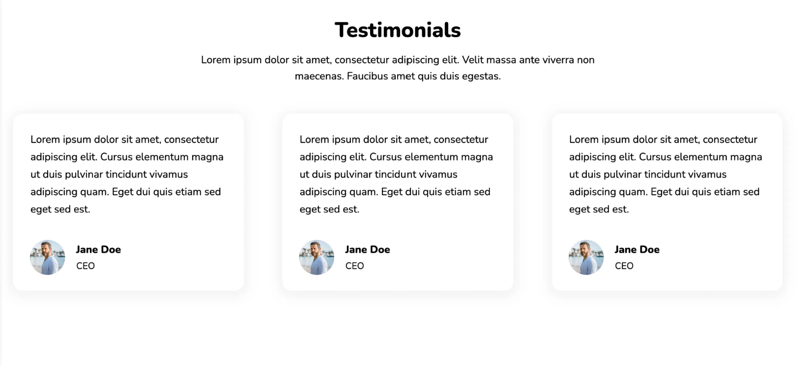I didn’t like the ‘my plan’ page. I thought it looked old rather than sleek and modern I decided to try a js based, testimonial scroller. Each testimonial would display a single day and they can be clicked on to expand for more info.

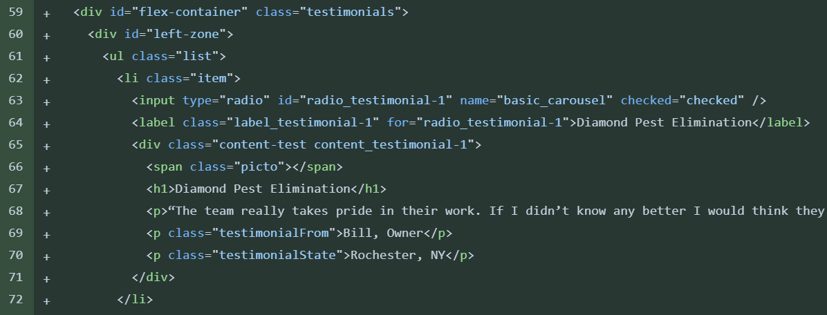This is the model I am using to base my design on. The user should be able to scroll left or right using the mouse to click and drag.

On the left is the html I used for an individual list item; each testimonial is a list item. For now, there are just place holder text for where the plan info will be displayed.

On the next page is the JavaScript code to get the list items to scroll. However, I couldn’t get this to work so I decided to stick with the current solution since it was fully functional.

The code below was also trying to cycle the testimonials on a timer also.

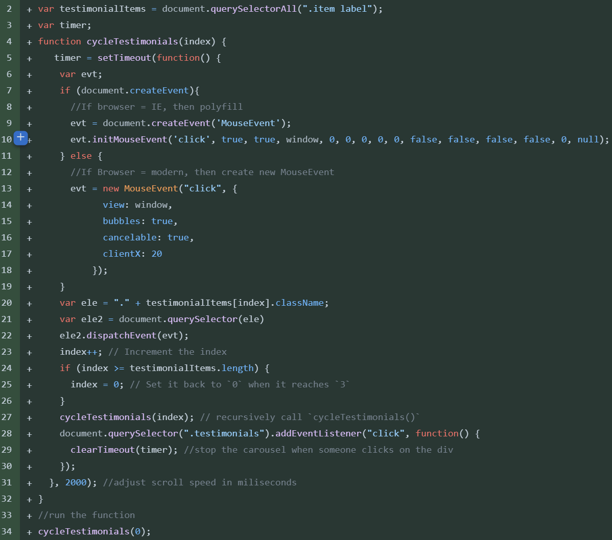

## Bug Fixing 2:

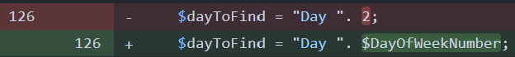I added protection for submissions that didn’t contain any data on the today page. This would stop the saveHistory() function returning an error since it was trying to append nothing.

I also changed the displayed today page back to the correct day of the week. Originally, I was using day 2 since the current day was a rest day and this meant it was hard to code with since the code, I was writing wasn’t being run. After I finished the code, I obviously forgot to change the number back to the variable.

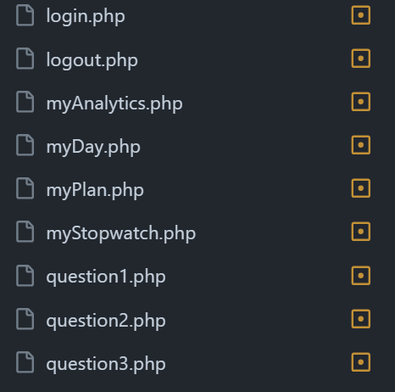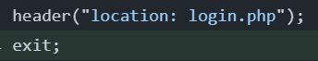I also went through all the code an added exit; statements after all header tags to stop code after the header being ran. I have done this before but since then any new header statements have been added. I found need for this line in all the files on the left. I used the built-in search for word feature on VS code to find all instances of the word header and then manually added in the exit; tag. 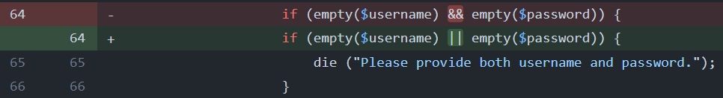I fixed a logic error with the login page. The code is supposed to return the message to provide a username and password when either one was not entered in the login form. However, in my if statement I used ‘&&’ instead of ‘||’ this meant the message would only be displayed if the user forgot to enter both the username and the password. This would cause errors in the SQL queries down the line if the user submitted a form with only the username or password.

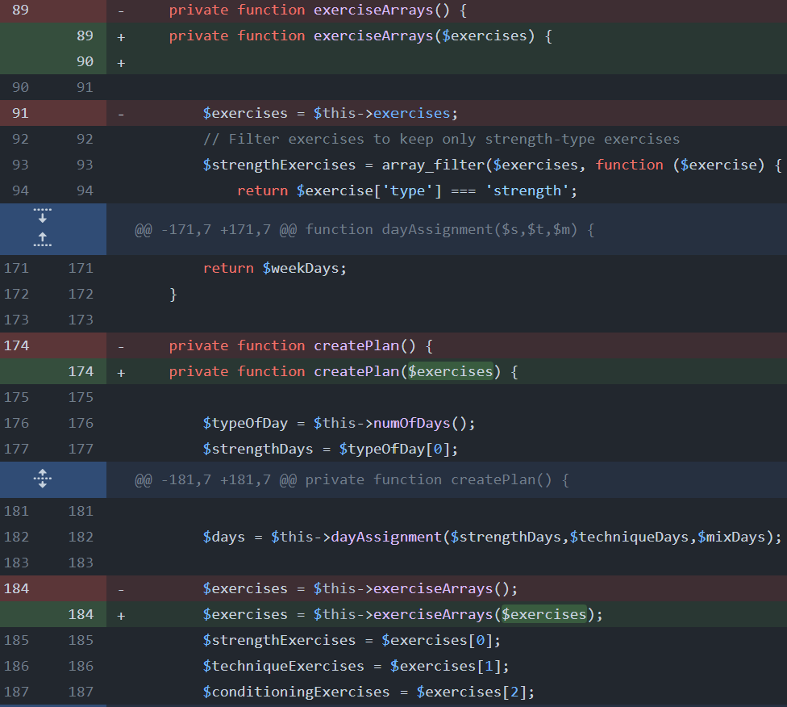I fixed a logic error that meant the users exercises were not being filtered by difficulty. Originally, I would call the filterExercises() function that would return an array of exercises that are in the user’s difficulty range. However, after calling this function, I continued to use the original array of exercises that was passed into the filterExercises() function instead of the new array.

To fix this I assigned the new array to a variable and passed it into the necessary functions as a parameter.

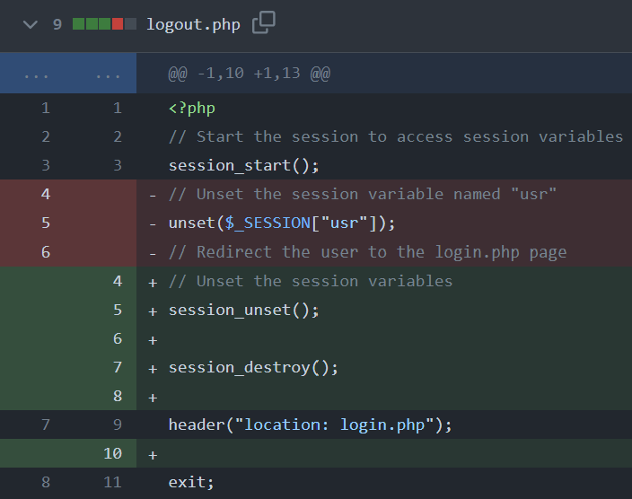I also improved the logout.php method to unset all session variables not just the ‘usr’ variable and also destroy the session. This is a more secure method of ending a session.

By unsetting all variables this future proofs the code in case I add more session variables in the future.

Another bug I found was tat the submit buttons for the individual exercises on the today page were placed on the wrong part of the page. This was due to some CSS styling issues.

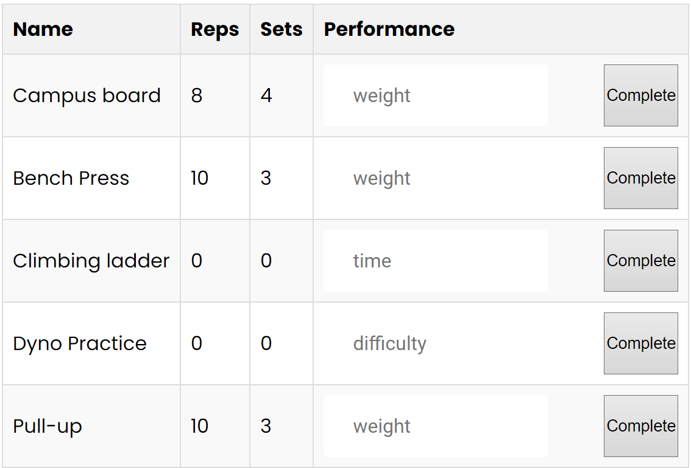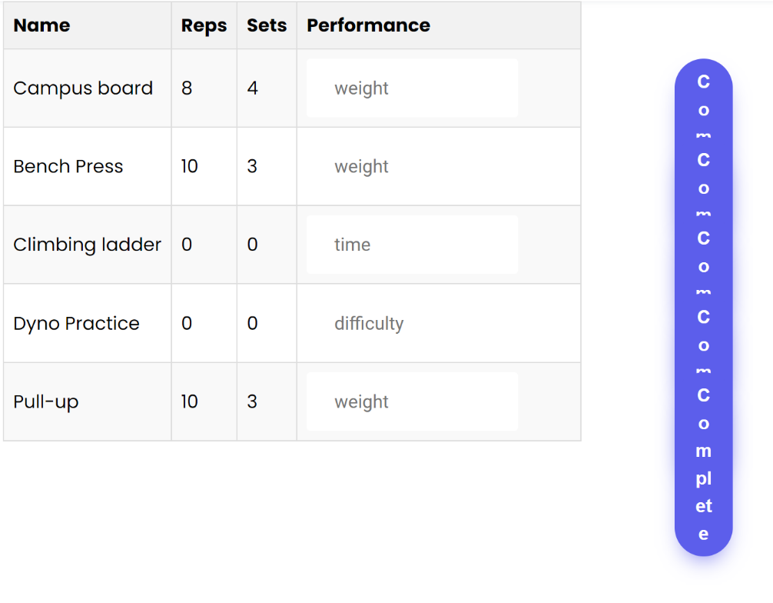I fixed this and now the buttons look like the image below rather than the image left.

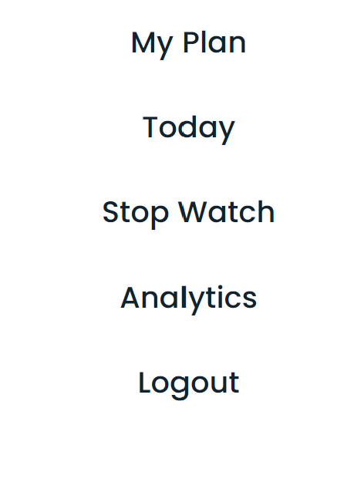Another issue was that when opening the navigation bar, it would display over the top of the content of the page. I overlooked this issue before since when designing the navigation bar, I had other content on the page hidden to make the CSS styling easier. I fixed this by adding a background that would fade in when the navigation bar is clicked on.

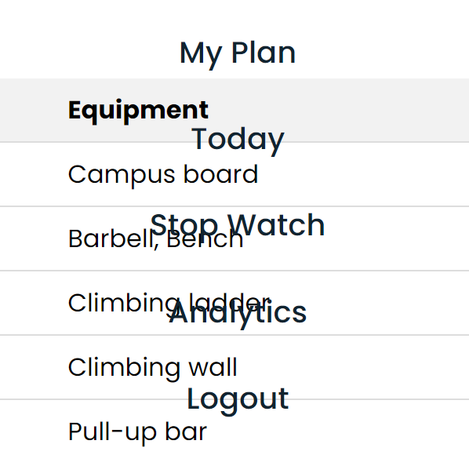

# Evaluation

## Feature Check List:

|  |  |  |  |  |
| --- | --- | --- | --- | --- |
| Num | Expectation | Inputs | Test | Outcome |
| 1. | Login screen looks like design section | N/A | N/A | Login screen looks similar to desired design |
| 2. |  |  |  |  |